SPACETIME DISTORTION BY THE NEUTRINO

Gareth Mayze

0 ABSTRACT

It is proposed that neutrinos directly influence spacetime by a hitherto unrecognised mechanism. Neutrinos emitted by celestial bodies create an energy-dependent scalar field equivalent to mass in addition to the overall baryonic mass, the resulting force is calculated using the Universal Law of Gravitation. The distance over which this field works effectively is then deduced from the multi-messenger detections made during the supernova eruption in 1987. Applying the method to self-gravitating systems using modelling produces results that are in close agreement with astronomical observations.

"What is the difference between neutrinos and the quanta of gravitational waves?"

Niels Bohr 1933

CONTENTS

1 INTRODUCTION . . . . . . . . . . . . . . . . . . . . . . . . . . . . . . . . . . . . . . . . . . 1

2 CONCEPTUAL ANALYSIS . . . . . . . . . . . . . . . . . . . . . . . . . . . . . . . . . . . . 3
2.1 Galactic halo analysis . . . . . . . . . . . . . . . . . . . . . . . . . . . . . . . . . . . . . . 3
2.2 Considerations of stellar emissions . . . . . . . . . . . . . . . . . . . . . . . . . . . . . . 5
2.3 Proposal for a mechanism . . . . . . . . . . . . . . . . . . . . . . . . . . . . . . . . . . . 6
2.4 Neutrinos and gravitational theories - a general view . . . . . . . . . . . . . . . . . . . 8

3 MATHEMATICAL MODEL . . . . . . . . . . . . . . . . . . . . . . . . . . . . . . . . . . . . 11
3.1 Incorporating the model into the virial theorem . . . . . . . . . . . . . . . . . . . . . . 12

4 THE TULLY-FISHER COLOUR RELATIONSHIP . . . . . . . . . . . . . . . . . . . . . . . 13
4.1 Nuclear fusion chains . . . . . . . . . . . . . . . . . . . . . . . . . . . . . . . . . . . . . . 13
4.2 Proton-proton chains in the sun . . . . . . . . . . . . . . . . . . . . . . . . . . . . . . . . 13
4.2.1 PPI chain . . . . . . . . . . . . . . . . . . . . . . . . . . . . . . . . . . . . . . . . . . . 13
4.2.2 PPII chain . . . . . . . . . . . . . . . . . . . . . . . . . . . . . . . . . . . . . . . . . . 14
4.2.3 PPIII chain . . . . . . . . . . . . . . . . . . . . . . . . . . . . . . . . . . . . . . . . . 14
4.3 Carbon-nitrogen-oxygen cold cycles . . . . . . . . . . . . . . . . . . . . . . . . . . . . . 15
4.3.1 CNO-I chain . . . . . . . . . . . . . . . . . . . . . . . . . . . . . . . . . . . . . . . . 15
4.3.2 CNO-II chain . . . . . . . . . . . . . . . . . . . . . . . . . . . . . . . . . . . . . . . . 16
4.3.3 CNO-III and CNO-IV chains . . . . . . . . . . . . . . . . . . . . . . . . . . . . . . . 16
4.4 Galaxy rotation model . . . . . . . . . . . . . . . . . . . . . . . . . . . . . . . . . . . . . 16
4.5 Cross-sectional area and energy . . . . . . . . . . . . . . . . . . . . . . . . . . . . . . . . 18
4.6 Tully-Fisher, colour versus rotation velocity . . . . . . . . . . . . . . . . . . . . . . . . . 18
4.7 Chapter conclusion . . . . . . . . . . . . . . . . . . . . . . . . . . . . . . . . . . . . . . . 21

5 SUPERNOVA SN1987A . . . . . . . . . . . . . . . . . . . . . . . . . . . . . . . . . . . . . . 23
5.1 SN1987a data overview . . . . . . . . . . . . . . . . . . . . . . . . . . . . . . . . . . . . . 24
5.2 Main burst at 7:35am compared to core collapse theories . . . . . . . . . . . . . . . . . 24
5.2.1 How well do theories of neutrino energy match detections? . . . . . . . . . . . . . 25
5.2.2 How long was thermal cooling predicted to last? . . . . . . . . . . . . . . . . . . . 27
5.2.3 Variations in neutrino energy from opacity vs detection . . . . . . . . . . . . . . . 27
5.2.4 How well do theories predict total energy released? . . . . . . . . . . . . . . . . . 27
5.2.5 Were the detections as isotropic as theories presume? . . . . . . . . . . . . . . . . . 28
5.2.6 Section summary . . . . . . . . . . . . . . . . . . . . . . . . . . . . . . . . . . . . . . 28
5.3 When did the core collapse? . . . . . . . . . . . . . . . . . . . . . . . . . . . . . . . . . . 29
5.3.1 Other data to corroborate the lsd burst . . . . . . . . . . . . . . . . . . . . . . . . . 29
5.3.2 Statistical analysis around the lsd time . . . . . . . . . . . . . . . . . . . . . . . . . 31
5.3.3 Possible causes of the antineutrino detections . . . . . . . . . . . . . . . . . . . . . 33
5.3.4 Did the core really collapse at 2:52? . . . . . . . . . . . . . . . . . . . . . . . . . . . . 34
5.4 Analysis of the core collapse at 2:52am . . . . . . . . . . . . . . . . . . . . . . . . . . . . 35
5.4.1 Comparison of theory against antineutrino energy at the lsd time . . . . . . . . . . 35
5.4.2 Gravitational effects during thermal cooling . . . . . . . . . . . . . . . . . . . . . . 39
5.5 Heavy element production via the r-process . . . . . . . . . . . . . . . . . . . . . . . . 40
5.6 Interpretation of data after 2:53am . . . . . . . . . . . . . . . . . . . . . . . . . . . . . . 44
5.7 Interpretation of data before 2:52am . . . . . . . . . . . . . . . . . . . . . . . . . . . . . 46
5.7.1 Comments on the last three sections . . . . . . . . . . . . . . . . . . . . . . . . . . 48
5.8 Events at the detection time of 7:35am . . . . . . . . . . . . . . . . . . . . . . . . . . . . 49
5.9 Comparison of 7:35 burst to an earlier detection . . . . . . . . . . . . . . . . . . . . . . . 50

5.10 Alternative interpretation of 7:35 data . . . . . . . . . . . . . . . . . . . . . . . . . . . 51
5.11 Interpretation of data after 7:35 . . . . . . . . . . . . . . . . . . . . . . . . . . . . . . . 54

6 BLACK HOLES AND NEUTRINO GRAVITATION . . . . . . . . . . . . . . . . . . . . . 57
6.1 Non-accreting black hole in galaxy NGC3115 . . . . . . . . . . . . . . . . . . . . . . . . 58
6.2 Accreting black holes in galaxies M87 and M104 . . . . . . . . . . . . . . . . . . . . . . 59
6.3 Explanation of black hole 'natal kicks' . . . . . . . . . . . . . . . . . . . . . . . . . . . . 62
6.4 The 'mass gap' between neutron stars and black holes . . . . . . . . . . . . . . . . . . . 62
6.5 Why the horizon is an essential feature . . . . . . . . . . . . . . . . . . . . . . . . . . . 63
6.6 Quark cores as a source of long gamma-ray bursts . . . . . . . . . . . . . . . . . . . . . 65
6.7 Early galactic evolution . . . . . . . . . . . . . . . . . . . . . . . . . . . . . . . . . . . . 66
6.7.1 ∆cdm approach . . . . . . . . . . . . . . . . . . . . . . . . . . . . . . . . . . . . . . 66
6.7.2 Neutrino approach . . . . . . . . . . . . . . . . . . . . . . . . . . . . . . . . . . . . 67
6.7.3 Summary of differences between the two approaches . . . . . . . . . . . . . . . . 67
6.8 Do primordial black holes exist? . . . . . . . . . . . . . . . . . . . . . . . . . . . . . . . 68
6.9 Detection of gravitational waves in the galactic plane . . . . . . . . . . . . . . . . . . . 68
6.10 Composition of the core . . . . . . . . . . . . . . . . . . . . . . . . . . . . . . . . . . . 70
6.11 The 'Brownian' heating mechanism . . . . . . . . . . . . . . . . . . . . . . . . . . . . . 72
6.12 The information loss paradox . . . . . . . . . . . . . . . . . . . . . . . . . . . . . . . . 73

7 WHY THE NEUTRINO? . . . . . . . . . . . . . . . . . . . . . . . . . . . . . . . . . . . . . . 75
7.1 Velocity . . . . . . . . . . . . . . . . . . . . . . . . . . . . . . . . . . . . . . . . . . . . . . 75
7.2 Mass . . . . . . . . . . . . . . . . . . . . . . . . . . . . . . . . . . . . . . . . . . . . . . . 76
7.3 Ubiquity . . . . . . . . . . . . . . . . . . . . . . . . . . . . . . . . . . . . . . . . . . . . . 76
7.4 Electric charge . . . . . . . . . . . . . . . . . . . . . . . . . . . . . . . . . . . . . . . . . . 77
7.5 Energy loss function or not? . . . . . . . . . . . . . . . . . . . . . . . . . . . . . . . . . . 77
7.6 Antiparticle and chirality . . . . . . . . . . . . . . . . . . . . . . . . . . . . . . . . . . . . 78
7.7 Comparison of hypothetical particle vs neutrinos . . . . . . . . . . . . . . . . . . . . . 78

8 THE COMA CLUSTER . . . . . . . . . . . . . . . . . . . . . . . . . . . . . . . . . . . . . . . 79
8.1 Testing the energy loss function for neutrinos . . . . . . . . . . . . . . . . . . . . . . . . 79
8.2 Results of energy loss function applied to neutrinos . . . . . . . . . . . . . . . . . . . . 81

9 UNIVERSAL EXPANSION AND THE HUBBLE TENSION . . . . . . . . . . . . . . . . . 83
9.1 Observational problems proposed by new inflation . . . . . . . . . . . . . . . . . . . . 83
9.2 Universal expansion mechanism . . . . . . . . . . . . . . . . . . . . . . . . . . . . . . . 85
9.3 The Hubble tension . . . . . . . . . . . . . . . . . . . . . . . . . . . . . . . . . . . . . . . 87
9.4 Considerations of the 'dark energy' model . . . . . . . . . . . . . . . . . . . . . . . . . . 92

10 DISCUSSION . . . . . . . . . . . . . . . . . . . . . . . . . . . . . . . . . . . . . . . . . . . 95
10.1 Significance of neutrino virtual mass to astrophysics . . . . . . . . . . . . . . . . . . 98

11 CONCLUSIONS . . . . . . . . . . . . . . . . . . . . . . . . . . . . . . . . . . . . . . . . . . 105

APPENDIX 1 Galaxy NGC5005 rotation curve . . . . . . . . . . . . . . . . . . . . . . . . . . . 109
APPENDIX 2 Galaxy NGC1560 rotation curve . . . . . . . . . . . . . . . . . . . . . . . . . . . 110
APPENDIX 3 Antineutrino data at 7:35am . . . . . . . . . . . . . . . . . . . . . . . . . . . . . 111
APPENDIX 4 Gravitational waves and antineutrinos at Lsd time . . . . . . . . . . . . . . . . 112
APPENDIX 5 Early detections 1:47-3:43am . . . . . . . . . . . . . . . . . . . . . . . . . . . . . 113
APPENDIX 6 Antineutrino energy loss functions . . . . . . . . . . . . . . . . . . . . . . . . . 114
APPENDIX 7 R-process calculations . . . . . . . . . . . . . . . . . . . . . . . . . . . . . . . . 115
APPENDIX 8 Neutron star radii approximator . . . . . . . . . . . . . . . . . . . . . . . . . . 116
APPENDIX 9 Mass and radius values for M87 black hole . . . . . . . . . . . . . . . . . . . . 117
APPENDIX 10 Mass and radius for M104 black hole . . . . . . . . . . . . . . . . . . . . . . . 118
APPENDIX 11 Coma Cluster mass and luminosity data . . . . . . . . . . . . . . . . . . . . . 119
APPENDIX 12 Model for the energy loss function and Hubble Constant . . . . . . . . . . . . 120
APPENDIX 13 Neutrino attributes . . . . . . . . . . . . . . . . . . . . . . . . . . . . . . . . . 121
APPENDIX 14 List of formulae . . . . . . . . . . . . . . . . . . . . . . . . . . . . . . . . . . . 122
APPENDIX 15 List of figures and tables . . . . . . . . . . . . . . . . . . . . . . . . . . . . . . 123

ACKNOWLEDGEMENTS . . . . . . . . . . . . . . . . . . . . . . . . . . . . . . . . . . . . . . 124

REFERENCES . . . . . . . . . . . . . . . . . . . . . . . . . . . . . . . . . . . . . . . . . . . . . . 125

1 INTRODUCTION

What is Gravity?

Just how well do we really understand it?

With the cause of around 5/6th of it as yet not properly explained, it would seem there is still a significant gap in our knowledge. The recent confirmation of the Higgs Boson now indicates that we have a well-established subatomic theory with a field and associated particle that produces baryonic mass. If that is true then why do we not also have a corresponding, detailed theory to describe the other greater components?

The problem was brought to light in 1884 by Scottish physicist Lord Kelvin who used a study of stellar kinematics in the Milky Way to show that there wasn't enough visible mass to account for the observed velocities. In 1933 Swiss astronomer Fritz Zwicky was the first to apply the virial theorem to a large gravitating structure and came to the same conclusion. Studying the Coma cluster of galaxies led to the inference that to keep the system gravitationally bound required far more mass than was apparent as stellar matter. He coined a phrase for this missing mass, something he called 'dunkle materie' or dark matter.

A similar phenomenon was discovered in the 1970's by American astronomers Vera Rubin and W. Kent Ford where stars in the outer edges of spiral galaxies were found to be rotating faster than the observed mass would allow. The concept of missing mass, while unexplained seemed obvious and soon became paradigm.

While modified gravity, missing mass and other theories all have their own particular strengths and weaknesses, there is currently no consensus about which if any constitute the definitive answer. This really is the heart of the problem - it's not sufficient for a theory involving gravitation to succeed in one or two areas, it must apply universally. Dark matter for example works in the ∆CDM model and the cosmic microwave background, galactic halos however require contrived density profiles and can't be made to track baryonic mass. Modified gravity theories often work better at describing galactic rotation, but fail to model structures like the Bullet Cluster where rotation tracks the stellar component and not the overall baryonic mass.

Whether the solution is a completely new law of physics, new type of matter, or an unanticipated property of existing matter the final arbiter is simple - whichever describes observation best.

Examining the problem in a heuristic way, why should we not ask whether the effect is being caused by normal visible matter that we know exists? In fact, the suggestion that matter could be able to structure itself by creating gravity on an astronomical scale might be seen as an example of self-organisation, a familiar phenomenon in many areas of science. If this were the case, and there are certainly a number of unknowns in physics, could we have overlooked a property that is hiding in plain sight?

1
The goal of this project is to investigate an alternative: whether there might be a link between neutrinos and spacetime curvature, as well as what the mathematical relationship could be. As such, there is no ambition to generate a new particle theory, only to try to
explain the phenomenon described above. Aside from the proposed link between neutrinos and spacetime, all work will be done using standard physics and will not invoke any new particles or fields.

There is of course a strong suggestion here, indeed almost by definition, that the neutrino must therefore have something to couple to. This implies that spacetime is more than just a smooth continuum and possesses some form of internal, mechanical structure. Indeed, it appears to be a popular topic in physics to suggest that a quantum gravity theory might be the eventual goal, where the overall form of General Relativity is retained but with an internal structure [1]. Just as with two overlapping sets, information about one set may allow the deduction of some of the properties of the other. In studies such as this, if correct, could allow the inference of some of the internal properties of spacetime - if it does indeed have an internal structure to decipher.

By necessity most of the work will have to start from first principles. Complex computer simulations are outside the scope of this project, although simple calculations using spreadsheets will be quite sufficient to analyse the systems under study. The analysis will be done for non-relativistic velocities which will be quite sufficient at this stage.

A technique used often in these spreadsheets is to start by collecting suitable data about an astrophysical object from around typically ten or so independent sources. Where possible, corrections are applied to the data using an up to date value of the Hubble constant, this method produces consistent data sets to work from. This data is then inserted into a graph and a trendline of a suitable function produced which could be either linear, exponential or polynomial depending on the nature of the data. This is used to test the gravitational model of the object.

Chapter 2 considers the viability of various physical mechanisms that are proposed followed by the mathematical framework in chapter 3. Case studies are then used from chapter 4-6 to elucidate properties of the neutrino and antineutrino, as well as solving the gravitational behaviour of the systems involved. Chapter 7 considers what properties would be desirable in a hypothetical particle and antiparticle to produce the gravitation and baryonic interactions of the neutrino and antineutrino. Chapters 8&9 then test the mechanism at increasingly large distances.

Readers wanting a summary of the calculations and outcomes from the main chapters should refer to chapter 10, Discussion. Readers wanting a more detailed understanding of the calculations done can view excerpts from the spreadsheets in Appendices 1-12. Neutrino attributes, current and proposed, formulae, figures and tables can be found in Appendices 13,14 and 15 respectively.

2
2 CONCEPTUAL ANALYSIS

Astronomers have over the years discovered a vast array of fascinating, curious, bizarre and often beautiful objects. Traditionally these were done using optical instruments, but recent developments have added radio astronomy, neutrino detection and gravity wave detection to the list. Neutron stars and black holes have been measured merging, gravity waves detected seconds before short gamma ray bursts, and of course the core-collapse supernova back in 1987.

These works have produced a wealth of information to analyse but at the same time raised the challenge of providing a plausible explanation for these events. Often the energy levels involved are simply too high to simulate with current technology, even with state-of-the-art instruments like the Large Hadron Collider or LHC. What this has left is a gap between observation and theoretical understanding, not least the means to properly explain gravity, both for its local effect holding galaxies and clusters together but also why the universe is being pushed apart at an accelerated rate.

This study was initiated by a simple observation based on galactic filament structures, and one that lead to a remarkably simple suggestion for the cause of the missing mass problem.

2.1 GALACTIC HALO ANALYSIS

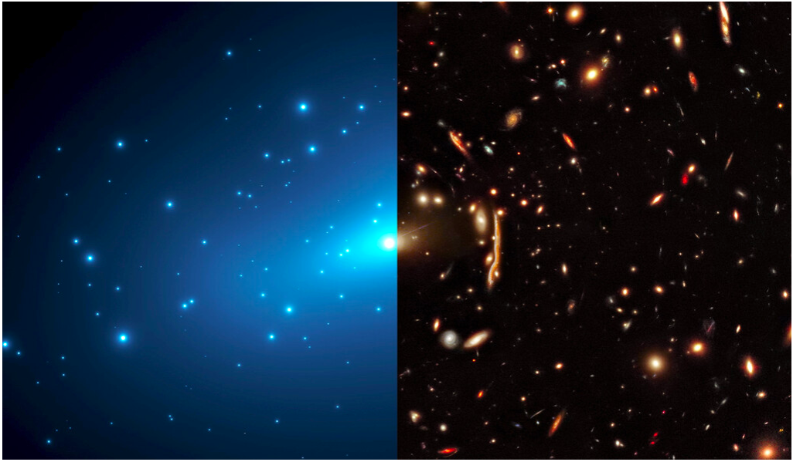

Figure 1. Galaxies in clusters producing gravitational lensing

3
The left side of figure 1. shows three separate elements [2]:

1. In white, the luminous stars forming the galaxies at visible wavelengths
2. In blue, artists impression to show the location of the calculated missing mass
3. In black, the voids of largely empty space between the galactic structure

Figure 2. shows the calculated mass distribution of a cluster of galaxies as derived from the lensing data. Overall mass is depicted by the central ‘mountain’ with additional concentrated peaks from individual galaxies.

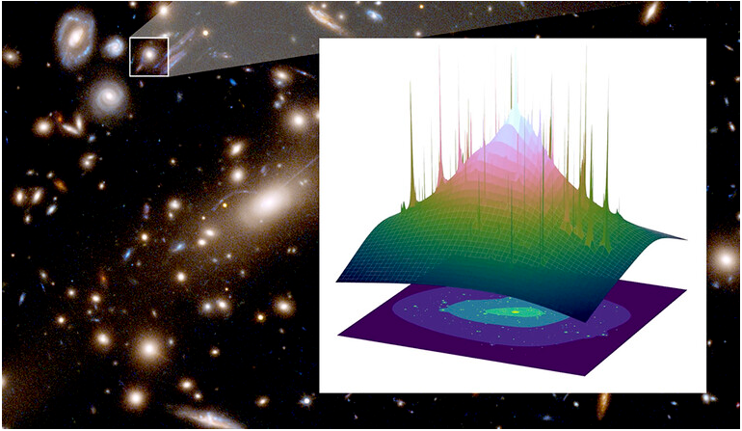

Figure 2. Contour map of mass distribution

What is key to interpreting these images is the relationship between the elements they contain. The extra gravity appears coincident with the baryonic matter, and both opposite spatially from the voids. How we interpret this organisation from a temporal point of view is crucial to how we explain it.

If we assume the gravitational effect came first, before the baryonic matter coalesced, we have to then explain how this gravity arose and what is causing it. This leads to an immediate restriction in what our theory can be, in essence we have to add a new entity of some sort, one which has yet to be discovered, and then after that explain it.

If without any theorem that definitively proves that all gravitational effects can only be caused by a form of material mass or energy, we then go on to assume that it is some form of matter, we have confused a cause, a priori with the effect. What is actually observed according to General Relativity is the effect of the curvature of spacetime on light and matter, not what is causing the effect.

4
Mass isn’t measured directly, it is inferred from other measurements, for example optical data such as red-shift, distance, luminosity and parallax are used to calculate the mass and energy present. Simply because the effect has the appearance of extra mass doesn't prove that it actually is a form of matter.

The focus therefore has to be on the outcome sought, in this case it can be argued quite reasonably and quite specifically that we’re trying to explain the curvature of spacetime, nothing else. What should therefore be avoided is to start by making assumptions that may at face value seem reasonable, but are neither provable or particularly logical.

Looking at figure 1. there are three entities shown as listed above. What else can we safely infer from this? From a temporal point of view nothing, it is a snapshot of the universe as we see it today. To be able to rewind time accurately would require almost or total knowledge of all the laws of physics and a level of detailed measurement of all the stuff contained within it, as well as the assumption that all the physical laws are deterministic.
If making temporal speculations can’t be justified then what else can be learned?

Being strict, the only justifiable statement that can be made about this system is that the extra, unexplained gravitational effect can be seen to be coincident with the stellar mass. In effect this could be added as 'element 4' of the image, anything beyond this can only be speculative and therefore cannot form a reliable basis for the theory under investigation. This zealous approach is justifiable, one wrong assumption at this early stage could lead to a path which increasingly diverges from reality.
By taking ‘element 4’ literally at face value, it was considered that the simplest answer could actually be the correct one: a direct cause and effect link between stars and their local gravity. It is proposed that over and above their conventional baryonic mass, stars increase the curvature of spacetime around them in a manner consistent in appearance to there being additional unseen mass present. While this may be an unconventional approach, proposing a link between two existing but not fully understood entities, it allows the analysis that follows to proceed unrestricted by the prior stipulation of a third, as yet undetected element.

If it is actually stars that are responsible for this effect, then realistic options are quite limited.

2.2 CONSIDERATIONS OF STELLAR EMISSIONS

Starting with the electromagnetic, photons are ubiquitous but their properties are presently it is believed, well understood. While this should not completely rule them out, analysis later in this paper would appear to suggest that they are not the correct explanation. Solar winds and mass ejection also seem poor candidates given that they comprise Standard Model particles and shouldn't offer any completely unexpected properties, nor do they possess high energy levels or significant mass. The neutrino however is presently still not fully understood [3], and this allows a certain amount of scope to manoeuvre within the properties that are known.
Since the purpose of this project is to explain why the neutrino might be the unexplained cause of this gravitational effect, a mechanism needs to be selected from whatever possibilities can be envisaged.

5
These suggestions then need to be analysed to find the most probable, efficient or natural explanation for the phenomenon.

Returning to figure 1. we see that the effect radiates outwards from galactic systems, and therefore mostly from stars. One initial consideration was that the effect was directional as far as overlapping neutrino fluxes were concerned. This would help to explain the galactic filaments, if that is indeed what they are, by the two fluxes passing in opposite directions between the two galaxies interacting to produce a filament.

Reference [4] seems to show that this is in fact unnecessary, the effect has been measured radiating outwards from galaxies with no suggestion of greater or multiplied effect in between. This is fortunate as it would imply neutrinos interacting with each other to produce a gravitational effect dependent on their angle of passing or collision, possible though unlikely given their small cross-sectional areas and the short range of the weak nuclear force. While no evidence for this mechanism was discovered nor indeed anything that could necessarily disprove it, the idea does appear rather unlikely.

It was then considered that the neutrino flux could produce a gravitational attraction in the sense that it would act on all matter in the same way as normal Newtonian gravity. There are however three problems with this. First as the neutrino is a fermion, it cannot produce an inverse-square law of force according to the standard model [5] so it has to be ruled out on this basis alone. Another problem is the very weak interaction between neutrinos and ordinary matter. Also, in attempting to explain galactic rotation curves, an inverse-square law is a poor fit to the observed data. Multiplying the baryonic gravity of a galaxy by a given amount based on this law would simply produce faster rotation, not flatter rotation which is what is observed [6].

If we then consider neutrino emitting bodies acting upon other neutrino emitting bodies, like two stars producing a mutual gravitational pull on each other, it might seem that a far simpler model has been found. In fact, we have found quite the opposite. First it relies on neutrinos interacting with other neutrinos at source as well as the possibility of that interaction requiring directionality as above. Second, we fall foul of the non-inverse-square law stipulation, and third, even more obvious is that all matter on the same virial orbit is observed moving with the same velocity. If this proposal were true then the stellar matter would presumably be seen rotating faster in galaxies than the gas and dust elements, which is not the case [7].

2.3 PROPOSAL FOR A MECHANISM

Although the above analysis is by no means exhaustive, further analysis that follows in this study shows that the simplest possible description fits observations best;

The solution proposed is that as neutrinos traverse space they interact with spacetime directly, curving it to produce the same effect as if they were actually massive particles

6
What this proposal means is that while the particle can convey the equivalent of gravitational mass to spacetime, it does so with no inertial mass. This should not be read to imply that the neutrino has gravitational mass but not inertial mass as this would be an incorrect interpretation of what the proposal says, this would violate the principle of equivalence.

It appears to react with spacetime directly on a quantum level, something which avoids all of the above difficulties. What this means in practice is that it allows stars and galaxies to produce a surrounding scalar gravitational field which, as will be seen in the next chapter, gives rise to an inverse law of force in addition to existing baryonic gravitation.

This proposal also neatly sidesteps the difficult issue of neutrinos having a tiny but finite mass. The Standard Model does not permit neutrinos to have mass, the Higgs mechanism simply does not apply to them. A second contradiction is the observation that the heavier species in a family of particles always decay into lighter ones, this applies to composite particles like the neutron as well as fundamental particles. Having a mass hierarchy for the neutrino implies a lighter species oscillating into a heavier one, something which while not per-se violating the rules of the Standard Model does appear to go against it's spirit.

Furthermore, decades of experimentation have only succeeded in lowering the upper limit of the upper mass squared difference between states, not one experiment has ever produced a lower limit or a definitive mass for the neutrino. This coupled with the bizarre possible range of masses being at least six orders of magnitude lighter than the lightest known particle the electron, suggests that the possibility of neutrinos having mass must be very tentative indeed. There do not appear to be any a-priori predictions of what the neutrino's three mass states should be, and as such this suggests that there are therefore no underlying theoretical considerations on which to base this assumption. Contrast this with the Higgs boson where there were some theoretical guides to it's mass before it was found.

Another oddity that comes from mass eigenstates, no matter how tiny, is that at least two of the three flavour eigenstates must travel at a velocity less than that of light, c. If gravity waves travel at c, and light travels at c, then why would neutrinos travel at almost but not quite c? Just like the mass states being almost but not quite zero, this just below light speed seems quite unnatural. Certainly, to date no experiment or observation has verified this subluminal propagation.
Also, taken in the context of this proposal, with neutrinos causing spacetime curvature described by gravitational waves it would seem odd for these waves to propagate just ahead of their source.

Rather than dealing with this awkward issue of a tiny mass, having a regular quantum interaction with spacetime allows the possibility for neutrinos to oscillate at regular intervals as they travel, and hence the need for mass can be removed.

Predicting this actual (quantum) mechanism is however beyond the scope of this study, it's effects can only assessed on a macroscopic scale although some thought will be given to the matter in Discussion. This study will therefore approach the problem from an astrophysical rather than theoretical perspective.

7
2.4 NEUTRINOS AND GRAVITATIONAL THEORIES - A GENERAL VIEW

To understand where this idea sits within the broader context of gravitational theories, it is important to consider it from an overall viewpoint and see just what the proposal implies, and also where it differs from other theories.

First of all, normal baryonic gravity is left exactly as it is with stars, planets, gas and dust etc. all producing gravitation to an inverse square law. This is done using Newtonian physics in low energy systems or relativistic equations where the environments are extreme. The suggested mechanism is additive, i.e. neutrino gravitation is simply added to normal baryonic gravitation to produce the total gravitation.

The proposal is therefore clearly not a modified-gravity theory.

The proposal is also emphatically not an attempt to prove dark matter, it has in fact got nothing fundamentally in common with the theory. Fitting astronomical observations to rotation rates and virial mass was initially an entirely logical step in deducing this unseen 'mass', if the proposal was made today it would fail to gain acceptance as it does not make self-consistent or testable predictions.
To illustrate this, galactic rotation curves are corrected by choosing a halo density profile, a contrived construct, and then adjusting the halo mass up or down to produce the best fit to the measured rotation rate. There is absolutely no a-priori method to predict these variables for any given size or type of galaxy, they are simply added and adjusted on an a-hoc basis for each individual galaxy, i.e. dark matter is a fudge.

By way of contrast, it will be seen later that neutrino gravitation uses a model that starts on an a-posteriori basis and applies it to a real galaxy and derives the value of the constant relating neutrino energy to virtual or 'pseudo mass'. This is very similar to the way the universal gravitational constant G was worked out empirically.
The same mathematics can then be used a-priori by inserting the known attributes or physical quantities for another galaxy, like luminosity for example, to produce specific and accurate predictions. The emphasis here should be on real physical quantities, things that can actually be observed and measured.
This is stark contrast to dark matter which is not based on any known laws of physics. Until such time as it makes an appearance in a detector it is a purely hypothetical theory of material from an unknown origin, it is conjecture.

Neutrino gravitation is also not what the reader might now be assuming, leading up to this point - an attempt to prove the sterile neutrino. Just as with weakly interacting massive particles, or wimps, the Standard Model makes no provision for these neutrinos. No fermion has ever been it's own antiparticle, something which very good evidence is given for later.

Recent experiments that measure double neutrino-less beta decay have all failed to produce a signal, and baseline experiments like MiniBoone give no room for their inclusion. A study of data from the Planck space station has also concluded that there is no room for a fourth species of neutrino. Microboone has now definitively ruled out their existence [8].

8
As will be seen later in this study, Majorana neutrinos are contradictory to and wholly incompatible with this theory.

All the above current theories involve hypothesising new laws of physics and new types of particles. The approach taken here is quite different. An existing particle - the neutrino - is seen to be present and correct around stars where this unexplained gravitation takes place, and it is assigned a new property.

This approach introduces a new concept to physics - that some internal structure of spacetime is influenced directly by neutrinos. It is not some form of assumed mass or their energy bending spacetime in the same way that photons and gluons do, it is a direct quantum mechanical interaction.

An analogy is to think of the neutrino and spacetime acting like a field effect transistor. These devices consist of an active channel through which charge carriers, electrons or holes, flow from the source to the drain terminal, this represents an increase in the curvature of spacetime. The gate terminal is insulated electrically from the source and drain so almost no current flows through it, but voltage applied to the gate, or in other words the passing of a neutrino, leads to a greatly amplified effect.

Unlike existing theories no physical laws are violated by this proposal, it is complementary and additional to them, and shows that neutrinos are more than just a by-product of the weak interaction. Indeed, a later chapter will ask the question that if we wanted to design a particle to produce the effect described above, what properties would we want the particle to have? These properties are then compared with the actual neutrino attributes - with interesting results.

9

3 MATHEMATICAL MODEL

To calculate the total virial mass $Mvir$ for a star we take the stellar mass $Ms$ and add the neutrino equivalent, or virtual mass $Mv$ (the same general principle also applies to a galaxy which might have the addition of more mass in the form of gas and dust). This acts on the orbiting mass $Mo$ at virial radius $R$, with the neutrinos travelling at the speed of light c, $3×{10}^{8}ms^{-1}$.

For a source, continuously emitting neutrinos with an equivalent or virtual mass at the rate of $N kgs^{-1}$ over a time of R/c seconds, $Mv$ is given by
 | $$Mv=N\frac{R}{c}$$ | (1)

It is assumed that these masses $Ms$ and $Mv$ lying inside the radius $R$ act as if they are a point source at the centre, and everything outside integrates to zero net effect as is expected with the generalised virial theorem.
At this initial stage, and for the sake of illustration only, the stellar mass $Ms$ is omitted and only the interaction between the neutrinos and $Mo$ is shown.
Incorporating $Mv$ and $Mo$ into the equation for universal gravitation produces:

$$F=\frac{GMvMo}{R^{2}}$$

With $G$ the gravitational constant of $6.674×{10}^{-11}m^{3}.{kg}^{-1}.s^{-2}$

Substituting (1) produces:
$$F=\frac{GNRMo}{cR^{2}}$$
Cancelling Rs gives:
 | $$F=\frac{GNMo}{cR}$$ | (2)

What is noticeable is that having a time-dependent term $R/c$ for the neutrino virtual mass, the force varies as $1/R$, and not as an inverse-square law. This is of course the effect the neutrino element alone has on the orbiting baryonic mass, and was used as a simplified example to illustrate this relationship.
For most systems under study the baryonic mass is non-negligible, and so to calculate for a virial rotating system, like a galaxy, the stellar mass is added to the neutrino equivalent mass plus any other significant masses like Gas, $Mg$ and Dust, $Md$ to obtain an overall virial total:
$Mvir=N\frac{R}{c}+Ms+Mg+Md$ (3)

Substituting (3) into the universal gravitational law gives the complete combined expression:

$$F=\frac{GMvirMo}{R^{2}}$$

Since we are concerned mainly with calculating orbital velocity $V$, the attractive gravitational force $F$ is equal to the centripetal acceleration, hence:

$$\frac{MoV^{2}}{R}=\frac{GMvirMo}{R^{2}}$$

Cancelling and taking the square root yields:

 | $V=$ $\sqrt{\frac{GMvir}{R}}$ | (4)

Having produced a mechanism, how is it implemented it to calculate $V$ for a specified virial system and produce a rotation curve?

3.1 INCORPORATING THE MODEL INTO THE VIRIAL THEOREM

First the system is divided up into individual concentric circular orbits of approximately equal separation which encircle increasing virial mass/volumes as a function of increasing radius.
A feature of the virial theorem is that whether the system is spherical or an oblate spheroid, the same mathematical rules apply so long as the axis of rotation is chosen to be an axis of symmetry. This is very convenient since it allows the same formulae to be used for say a spherical elliptical galaxy or bulge in a spiral galaxy, and also the disk of a spiral galaxy can be treated as a flattened oblate in the same way.
Next, a stellar density profile, if say a galaxy is being studied, is needed to calculate the neutrino luminosity of each volume, this luminosity relates to the virtual mass that the neutrinos impart.
The density profile also gives the standard stellar mass, and to this separate gas and dust density components may be added if required. All of this information would need to be measured individually for each system/galaxy under consideration, or modelled by standard empirical formulae such as de Vancoullier’s or Jaffrey’s density profile, for example.

Finally, it is assumed that to calculate for each volume radius $R$, the mean path length of all the neutrinos emitted internally to $R$ is equal to $R$.
This may seem rather arbitrary for a hypothetical, perfectly circular set of shells, but given the range of shapes of the multitude of celestial bodies that could be modelled using a computer, it would seem intuitive that the geometric irregularities of each body would have to be computed in practice on a case by case basis.
For our simplified model this assumption is quite adequate, especially as the vast majority of galaxies have a much higher stellar central density than in their outer reaches.

12
4 THE TULLY-FISHER COLOUR RELATIONSHIP

The Tully-Fisher and equivalent Faber-Jackson relationships are empirical formulae that link the luminosity, mass and rotation of spiral and elliptical galaxies respectively. They are used in astronomy principally to establish ‘standard candles’ to determine distance, the fit between the three variables being in fact remarkably tight [9] despite the lack of a theoretical explanation. According to these theories, the more luminous a galaxy, all other things being equal, the faster it will on average rotate [10].
If we propose neutrinos as a gravitational mechanism, greater Bolometric luminosity $Lb$ would generally imply greater neutrino luminosity $Lv$, this being true it might explain the above relationship between Bolometric luminosity and rotational velocity. It would seem to offer a simple, natural explanation for this phenomenon as well as linking the observed correlation between luminous baryonic mass and the gravity associated with it [9].

If this proposal is correct then it leads to a basic question: does the effect relate to the number of neutrinos emitted (a) or their luminosity (b) which is a combination of number emitted times their energy? The above observation that greater luminosity equates to faster rotation does not immediately differentiate between options a and b. Given that the number emitted is inherent to both a and b, it will be assumed at this early stage of investigation that more neutrinos equals more gravity. If the effect is therefore only related to the presence of neutrinos, and not their energy, it would seem necessary to investigate any system that could help discriminate between these two possibilities.

For this effect to be analysed some rudimentary nuclear physics is required to derive values for the neutrino luminosities of different star types.

4.1 NUCLEAR FUSION CHAINS

Stars come in a wide variety of masses, luminosities, sizes, metallicity, age and so on. Almost all lie on the so-called main sequence, illustrated by the Hertzsprung-Russell diagram. What is most significant from our perspective is that there are essentially two distinct chains of nuclear fusion responsible for the luminous output of stars, as well as their neutrino emissions. Although both chains emit electron neutrinos initially before oscillation, it is the energy level of these that is of interest here.

4.2 PROTON-PROTON CHAINS IN THE SUN

First is the Proton-Proton chain or PP chain for short, which is dominant in stars of around 1.3 times the mass of the Sun or less [11]. There are three main distinct branches of this fusion path, PPI, II and III each with different neutrino emissivity’s.

4.2.1 PPI CHAIN

This chain dominates at core temperatures between around 10-14 Million Kelvin (MK). The reaction is:

$$4 {}_{1}^{1}{H→{}_{2}^{4}{He+2e^{+}}+2v_{e}}+26.73Mev$$

13
In the Sun, PPI accounts for 83.3% of the Sun’s total energy output, with the two neutrinos carrying away 2% of the energy per chain.

4.2.2 PPII CHAIN

Dominates between 14-23 MK and produces 16.68% of the Sun’s output and also releases a total of 26.73 Mev per chain. Two protons collide to produce one neutrino with an energy of 0.2673 Mev. A second neutrino is produced later in the chain via:

$${}_{4}^{7}{Be}+e^{-}→{}_{3}^{7}{Li}+v_{e }\left(0.861Mev 90\%, 0.383Mev 10\%\right)$$

(For the 0.861 Mev neutrinos the Lithium is produced in its ground state, for the 0.383 Mev neutrinos it is produced in its excited or metastable state hence the lower neutrino energy)

Total neutrino energy is therefore:

$$0.2673+0.9×0.861+0.1×0.383=1.0805Mev$$

The percentage of the total energy released per chain, 26.732 Mev as neutrinos is:

$$\frac{100×1.0805}{26.732}=4.04\%$$
4.2.3 PPIII CHAIN

This dominates above 23 MK and accounts for only 0.11% of the Sun’s output. It is however of great historical importance [12] as it was the second neutrino emitted in the chain that was the only one from the Sun that had a high enough energy to be measured in the famous Brookhaven Solar Neutrino Observatory. This was the work of Ray Davis and John Bahcall and was the first successful experiment to detect solar neutrinos deep underground in the Homestake Gold Mine. It led to the so called ‘solar neutrino problem’ which initially was a suspected problem with the equipment used (a vast 400000 litre vat of $C_{2}{Cl}_{4}$ fluid or tetrachloroethylene that would react with only the high energy neutrinos in the second part of the PPIII chain to produce a small but measurable amount of argon gas). This eventually led to the idea that neutrinos oscillate, although this had actually been predicted several years earlier by Bruno Pontecorvo.

The chains start with the combination of ${He}_{3}$and existing ${He}_{4 }$nuclei, after several more stages the Boron-8 nucleus produced then beta decays to Beryllium-8 releasing a positron and the high energy neutrino.
As in the PPII chain, the first neutrino receives an energy of 0.2673 Mev, the second with energies up to 14.06 Mev carries on average 28.3% of the total energy released or

$0.283×26.732=7.297Mev$

$$\frac{100×(0.2673+28.3)}{26.732}=29.3\%$$

14
Combined Totals.

It is now a simple calculation to take weighted figures to determine what percentage of the Sun’s Bolometric or electromagnetic output is emitted as neutrinos. Using the above values with percentages of energy converted to fractions multiplied by the percentage attributable to each chain we get:

PPI $83.30×0.020=1.6670\%$
PPII $16.68×0.0404=0.6672\%$
PPIII $0.11×0.2930=0.0322\%$
TOTAL $2.3654\%$

This is the percentage of the total energy released by these three chains, thus to get the final fraction of the Bolometric output:

$$\frac{100×2.3654}{100-2.3654}=2.423\%$$

The actual Bolometric luminosity of the Sun is $3.83×{10}^{26}W$, so the neutrino luminosity $Lv$ is:

$$\frac{2.423}{100}×3.83×{10}^{26}$$

$$≈9.28×{10}^{24}W$$

This is an approximate value for the sun, lower mass (K and M spectral class) stars would favour the PPI chain mainly. As the mass of a star is examined on the main sequence, the relationship that luminosity has to mass is approximately

$$L∝M^{3.4}$$

In addition to this, as the mass rises to only around 1.3 times that of the Sun, there is a rapid switch from the PP chains to the Carbon-Nitrogen-Oxygen chains.

4.3 CARBON-NITROGEN-OXYGEN COLD CYCLES

Ignoring the rare ‘hot’ CNO cycles there are four main ‘cold’ CNO cycles [13]. As with the PP chains, the CNO cycles are temperature-dependent and release a certain percentage of the total energy in each chain as neutrino emissions. Interestingly, each chain in all of the seven releases the same amount of energy: 26.732 Mev.

4.3.1 CNO-I CHAIN

On average 1.7 Mev is removed by neutrino emissions by two chains that have maximum neutrino energies of 1.20 and 1.73Mev, so

15
% of maximum neutrino total:

$$\frac{1.70}{1.20+1.73}×100=58\%$$
% of chain energy total:
$$\frac{100×1.70}{26.732}=6.36\%$$
4.3.2 CNO-II CHAIN
$$0.58×\left(2.76+2.75\right)=3.196Mev$$
Giving a percentage of:
$$\frac{100×3.196}{26.732}=11.95\%$$
4.3.3 CNO-III AND CNO-IV CHAINS

$$0.58×(1.656+2.76)=2.561Mev$$
Giving a percentage of:
$$\frac{100×2.561}{26.732}=9.58\%$$

This analysis unlike the previous PP chain is not for any particular star. Rather it applies to O, B, A and to a lesser degree F class stars which cover a wide range of larger, more luminous blue stars. If we calculate the average of the four CNO chains it comes out as 9.37%, thus the percentage of $Lb$ released as neutrinos is:

$$\frac{100×9.37}{100-9.37}=10.34\%$$

This gives us a means of estimating the neutrino luminosity of a galaxy by using an estimate of the percentage of predominantly PP chain driven stars versus CNO chain stars. If say we assume say a galactic bulge has a relatively old smaller, redder stellar population we might put 90% PP chain and 10% CNO. Taking the above results this would give:

$$0.9×2.423+0.1×10.36=3.215\%$$
Or in other words:
$$Lv=0.03215Lb$$

4.4 GALAXY ROTATION MODEL

It is now possible to generate a spreadsheet and produce a model, in this case NGC 5005, a fairly average sized spiral galaxy in the Canes Venatici Cluster in the Northern Hemisphere.
The mathematics is a combination of the elements of equation (3) to get the virial masses as functions of radius, and then equation (4) is used to determine the individual and combined rotational velocities. Astronomical data about the galaxy is taken from a galactic rotation graph [14] giving radius, stellar density and mass, gas and dust distribution. An estimate of neutrino luminosity is based on the galaxy’s Bolometric luminosity [15] combined with the above nuclear calculations to include both PP and CNO chains. The constant used, Y (column E30-E47) relating mass to energy is estimated empirically by taking an $L_{v}/L_{b}$ ratio as the mean between those from PP and CNO of 6%, and then adjusting the constant to flatten the rotation curve.

16
The result is compiled in a spreadsheet to be found in appendix 1, the output is shown below in Figure 3.

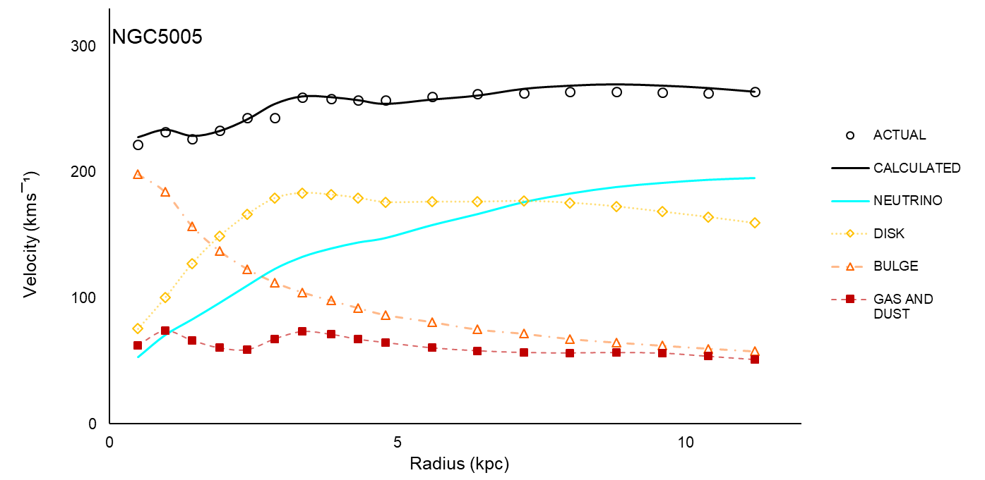

Figure 3. Composite rotation curve for spiral galaxy NGC5005

What is notable about the graph is that if neutrino generated gravity is removed from the calculation, the rotation curve drops as Keplerian Laws would predict, with neutrinos the outer curve is corrected and produces a good approximation to the observed values. The general shape of the curve produced illustrates that the mechanism does appear to work, plus it is based on measured velocity profiles, known nuclear physics, and only one simple new property for an existing particle. It is therefore proposed:

An explanation for the missing mass problem is neutrino generated gravitation

Altering the values entered into the spreadsheet alters the rotation curve. Increasing the percentage of CNO neutrinos in the galaxy has the effect of increasing the rotational velocity, a result while not immediately obvious is what might be expected. Since this happens because the energy level of the neutrinos increased, it seems we have discovered a property of them - that the gravitational effect they produce is related to their energy. In this particular case the relationship modelled is a linear one, while it has been chosen arbitrarily it comes without prior justification and certainly does not prove a linear relationship.

The technique for producing a rotation curve for NGC5005 is now applied unaltered to data from another galaxy NGC1560 [16-21], see appendix 2, figure 4. The same value for neutrino luminosity of 6% is used along with the same value for the mass to energy constant Y. This illustrates that the method of adding neutrino gravitation to baryonic mass works, and it does so without having to fine tune the variables.
The neutrino gravitation produces the same type of effect as a dark matter halo but it does so with a prior theory being in place that is based on real physics. Studies in later chapters will show this technique also works for quite different astrophysical objects.

17
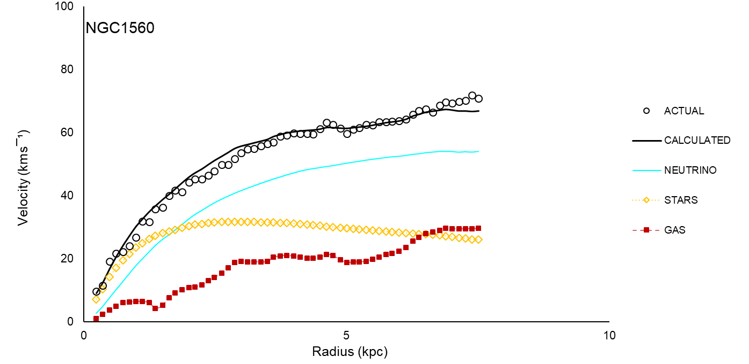

Figure 4. Composite rotation curve for spiral galaxy NGC1560

4.5 CROSS-SECTIONAL AREA AND ENERGY

What can we find to corroborate this result? One possibility is that the cross-section of the neutrino is related almost linearly [22] to its energy between approximately 1-10Mev, the range of energies under consideration here. Since the mechanism is based on the neutrino directly influencing spacetime, and if the effect is proportional to the cross-section area then:

The gravity produced is directly proportional to neutrino energy

With $M_{ν}$ as the virtual mass in kg, and $E_{ν}$ as the neutrino energy in joules and the constant of multiplication $Y=1.15×{10}^{-6}kg/j$

$M_{ν}=YE_{ν}$

where $M_{ν}=1.15×{10}^{-6}E_{ν}kg/j$ (5)

4.6 TULLY-FISHER, COLOUR VERSUS ROTATION VELOCITY

Another argument which could be used to assess whether the energy/gravity relationship is indeed linear comes from empirical formulae in the Tully-Fisher relationship. These allow the absolute magnitude ($A_{b}$ for blue and $A_{r}$ for red, the symbol $A$ being used in place of the more common $M$ to avoid confusion with the symbols used for mass in the preceding chapter) of a galaxy to be estimated from its rotational velocity and pass band centre frequency of the filter it was measured with. In this case blue is defined as 445 nanometres (nm) and red, 658 nm.
One curiosity of these relationships comes from this method of measurement. Long slit spectroscopy feeding through coloured filters selects various wavelengths from the telescopes, from far infra-red up to blue visible light and ultraviolet. Typically, comparing galaxies with the same bolometric luminosity but through different filters, it was found that curiously the bluer a galaxy, the faster it would on average rotate.

For blue filter the formula [23] is:

$$A_{b}=-7.48\left(logV_{b}-2.50\right)-19.55$$

where $V_{b}$ is the rotational velocity for blue in $kms^{-1}$

Please note, here we are using $A_{ }$for absolute magnitude normally denoted by M, also not to confused with $L$ for bolometric luminosity as before, the two are related by the function:

$A=3.018×{10}^{28}×{10}^{(-0.4L)} in watts$ (6)
Rearranging gives:
 | $$V_{b}={10}^{(-{0.1337A}_{b}-0.1136)}$$ | (7)
Similarly, for the red filter:
$$A_{r}=-8.23\left(logV_{r}-2.50\right)-20.46$$
Rearranging gives:
 | $$V_{r}={10}^{(-{0.1215A}_{r}+0.0140)}$$ | (8)

where $V_{r}$ is the rotational velocity for red in $kms^{-1}$

Using eqs. 5&6 values for rotational velocity can be calculated for a range of faint, (-17) to luminous, (-23) galaxies (Milky Way approx. -21). These values are shown in table 1 below, with the ratio of the blue to red velocities compared for each value of magnitude.

Mag | $$V_{b}$$ | $$V_{r}$$ | $$V_{b}/V_{r}$$
-17 | 144.2 | 120.1 | 1.201
-18 | 196.2 | 158.9 | 1.235
-19 | 267.0 | 210.2 | 1.270
-20 | 363.2 | 278.0 | 1.306
-21 | 494.1 | 367.8 | 1.343
-22 | 672.3 | 486.5 | 1.382
-23 | 914.6 | 643.6 | 1.421

Table 1. Tully-Fisher Galaxy Rotation Velocities in kms¯¹

Of interest is the actual values of these ratios. If the assumption that most galaxies are dominated by an invisible gravitational force and not their baryonic mass is indeed correct, then it should be possible to test a theory which predicts this force and whether it correctly predicts the above results.

19
If the nuclear calculations are accurate, then it would be seen that larger bluer stars are powered for the most part by the CNO cycle where an average of the four chains give a neutrino luminosity equal to about 10.3% of the bolometric luminosity. Smaller redder stars dominated by the PPI cycle have an equivalent value of around 1.7% or thereabouts. If the above postulation that the gravitational effect is directly proportional to the neutrino energy is correct, then an estimate can be made of the difference in rotational speeds. Taking eq. (4), it can be seen that for a given radius R, the orbital velocity is proportional to the square root of the enclosed mass. If the above 10.3% CNO equates to around six times as much equivalent mass as the 1.7% PPI result, then the square root of the difference is approximately:

$$\sqrt{\frac{10.3}{1.7}}≈2.5$$

Some older galaxies where star formation has mostly ceased can be composed largely of older redder stars. These have disproportionately longer lives than the massive blue stars which can burn through their nuclear fuel in as little as a few million years. The converse is not generally true, some galaxy’s luminosity can be dominated by a relatively small percentage of bluer stars [24], but it is unlikely that any galaxy is formed exclusively of blue stars. The above value of 2.5 is therefore an extreme value unlikely to be found in practice.

The values computed in table 1 however only go up to around 1.4 times the rotational velocity, which equates to around double the mass. This would seem like an entirely reasonable result as it can be seen that by changing $L_{v}/L_{b}$ values in the spreadsheet within reasonable bounds, changes in rotational velocity vary much in line with the empirical functions above. Also, calculating the black body radiation temperatures from Wien’s Law:

$$T=\frac{2897771}{λ}$$

where $λ$ is the centre wavelength in nanometres or nm, and temperature is measured in Kelvin’s, K gives the following values:

$$445nm≈6512K$$
$$658nm≈4404K$$

A temperature of 4404K corresponds closely to spectral class K stars with masses around 0.7 solar masses and therefore PP dominated. Similarly, 6512K, or 445nm corresponds closely to F class stars with masses around 1.5 solar masses and therefore CNO dominated.
In other words, the blue filter is more sensitive to galaxies with stellar populations having higher neutrino luminosities compared to those measured by the red filter with the same overall bolometric luminosity.
This in turn relates to the higher rotational velocities observed through the blue filters and is therefore proposed as a significant step towards showing the relationship between neutrinos, the gravity they produce and their energy.

20
4.7 CHAPTER CONCLUSION

As well as successfully predicting the rotational velocity of an actual galaxy based on an existing particle and stellar properties, the model also predicts the maximum possible ratios between them purely from the maths used to calculate the neutrino luminosities. The fact that this result was derived theoretically and explains an empirical law, leads to the proposal that

Neutrino gravitation provides the theoretical basis for the Tully-Fisher colour relationship

Returning to the treatment of the relationship between energy level and gravity produced, while not absolutely rigorous, it appears that three factors support it being a linear relationship.

1. The computed rotation curve matches observation.

2. Mass to luminosity ratios in galaxies vary, but not within extreme bounds. The Tully-Fisher and Faber-Jackson relationships between magnitude and rotational velocity are relatively linear, a mathematically non-linear relationship between energy and gravitation could produce a much wider spread in the data for a large sample of galaxies. Being that this is not the case it would seem likely that a highly non-linear relationship is probably not the correct interpretation.

3. Cross-section and energy relate linearly over the levels of energy under investigation, in this case in the ~Mev range.

It is therefore with a lack of any evidence to the contrary that the conclusion is that neutrino gravitation is in fact directly proportional to neutrino energy.

21

5 SUPERNOVA SN1987A

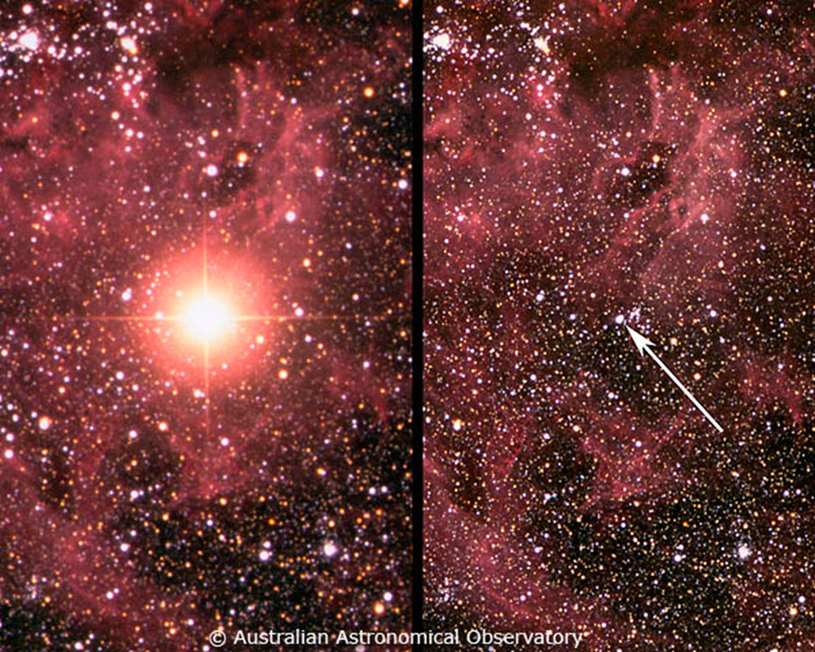

Figure 5. Progenitor star and resulting supernova following core collapse

When a blue giant star, later identified as Sanduleak 69-202 in the Large Magellanic Cloud reached the end of its element fusing live, it exploded as a type II supernova. On Earth, February 23rd 1987 at a distance of 51 Kpc a number of antineutrinos were detected rather surreptitiously several hours before the optical light curve arrived. Two of the four instruments that made these detections were not expressly designed with the sole purpose of recording neutrino events, their main goal was to study the life-span of the proton, but fortunately were online at the time of the signal. In combination, all four detected some 29 antineutrino events at around 7:35, just as importantly three out of the four instruments also made additional antineutrino detections over a period of a few hours preceding this.

Of great significance also were the gravitational waves that registered in 2 separate Weber Bar resonant detectors during this earlier period. For a conventional gravitational collapse to explain these detections would require a quite abnormal release of energy [25] given the sensitivities and distances involved, so it is quite easy to see why they were dismissed. With neutrinos as the source of gravitation these detections are quite easy to explain.

To date, no other supernova has been recorded in this way, making the set of data completely unique.

23
An important note: in order to interpret the data correctly, analysis must be done in a very specific sequence. Thus, outcomes from one set of data whether that be the behaviour of the neutrino, or how the astrophysical body operated, must be understood before attempting analysis of the next set. The sequence therefore is not chronological, but done in the logical way that is necessary to derive these outcomes.

5.1 SN1987A DATA OVERVIEW

Data from this event can be delineated into 3 types of data spanning 5 time-frames.

Timing and type of data (all am):

1. 01:47-03:43 individual gravity with associated antineutrino
2. 02:52 gravity and antineutrino burst
3. 07:35 antineutrino main burst, no gravity
4. 07:54 antineutrino burst
5. 10:00 approx. optical

For the purposes of this paper only 1-4 need be considered, the later light curves offer no insight into the process of core-collapse, only serving to confirming the event as a type II supernova.

The six detectors were as follows, with references provided for technical descriptions of the laboratories:

1. Weber Bar, Maryland, USA [26]
2. Geograv, Rome, Italy [27]
3. Baksan Scintillation Telescope, Baksan, USSR [28]
4. Liquid Scintillation Detector, Rome, Italy [29]
5. Irvine Michigan and Brookhaven, USA [30]
6. Kamiokande II, Kamioka, Japan [31]

To ensure continuity with papers referred to here, they will be designated respectively as Mary, Rome, Bak, Lsd, Imb and Kam, gravity wave detectors four letters, neutrino detectors three.

5.2 MAIN BURST AT 7:35AM COMPARED TO CORE COLLAPSE THEORIES

At this time, a total of 29 (electron after oscillation) antineutrinos [28][32][33][34] were detected over a period of the first 25 seconds. The second Lsd detection at 37s is omitted due to the large time gap, although it is quite possible that it originates from the same event. The 4 additional detections at Kam are included in this total, analysis by [34] shows that they are compatible with the rest of the data set.
Although the energy levels and internal timing in all four were known, the relative timing of two of the detectors was uncertain. Imb and Lsd were timed accurately into Universal Time (UT) but Bak and Kam (which didn’t strictly need to, given that its main purpose was to monitor for proton decays) were not. This was described by [28] as an ‘uncomfortable situation’ and the initial interpretation placed the first detections of Bak and Kam at the same time as the first detection at Imb. This seems rather arbitrary, indeed one study [28] found correlations between Lsd and Bak, and Lsd and Kam that could give a reasonable absolute timing error for both. Another study found correlations between the gravity waves and Kam [20].

Applying the corrections in timing from [35] produces the following graph in figure 6. The corresponding spreadsheet is contained within appendix 3.

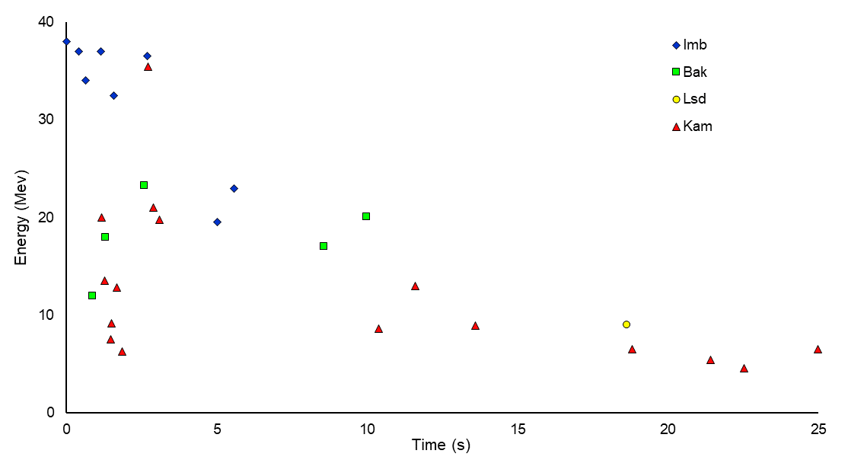
Figure 6. Antineutrino burst at 7:35am

The majority view at the time of writing is that the above data fits theories of core collapse well. Others [27][35][36] believe that the earlier data, i.e. pre 7:35 shouldn’t be discarded and that the process of collapse is more complex and extends over a longer period of time.
What is pertinent is how well these theories fit the data. Certainly, most of the physics is well established, and a lot of detailed work has produced models which agree to a large degree of consistency with each other. What will be examined in this section is how consistent the theories are with the data.

5.2.1 HOW WELL DO THEORIES OF NEUTRINO ENERGY MATCH DETECTIONS?

Taking core collapse theories from after the post shock bounce at 1 second to the generally proposed end of cooling at around 10 seconds [37][38[]39] produces an average antineutrino energy of approximately 11.8 Mev (all flavours). Graphs of energy versus time are used from these models so that the spreadsheet produced can calculate a trendline, this is then used to show visually how detection and prediction compare.
It is assumed that subject to oscillation only electron antineutrinos can be detected,

25
regardless of whether they were emitted as electron, muon or tau. The average values used from IMB (8 detections), KAM (9 detections) and BAK (5 detections) is 22.4 Mev, a discrepancy of over 90%, a value that cannot be reconciled with experimental errors of <20%. Even assuming that all four detectors were reading on the high side, and if say IMB had a lower threshold and had produced more detections the difference still cannot be accounted for.

The problem is illustrated below in figure 7. taken from appendix 3.

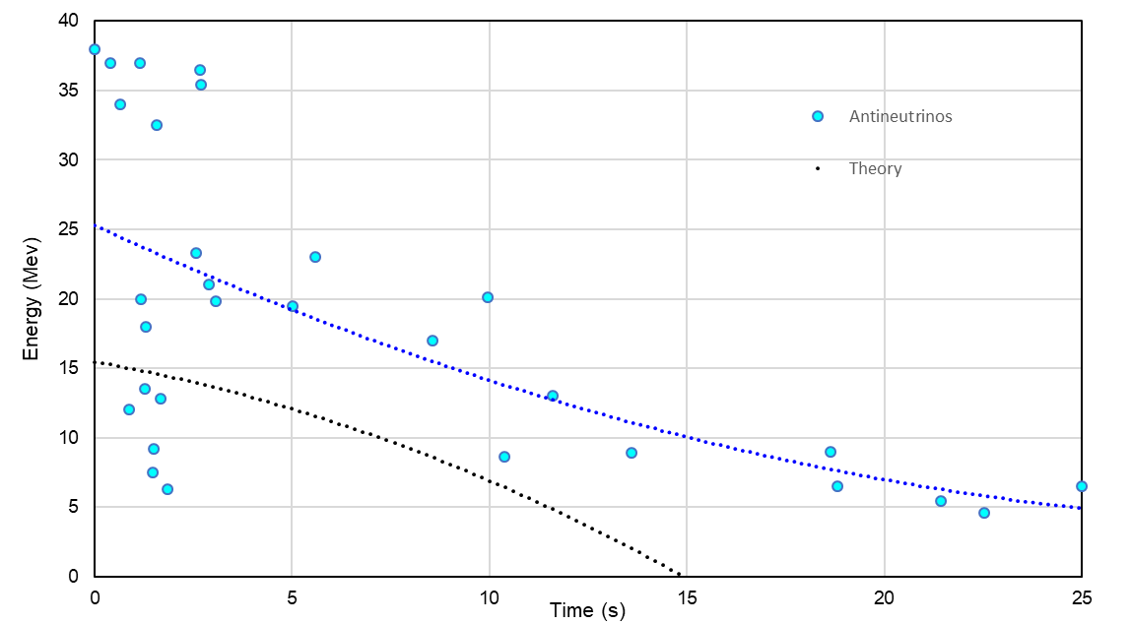

Figure 7. Antineutrino detections at 7:35am (blue circles) with trendline (blue dots) and theoretical
models averaged (black dots)

The detector involved in each antineutrino is deliberately not shown, we assume they are all producing competent data so the data points are not labelled as such and so the overall picture is made clearer. The blue trendline depicts the overall trend in the data and the black line shows three core-collapse theories modelled using a second-order polynomial function. Visually there is a clear mis-match between theory and data.

Another issue relating to the energy is the number of antineutrinos detected in the ~35Mev range. By measuring graphs produced in two theoretical models [33][34] an estimate of the relative abundance (as a fraction) of ~35Mev to average energy can be made. The values are counted once for electron antineutrino, and twice to account for muon and tau's being shown together as one curve. The 9 values of these ratios from graphs 5b,5c,6b,6c [40], and from fig2. normalised v spectra [41] are in order:

$$(25.5+2×1.44+12.0+2×1.48+6.85+2×2.06)/9≈6$$

With 22 detections in the first 10s an approximate number of $22/6≈3-4$ antineutrinos

26
in this range is the theoretical prediction that would be made from the above. This is at odds with the 7 actually detected, again a discrepancy of about 90%, not a particularly good match.
Paper [42] derives an even lower value, with a comparison between thresholds, temperature and mass for Kamiokande and IMB with the later only expected to detect around $1/7th$ the number of the former. Even stretching to all 16 Kamiokande detections would imply IMB should only have seen about 2 events given its high threshold of >20Mev.

5.2.2 HOW LONG WAS THERMAL COOLING PREDICTED TO LAST?

Most theories predict a cooling time of the order of a few seconds, perhaps ten or eleven at most [37][38][39], the average of these as simulated above drops to the threshold of LSD after around 12 seconds and to zero at around 15 seconds. Ignoring the second LSD detection (37sec), it would seem that the cooling lasted significantly longer than any theory predicts. No present theory predicts 18sec LSD (9.0 Mev) or 25sec KAM (6.5 Mev).
This suggests that the cooling mechanism, surface area, temperature or neutrino production rate have been incorrectly estimated for this particular event.

5.2.3 VARIATIONS IN NEUTRINO ENERGY FROM OPACITY VS DETECTION

Neutrino trapping caused by high material density is thought to average out the initial temperature and therefore the energy of the emissions [34][37], producing a more monochromatic energy level.
It is hard to see this mechanism operating here, the first 2 seconds alone have an energy spectrum extending from 6.3 to 38 Mev, a ratio of about 6:1. Conventional theory is therefore clearly insufficient in its description of neutrino opacity with respect to the data presented here.

5.2.4 HOW WELL DO THEORIES PREDICT TOTAL ENERGY RELEASED?

During cool down, the gravitational binding energy of the collapse to a neutron star is radiated by some ${10}^{58}$ neutrinos of all flavours. With a final radius of approximately 10-11km the total energy released is predicted to be $≈3-4.2×{10}^{53}$ ergs [34][37][39]. The theoretical value arrived at depends on the equation for energy released by gravitational collapse as well as the assumed final radius. Taking an average of the above:

$E≈3.6×{10}^{46}$ J

Various estimates [28][34][42][43][44] have been made of the energy detected in the form of electron antineutrinos during the 7:35 burst based on the physical properties of the detectors and antineutrinos.
Taking average values from the tables in [28][44] main text in [34][43] gives values of $10.43, 10.37, 5.0 and 8.0×{10}^{52}$ ergs respectively. Luminosity [42] is calculated as a total of $2×3×{10}^{53}$ ergs for all species in the full Kamiokande total mass, equating to $10×{10}^{52}$ ergs per species. Assuming these values represent 1/6th of the total energy, taking an average, multiplying by six and converting to Joules produces a net measured energy release detected of:

27
$E_{d}≈5.26×{10}^{46}$ J

In other words, detections produce a value 46% greater than theory, a difference difficult to explain from the assumptions and margins of error.

5.2.5 WERE THE DETECTIONS AS ISOTROPIC AS THEORIES PRESUME?

All theories explicitly assume isotropic emissions at a distance of around 51kpc in their calculations of antineutrino and neutrino flux.
Looking at figure 6. however, the arrival time at each of the four detectors seems to be in 'packets'. Studies [32][45][46] have examined this effect to try to establish if there are any temporal or statistical patterns in the data. Whether there are any underlying patterns or not, the emission of some ${10}^{58}$ neutrinos of all species at 51kpc would result in an electron antineutrino flux, taking oscillation into account, of approximately ${10}^{14}-{10}^{15}$ passing through each (small to large) detector. This should produce a statistically random distribution with the production rate dropping from 0s as the neutron star cools. This is not what is seen, the data includes statistically unexplained time gaps along with anomalies in the numbers of events expected when the properties of the detectors are compared.

If the detections suggest an anisotropic flux, what mechanism could explain it?

Fluctuations in the surface temperature could produce a certain amount of anisotropy, but even if the radiation was always perpendicular to the surface it would seem hard to understand how it could produce variations on the scale of ~1000km as far away as Earth.
Another difficulty is the extreme gravity around the object which allows one viewpoint to see the whole surface. As no one viewpoint is unique, this would reduce anisotropy.
There is however one effect known as streaming [47], universal to the propagation of waves through media and recently observed in light waves travelling through bubble membranes. Small variations in density or thickness cause the waves to form remarkably robust 'streams', these therefore give rise to variations in flux intensity perpendicular to the direction of travel.
If neutrinos are particles that obey the De Broglie wave/particle duality then it could at least be plausible that this effect directed them to the four detectors with a less than random distribution.

5.2.6 SECTION SUMMARY

A single discrepancy between a theory and the observations it describes is worthy of investigation, either leading to modifications to the theory or perhaps new observations resolve the difference and allow the theory to stand. Here however there are many such differences and while the general picture is similar, the details don't quite add up.
This is not to claim that the theories are wrong however or that they should be discarded due to the above, in fact their use is essential later in this chapter. What it does show is that there is still an outstanding question of the interpretation of data from 7:35am. This in turn justifies examining other data collected without having to concede to any pre-determined outcomes derived from the 7:35 event.

28
5.3 WHEN DID THE CORE COLLAPSE?

If there is significant doubt that the core collapsed at 7:35am, then when could it have collapsed?

Data collected on 23rd February 1987 shows more than a dozen gravitational waves detected between 1:47am and 3:25am [27], and dozens of individual antineutrino detections between 1:47am and 7:55am [28]. Although many of these were correlated, the only closely grouped 'burst' was detected under Mont Blanc at 2:52:36am when five relatively low energy antineutrinos arrived over a period of 7 seconds. The detections, often referred to as the 'Lsd Burst', have been variously dismissed as statistical fluctuations, false readings or even contrived, but are these views justified?

5.3.1 OTHER DATA TO CORROBORATE THE LSD BURST

If other laboratories collected data during this period, then this would help to validate the burst regardless of the nature of the other data.

Considering first the antineutrinos we apply the time corrections derived previously. Applying the appropriate time correction to the third Baksan event [44] figure 8a ( $≈20.3$ Mev) shifts it to between the 3rd and 4th Lsd events.

Three additional antineutrinos were detected in Kamioka [42] seemingly just before the Lsd time. Applying the time correction derived above shifts the third 7.5Mev Kamiokande antineutrino shown in 8b to a time position between the first and second Lsd event.
The 12Mev event is still outside the time window even if we regard the gravitational detections as part of the overall event, and therefore won't be considered here. The 4.9Mev detection just aligns with the start of the gravitational waves but also won't be considered as it lies below the noise threshold of Kamiokande. Events Kam13-Kam16, all below threshold, were used previously for the purpose of illustrating the tail of the curve around the first LSD event at 7:35am, they were not however used in any of the calculations.

Imb, despite its greater mass had a higher detection threshold of around 20Mev which probably explains why it made no detections at this time.

All seven events are collated in 8c.

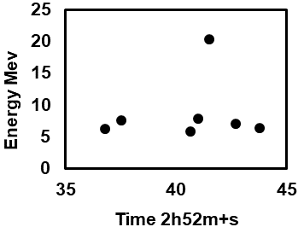
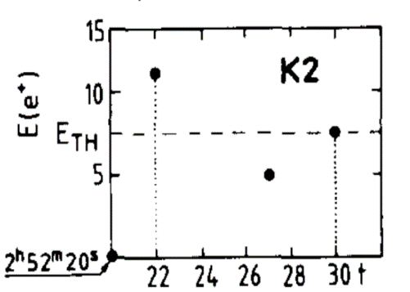
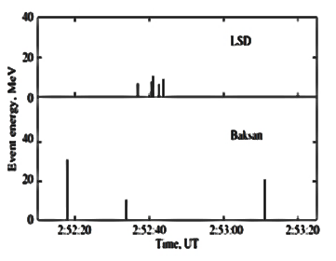

Figures 8a. Lsd+Bak 8b. Kam 8c. All

29
Paper [27] clearly shows significant gravitational data both before and during the LSD detection in both Rome and Maryland, detected as energy innovations in so called 'Weber Bars' after their inventor, Joseph Weber. These bars are separated from Mont Blanc by hundreds and thousands of kilometres respectively, ruling out any possibility of localised or statistical effects causing coincidental readings.
Usually, the gravitational detections preceded the antineutrinos by a few seconds so the event lasted in the order of some ten seconds in total. Just in themselves, these three simultaneous detections are highly significant - how could two completely different types of data, conventionally considered to be independent of each other be coincident for such a unique event?

The two Weber bar gravitational wave detectors had different sensitivities due to the different masses used, 1200kg in Maryland and 2300kg in Geograv. This gave them different resonant frequencies of 1660Hz and 814Hz respectively, also, they had different orientations for their cylindrical bars, E-W for Maryland and S-N for Geograv.
Although both gravitational traces look broadly similar there are noticeable differences, explained by the technical differences outlined above.

What is crucial to reading these graphs is that they are not recordings of gravity wave amplitude in real time, rather they are the effects of a passing transient on a resonant aluminium bar.

As such the bars ‘ring’ in a similar way to a bell being struck (fundamental plus harmonics), the energy imparted to the bar being gradually dissipated over tens of seconds by the material’s hysteresis with the vibrations measured by piezoelectric sensors attached to the bars surface. These signals sit on top of thermal noise minimised by the application of careful engineering.

Given the absolute sensitivities of these two instruments, neither baryonic matter collapsing or accelerating rapidly, nor vast amounts of diffuse missing mass can explain these detections. All the data for the five detectors is shown below in figure 9. with the energy scale in Kelvins for the gravitational waves. No particular annotation is given to the antineutrino energies, the relative timing being of greater interest. Data comes from the spreadsheet in appendix 4.

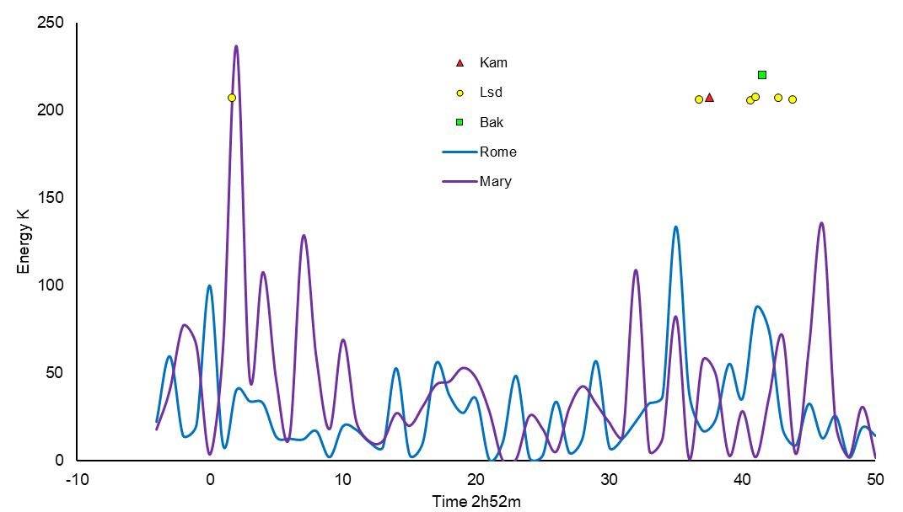

Figure 9. Gravitational and Neutrino data taken at the Lsd time

In short, no less than five different laboratories made detections completely independently of each other during this 10 second window. None of them were immediately aware of their detections, it was only when the supernova was detected optically many hours later that they would have received communications to check their recordings.

5.3.2 STATISTICAL ANALYSIS AROUND THE LSD TIME

The data detected so far has been discussed in relation to the physical interpretation of how a blue giant underwent core-collapse to produce, it is believed, a neutron star.

An alternative approach is to employ mathematical methods where the physical meaning of the data is omitted and sets of data from different detectors are compared to find correlations. These involve comparison between sets of neutrino data, and between neutrino and gravitational wave data, however as the last gravitational event was around 3:24am only neutrino data can be compared at the 7:35am time.

Many such studies [27][35][36][48] find strong correlations around the Lsd time of 2:52am, an example of which from [48] is re-printed below in figure 10 to illustrate. While these results in themselves do not necessarily preclude 7:35am being the time of collapse, they do suggest significant activity at the Lsd time.

31
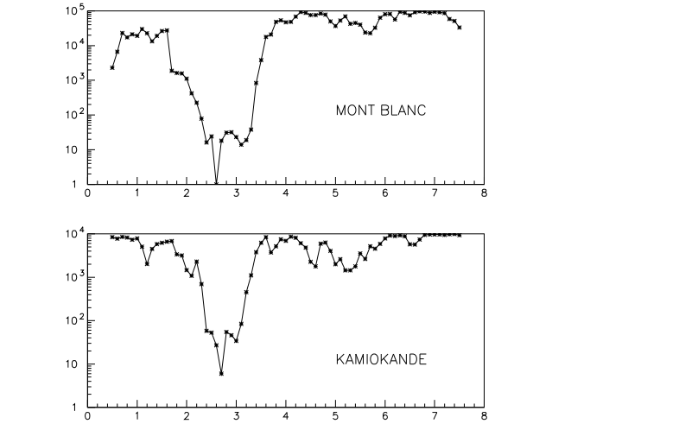

Figure 10. Correlations between the gravity wave detectors and the LSD and Kamiokande neutrino detectors from 0.5 to 7.5 UT hours during one-hour running time periods. 7.8 seconds have been added to the recorded Kamiokande time.

A simpler way perhaps to illustrate these coincidences is to plot them as data points on a graph with the energies omitted to produce a clear picture of the timing alone. Data from [27][29][32][35][42][44][49] have been collated for each detector separately to produce an individual timeline, figure 11. see appendix 5. Two gravitational waves are omitted from the Maryland data as they are below the noise threshold but were considered a combined data point when added to the Rome detections at that time.
Every data point on this graph, either gravity wave or antineutrino detection correlates with at least one other simultaneous detection, often more. It can be seen that the window of maximum activity 2-3.5 hours correlates closely with the statistical analysis above

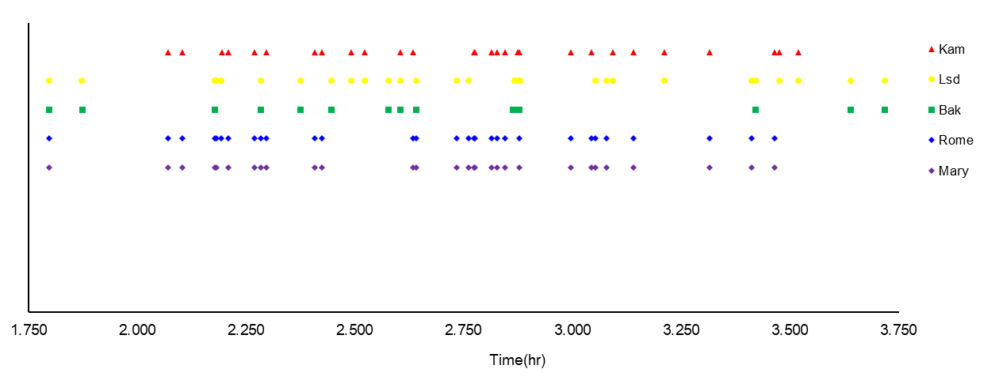
Figure 11. Timing correlations of antineutrino and gravitational data

32
Even if one acknowledges other uncorrelated detections from these sites and the lack of conventional theoretical explanation, to find such a strong pattern in the data is very hard to dismiss. The probability of this number of coincidences being due to random chance must be very small indeed.
Another telling detail is the small range of time delays between gravitational waves being detected before the arrival of the antineutrino(s). The range only spans roughly three quarters to one and a half seconds, a ratio of about 2:1. In itself, this suggests that the same kind of event is occurring multiple times.

5.3.3 POSSIBLE CAUSES OF THE ANTINEUTRINO DETECTIONS

There are three processes that emit antineutrinos. Nuclear fission (electron), beta minus decay (electron) and thermal emission from electrically neutral particles (all species).
The detectors running in 1987 were only really partial to electron antineutrino measurements. Sensitivity to electron neutrinos was around two orders of magnitude lower, and muon antineutrinos around seven hundred times lower. Tau species were essentially undetectable.
Oscillation however meant that about one third of any antineutrino species could be detected if it was captured in the electron phase.

A core composed of ${}_{26}^{56}{Fe}$ ${}_{27}^{56}{Co}$ and ${}_{28}^{56}{Ni}$ is effectively radioactively stable, only Cobalt 56 can decay but with a half-life of 77 days which is of no consequence here. However, some form of fission must occur first if radioactive decay is to occur. Prompt fission releases around 190Mev per reaction in the form of gamma rays and mainly kinetic energy of the products once the strong nuclear force is overcome and electrostatic repulsion pushes the fragments apart. It does not however produce antineutrinos, that only occurs when the products produced undergo decay.
Simply put, for any antineutrinos to have been detected on Earth by this process, fission must have preceded radioactive decay in the core. If this was the case then a large amount of heat must have been imparted to the core to initiate fission by neutron bombardment or photodissociation. The products could then decay releasing antineutrinos.

This leads to the first serious difficulty in explaining the 2:52 detections. For the three isotopes to have been split would require the application of a large amount of energy in the form of heat, as iron is the most stable of the elements and takes in heat during fusion the only available source therefore is gravitational collapse. This in itself almost immediately sinks objections to the 2:52 data as it implies the core has already collapsed. Worse however, is yet to come.
If we take an average kinetic plus gamma and decay output of around 190Mev per isotope, ignoring the amount removed by antineutrinos, the energetic release of a $1.4Mo$ core splitting would be:

$$≈9×{10}^{44}J$$

almost an order of magnitude greater than the energy needed to completely disrupt the star. This would surely have been observed by astronomers as phenomenal electromagnetic and kinetic output and it would seem unlikely there would be any compact remnant left!

Reverse-engineering a final radioactive decay to produce the antineutrinos detected both in time and number shows that this explanation is quite ridiculous.
Only certain isotopes with a half-life equal to a few seconds can explain the detections. Anything much longer or shorter would produce a very low-level extended emission or a much shorter, stronger emission, neither of which would fit the observations. Only a handful of radioactive isotopes decay within a few seconds and not all of those have energy levels that are close, within experimental error to the antineutrino detection energies. These are:
$${}_{8}^{22}{O half life 2.25s, energy 6.49Mev}$$
$${}_{8}^{21}O half life 3.42s, energy 8.11Mev$$
$${}_{9}^{20}F half life 4.16s, energy 5.68Mev$$

These three could explain the energy of the Kamiokande and Mont Blanc detections but there is no isotope that could account for the 20Mev detection at Baksan.

The final failure relates to the number of antineutrino detections made. Conventional theory predicts the emission of around ${10}^{58}$ neutrinos of all flavours, say $5×{10}^{57}$ antineutrinos in total. Dividing half the core's mass of ~1.4Mo by neutron mass yields an emission of some ${8.75×10}^{56}$ antineutrinos, of which only around one-third would be detectable. To sum up, if every neutron in the core decayed releasing an antineutrino, the total output would still be six times less than predicted - and the end product would be a proton star!
Clearly the only realistic option from the three sources of antineutrinos is thermal emission, otherwise the detections could not have been made. This in turn implies that the core must have collapsed at 2:52:36.

5.3.4 DID THE CORE REALLY COLLAPSE AT 2:52?

Absolutely fundamental to the analysis and all the outcomes that will follow is the question of when the core collapsed. This is why a large amount of time has been devoted here to analysing the data available, given that it is the only direct measurement of a real core collapse supernova. So what choices does this leave? We could stick with 7:35am and ignore all the discrepancies, of which there are many. As it stands however, theory and data do not seem to agree, so 7:35am probably wasn't the time of collapse.
We could dismiss the 2:52 data on whatever grounds we think deem appropriate, something which is indeed a popular choice thus providing effectively as it were an inverted justification for the 7:35 time. The probability of five independent laboratories making detections in the same 10 second window, as well as all the other statistical and energetic coincidences (figure 12. below) also pointing to the Lsd time make its dismissal problematic.
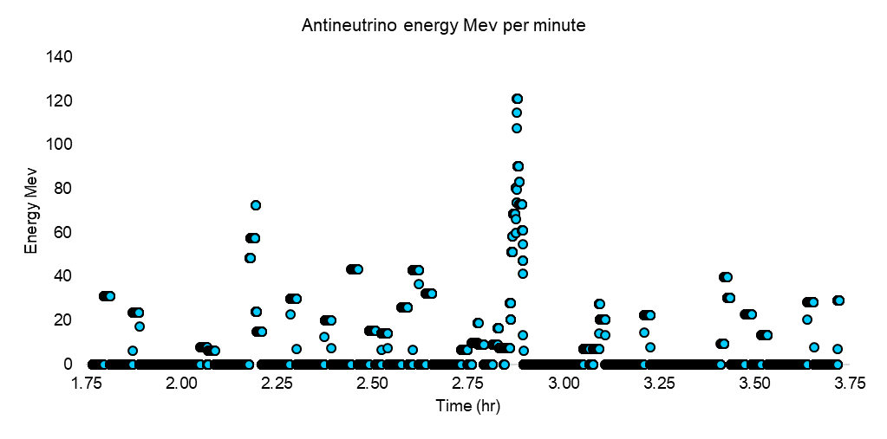

Figure 12. Antineutrino energetics around the LSD time in Mev per minute

What does however differentiate between the two times, and what the event actually was is what real physical process could have produced the antineutrinos. Fission followed by decay produces quite absurd answers, so since only thermal emissions can explain the data, and the event happened first, we are forced to accept that

The only plausible explanation for the 2:52 detections is that they were caused by the collapse of the core

5.4 ANALYSIS OF THE CORE COLLAPSE AT 2:52AM

It was stated earlier that the overall analysis must proceed with each event being analysed in a precise order. Starting with the core collapse first is therefore done not because it's the core collapse, but because it derives two new properties of the neutrino (or more specifically the antineutrino) that would not be possible to work out anywhere else.
It may appear surprising given the supernova study so far that we will draw on conventional core collapse theories. This is in fact no contradiction, we have in no way set out to disprove these theories, only to illuminate the differences between their predictions and the data that was collected at 7:35am. These theories actually contain an essential reference point without which one of the two new properties of the antineutrino could not easily be deduced.

5.4.1 COMPARISON OF THEORY AGAINST ANTINEUTRINO ENERGY AT THE LSD TIME

The Lsd burst, containing we believe seven reliable detections, lasted for 7 seconds. Standard core collapse theory predicts electron capture, releasing a 10-20ms burst of electron neutrinos followed by post-shock accretion and then at around 1 second after the start of collapse, thermal cooling. The predicted energy of this thermal cooling will be studied from the start of cooling out to 8 seconds, i.e. a period of 7 seconds hopefully corresponding closely to the Lsd burst.

35
Values from five separate theories [37][38][39][40][41] will be used to produce an average predicted energy for these antineutrinos in Mev which will then be compared to the average of the seven detections. The predictions in this order are: 12.9Mev, 11.8Mev, 12.2Mev (spreadsheet 3) and using the electron antineutrinos once plus the muon and tau species twice (as they've been lumped together in the graphs):

$$(13.6+2×23.6+14.7+2×22.4)/6=20.1Mev$$
plus:
$$(13.4+2×19.0)/3=17.1Mev$$

giving an average over the five figures of:

14.82Mev

For the 7 detections we have from [32][42][44] respectively 6.2, 5.8, 7.8, 7.0, 6.0, 7.5 and 20.3Mev giving an average of:

8.66Mev

It appears that on their 51kpc journey to Earth the antineutrinos have lost around 40% of their initial energy. Where could it have gone? We saw at the end of chapter 4 that cross-sectional area might be linear with energy [22], could it be that as the neutrino barges through (possibly quantised) spacetime it gradually has its energy absorbed in the process?
Gravitational redshift cannot be responsible for the entire loss, putting typical values of M=1.4Mʘ and r= 11km into the standard formula of:

 | $$1+z=\frac{1}{√1-\frac{2GM}{rc^{2}}}$$ | (9)

gives a ratio of 1.265, much less than the ratio of the emitted and detected energies above.

This raises two important questions:

1. What is the transfer function, and
2. How does it relate to energy & mass in the metric tensor in Relativity?

Dealing with 2 first, a simple check is to plug the value of the coupling constant derived from the galactic rotation model into the mass/energy relationship. If we assume we have neutrino(s) with an energy of 1 Joule and a constant of $1.15×{10}^{-6}Kg/J$ the energy equivalent of this mass is:

$$1.15×{10}^{-6}×c^{2}=1.035×{10}^{11}J$$

In other words, it's certainly not the energy of the neutrino that's causing the overall effect, more likely something similar to the cross section interacting directly with spacetime.

At first glance this amplifying effect might seem like a blatant violation of the conservation of energy, but four points can be made in a global sense that show that this is not necessarily a problem.
First, the actual gravitational to spacetime mechanism is presently unknown for all particles, including the neutrino. Second, the vacuum energy is [5] of the order of ${10}^{92}Jm^{-3}$, an enormous value that is thought to permeate all space, so anything that transferred even a tiny fraction of this energy to spacetime would not necessarily violate conservation. Third, the physical scale of neutrinos is the smallest of any known particle and could be, within a few orders of magnitude similar to the scale of the quantum level and could therefore interact directly with it. Forth, neutrinos only constitute a very small fraction of the conventional total mass/energy in the universe.

Next consideration is how this energy drops with distance (or time). Unfortunately, with only two data points to analyse mathematics alone can't provide an answer. It is necessary to examine how different functions would behave under the same astrophysical settings and determine which ansatz fits best.
As there are no single discrete and continuous sources of antineutrinos in the cosmos to analyse, we will suppose that neutrinos also have this property and now consider what type of function would describe an energy loss function for the neutrino best.
While only two functions will be tested, linear and exponential, there are of course limitless options but in the interests of economy, only the two most 'obvious' will be considered.

A linear function would be described by:

$$(14.82-8.66)/51=0.12Mev/kpc$$

For a P-P chain star the limit before the neutrino had no energy and therefore no gravitational effect would be approximately:

$$.63Mev/0.12≈5kpc$$

For a CNO chain star the distance would be around four times further, $≈20$kpc.

While this might seem to be an appealing, simple description, it probably isn't correct. In chapter 4 we found that to satisfy the Tully-Fisher and Faber-Jackson relationships gravity created by the neutrino needed to be proportional to energy. If the virtual mass of the neutrino is proportional to energy and it drops linearly with distance then the total mass would be proportional to the square of the energy after emission. Another problem this would create is that the small distances calculated above wouldn't produce gravitation and hence flat rotation curves in anything but the smallest galaxies. This is due to the low energies of the neutrinos involved and is illustrated below, figure 13, calculations found in appendix 6.

37
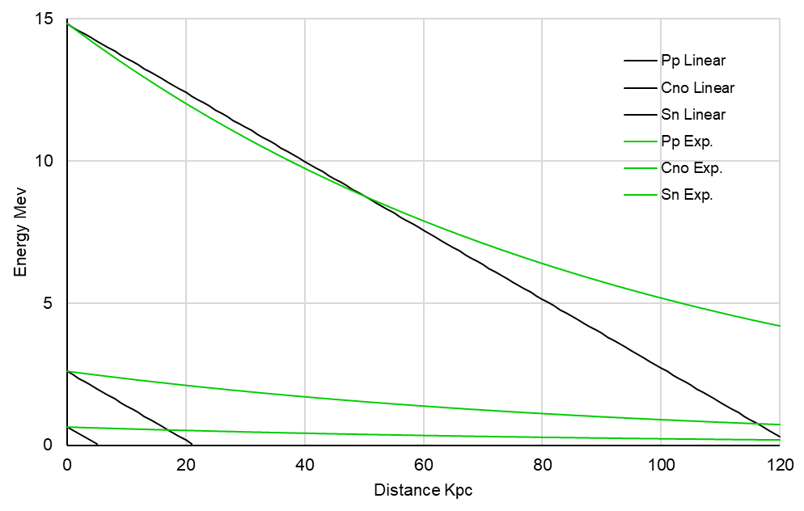
Figure 13: Antineutrino energy loss functions

This would also be in contradiction with study [4] which predicts mass distributions around galaxies from gravitational lensing to extend to a few 100kpc outside the pseudo viral radius of the visible matter. This is clearly well outside the range given above of 5-20kpc and so a linear function does not fit observation for neutrinos.
This leads us to consider a simple exponential function. It preserves the relationship of mass proportional to energy/cross-section and allows the effect to operate over reasonably long distances. Given that there are only two data values to analyse there would seem to be little point trying to over-analyse the problem, therefore in the interests of efficiency we will use the exponential function on the basis that it calculates in a way that seems to be consistent with astronomical observations. This leads to the first proposed property of the antineutrino:-

As antineutrinos traverse space, they lose energy at a rate exponential with distance

The function derived from the above gives a ratio of energy at distance d in kpc, $E_{d}$, and energy on emission at source, $E_{s}$ of:

$E_{d}=E_{s}e^{-0.0105d}$ (10)

This proposal is however rather difficult to test directly, to detect a 40% loss as above would require a 166000 year wait. If a gravitational 'standard candle' could be reliably modelled, like a core collapse, then neutrino detections could be compared with laser inferometer readings and optical detections, the neutrinos would of course not be greatly affected by intervening matter, unlike electromagnetic emissions.

5.4.2 GRAVITATIONAL EFFECTS DURING THERMAL COOLING

If around ${10}^{46}J$ of neutrinos are released during thermal cool down over approximately 10 seconds, within a sphere of around 10km radius the mass would be:

$$\frac{{10}^{46}×1.15×{10}^{-6}}{10}×\frac{10000}{c}≈3.8×{10}^{34}kg$$

In other words, a neutrino mass of around 19 thousand solar masses! Clearly the only possible outcome would be the formation of a black hole, but the data from 7:35 suggests otherwise. It would seem that we should immediately suspect the constant of multiplication to be wrong, especially in light of the mass energy relationship derived above. However, we should remember that this constant produced 2 remarkably accurate galactic rotation curves and so the error margins should be only of the same order as the luminosity and stellar mass and distribution errors from astronomical observations.

Alternatively, it could be that the ultra-high densities reached preclude the neutrinos from behaving as if they have mass, and so no other gravitational effect other than the expected baryonic mass acts on the collapsed core. Once they escape the proto neutron star surface they would have little effect even though no longer bound by the high density since they would now be outside the core's virial radius. Large amounts of material lying outside the radius of the pre-collapse core would however be pulled inwards rapidly by this gravitational burst. Only around 0.7 solar masses would have to be accreted onto the core for neutron degeneracy pressure to be exceeded and again a black hole would almost certainly have formed. It is therefore unlikely this explanation of high density is correct as antineutrinos did escape and were detected.
Additionally, there is still no robust explosion mechanism to account for the disruption of the outer layers which of course get thrown outwards, not inwards. Disruption to produce the supernova is a classic problem for conventional core-collapse theories: shock bounce doesn't seem to work except under very specific conditions and neutrino driven winds require the absorption of exactly the right amount of energy in relatively low-density regions outside the core.
There is however a simple solution to the problem. The idea is perhaps counter-intuitive, (although how many aspects of physics are truly intuitive?) and manages to circumvent all the difficulties of collapse/disruption discussed above.
If the neutrino as previously investigated produces 'gravity' and increases the apparent mass of galaxies by increasing the curvature of spacetime, why shouldn't we suppose that the antineutrino produces the opposite effect, in other words a reduction in the curvature of spacetime? Could it be that the left-handed chirality of the neutrino increases curvature analogous to a key winding up a clock, the right-handed chirality of the antineutrino 'unwinds' the spring?

39
This gives an important proposal for neutrino physics and gives the second property of the antineutrino:-

The antineutrino reduces the curvature of spacetime analogous to antigravity

Almost equal numbers and energies of the neutrino and antineutrinos species emitted during thermal cooling would then produce almost equal amounts of gravity and antigravity, cancelling each other out. The large gravitational imbalance would be cancelled at source in the core, and as it passed the outer layers of the star. The value of the constant and its effect would then become secondary.
A further benefit which will only be touched on at this stage comes from the supposed slight excess of antineutrino to neutrino energy during cooling. A significant amount of this difference, according to conventional theory, is due to the trapping of the electron neutrinos and their emission from close proximity to the (cooler) surface of the proto neutron star.
Assuming this proposed mechanism is approximately correct, it leads to an intriguing possibility: a small but significant net outward gravitational force over and above the conventional inward baryonic pull. Even if the inner shell layers were already starting to fall inwards, it is quite conceivable that a small outwards excess force over ten seconds could reverse the in-fall and accelerate the material to high outwards velocities explaining the disruption mechanism.

As will be seen in the next 3 sections, a small outward force, even if it only slight, overcomes the inward gravity and provides a mechanism which offers exciting new possibilities for the supernova mechanism.

5.5 HEAVY ELEMENT PRODUCTION VIA THE R-PROCESS

Two main sites are thought to account for most of the heavy elements in the universe presently: binary neutron star mergers and core-collapse type II supernova. Which is the most prevalent is currently an open question [50], indications are that neutron star collisions are probably quite rare, however for core collapse to be the most likely candidate the location and ejection mechanism must be reliably explained. Given that there is now a proposed antineutrino virtual antimass mechanism possible, it would seem an opportune time to evaluate whether it could actually explain the ejection mechanism.

The r-process involves temperatures > 10 billion Kelvin as well as extremely high neutron fluxes ${≈10}^{23}$ neutrons per cubic centimetre. Both of these conditions are easily met by conventional core-collapse theories, what they can't explain is how the material is ejected into space. If the material is formed in or close to the core it would seem difficult to understand how it could possibly escape. The neutron flux would [50] be extreme but so would the gravitational field. If it was formed further out, the flux would still have to be high enough to drive the process but attempts to model the post-bounce shock seem to indicate that it invariably stalls, failing to eject the r-process material.
The current situation is therefore that from figure 9. (page 31) we can see a large gravitational innovation at 2:52:01 along with an antineutrino detection by Lsd followed by Baksan. The r-process is predicted to last between 1-100 seconds [50], so let's suppose it occurred between 2:52:01 and 2:52:36 i.e. the 35 seconds before core-collapse. While interpretation of the gravitational information will be returned to later, what is of interest is how the process of photo-disintegration, neutron capture and beta minus decay could proceed during this 35 second period.
The overall proposal, which occurs before total collapse, is a modification to conventional core-collapse theories, the difference being that there is now an antineutrino mechanism from inverse beta decay that can at least temporarily resist gravity and slow the collapse. With the removal of thermal pressure and the Chandrasekar limit to electron degeneracy pressure exceeded, collapse is conventionally inevitable and brief. However, add an outward antineutrino gravitational force created during a contraction period, and the inward pull of gravity might not overcome the core so quickly.

What is of significance to this proposal is how the temperature affects the reaction rate and antineutrino luminosity. If there is too long a delay between contraction and antineutrino/antigravity production then the core would simply collapse. Theories [51][52] predict typical decay times of ~100ms, just quick enough to counter collapse.
If the reaction is sensitive to temperature, regions of higher density and therefore temperature would produce antineutrinos at an increased rate countering the inwards pull with a greater outwards push. Within a certain radius, baryonic gravity and the outward push of the antineutrino's antigravity could balance each other to temporarily slow the collapse. As the antineutrino travels at a constant speed, the outwards antigravitational force, assuming a steady emission rate would increase linearly with radius. At some given radius this would be equal to the inwards pull of baryonic gravity, i.e. we would in effect be describing a boundary, possibly near the outer radius of the core.

If the rate of change of outgoing force were to exceed the rate of change in baryonic gravitation outside this boundary (inverse vs inverse squared), then material would be slowly but forcibly ejected by an increasing outwards push. As the contraction progressed, this boundary would shrink inwards as more gravitational energy was released and so r-process material would continue to be produced some finding itself outside this boundary and being pushed outwards.
Eventually the rate of contraction would lead to an ever-increasing rate of gravitational energy release, temperature would increase and photodissociation would prevent heavy nuclei from remaining intact, ending the r-process. At this point, the production of antineutrinos would cease removing support against gravity and lead to a final core implosion at 2:52:36.

For this process to start would require the input of significant amounts of energy, which at this stage comes from gravitational energy released by the core contracting. The iron core starts at around 3 billion K and around 3500km radius and so accordingly would have to contract to a smaller radius and reach around 10 billion K to initiate the r-process. The analysis therefore comes in two stages.
First, the energy required to drive the process must be estimated to derive a value for the average contracting core radius during the 35s.

41
Secondly, once the neutron-bombarded seed nuclei reach the drip line they beta minus decay releasing antineutrinos, the energy of which is used to calculate a function to describe the outwards force, or 'antimass' with radius. If we set this to be equal but opposite to the baryonic mass the function will produce a second radius value, hopefully similar to the first, in other words the core would reach a quasi-equilibrium state while producing and ejecting r-process material before collapsing.

For the first radius we take three-quarters [53] of the 1.4Mʘ iron core to dissociate requiring 124.4mev and 27.1mev for the iron nuclei and each of the 13 alpha particles produced respectively.

let core mass dissociated $M_{c}=1.4×1.989×{10}^{30}×$ $\frac{3}{4}$ $=2.09×{10}^{30}kg$

then divide by proton mass $M_{p} 1.67×{10}^{-27}kg=1.25×{10}^{57} nucleons$

divide by the atomic mass of iron $56=2.23×{10}^{55} iron nuclei$

energy absorbed per nuclei: $124.4+13×27.1=476.7mev$

total energy in electronvolts: $476.7×{10}^{6}×2.23×{10}^{55}=1.063×{10}^{64}ev$

converting to joules: $×1.6×{10}^{-19}=1.7×{10}^{45}J$

This is the total amount of energy required from gravitational contraction to satisfy the above conditions, in other words the difference in gravitational potential between the initial radius of 3500km and the radius where the r-process occurs.

Applying this formula [39] to calculate radius from the above difference in energy:

 | $$E_{n}=0.6\frac{GM^{2}}{R}{(1-\frac{1}{2}\frac{GM}{Rc^{2}})}^{-1}$$ | (11)
which yields a dynamic, r-process radius of 175km, the formula takes into consideration relativistic effects.

An initial requirement for the second calculation is values of ejected mass for each of the elements produced. Approximate values from the lighter and heavier ends of the scale are entered into a graph and a trendline produced which yields an equation relating atomic number to mass produced. For the purposes of this investigation we are not interested in the relative amounts produced, a complex and important subject in its own right, only the overall trend and total amounts produced. This then leads to an approximate value of the antineutrino luminosity produced by the inverse beta decays, and hence the amount of antigravity emitted. This calculation is given in appendix 7 with values at the lighter (and therefore more model-critical) end being averaged from more than one source [54]-[57]. If this value of radius is somewhere near the radius when the r-process starts, and greater than the radius of the final neutron star then it would suggest the mechanism might be plausible.

42
It turns out that the radius of approximately 176km is surprisingly close to the value calculated for r-process contraction and still leaves most of the latent gravitational potential necessary to produce the neutron star.

Restraint should be exercised when digesting this section however:

1. The model used is relatively crude
2. Data values used are in themselves rather speculative
3. An exponential trend was chosen without any a-priori justification
4. Lack of concrete proof that type II supernova actually eject r-process material

The production of two values so close given all the uncertainty is undoubtedly coincidental. A more satisfactory result would in fact be for the second radius to be smaller than the first, this being possible for two entirely separate reasons.
One is that a greater potential for antigravity would allow for some margin of error, greater antineutrino luminosity would balance the baryonic mass at a smaller radius and therefore provide greater stability against collapse. This is especially true if the contraction started at a greater radius and finished at a smaller one. Aside from the question over the accuracy of the values used, the arbitrarily chosen exponential trend biases towards lower luminosity, a linear trend would however produce a higher luminosity and the smaller radius desired.
Also, the above calculations are based on the assumed values for heavy elements released from stars, in other words galactic abundances of these elements have been assessed in relation to factors such as the frequency of type II supernova and dispersion of material into interstellar space among others. As most matter is essentially transparent to neutrinos, the assumption that the amount of material ejected into space is actually equal to the amount produced in the calculations could also be wrong. Unstable nuclei beta decaying deeper inside the core could contribute significantly to the antineutrino luminosity without being able to escape as ejecta, therefore allowing for a smaller calculated radius.

Second is the assumption that ¾, or around one solar mass of all the core's iron nuclei and the helium nuclei they produce need to be split by photodissociation at this stage, leaving around one-third solar masses of seed nuclei to produce heavy elements. Summing all the r-process products in column T of the spreadsheet gives a total yield of only some one-hundredth of a solar mass, the dissociation of which would require a much smaller release of gravitational energy from contraction. This would give a starting radius much larger than 175km producing a satisfactory result as above but for an entirely different reason.
The choice of the value of ¾ total dissociation is probably well justified on the basis of a conventional gravitational collapse since it is anticipated to precede and assist neutronisation. With this model, such a large percentage is not an absolute requirement, dissociation would happen during the final collapse after the r-process ceased when the majority of gravitational potential would be released.
Interpretation of the above r-process analysis yields no new clues as to the properties of the antineutrino. However, the constant used of $1.15×{10}^{-6}kg/J$ which was derived from galactic rotation neutrinos has been used again without modification to explain antineutrinos moderating the r-process. This result alone, though tentative, makes the r-process study worthwhile.

43
5.6 INTERPRETATION OF DATA AFTER 2:53AM

Data taken from papers that used correlated detections to correct the timing discrepancies for both the Baksan and Kamiokande II detectors show that activity not only preceded the Lsd burst time by around an hour, but also continued afterwards for around the same length of time as shown in fig.11 (page 32). While the data used to produce this graph is remarkably similar throughout in terms of both energies and time delays, physical conditions before and after the Lsd burst would be quite different, assuming of course that the collapse to a neutron star did occur at that time.

The explanation for detections after the collapse could be infalling material onto the newly formed, hot neutron star. As the core comprises less than 10% of the progenitor star's mass, over 90% would still be left over from the inner and outer shells of elements lighter than iron. Subject to the enormous gravitational well of the neutron star, this material could either fall onto the surface directly, or form an accretion disk before being pulled in. This would heat the surface both from gravitational potential being converted into kinetic energy (possibly resulting in relativistic velocities) and violent nuclear reactions as it impacted the surface. Conditions of extreme pressure and temperature would neutronise the material.
Both the nuclear reactions and the neutronisation would emit electron neutrinos in a rapid burst, thereby explaining the gravitational waves. As stated previously, the four detectors were insensitive to neutrinos, registering only antineutrinos. This is unfortunate in the context of the events around the Lsd burst time as it would have confirmed or ruled out the above. It could also have differentiated between pre and post collapse gravitational sources as the antineutrino could theoretically produce the same waves as the neutrino (with inverted polarity) provided the magnitude and frequency were similar. The antineutrinos detected after collapse were most likely due to thermal cooling given their energy levels.

To calculate whether infall could account for these detections requires first of all an approximate value for the total mass infall ṁ. From [58] a value of peak fallback rate lies in the range 0.01-1Mʘ/s for a post-shock supernova core. If material is consumed at the rate of the geometric mean, 0.1Mʘ/s to produce neutrinos over a 1 second period (the average time delay from gravity wave to antineutrino is close to 1s) then the eight gravitational waves would have required the consumption of 0.8Mʘ.
Given that the most massive neutron star measured so far, J0740+6620 has a mass of 2.17Mʘ, total mass accreted ṁ will be taken at the slightly lower value of 0.72Mʘ so that added to the electron degenerate limit of around 1.4Mʘ produces a pre-7:35 value of 2.16Mʘ to ensure the core remains as a neutron star. Onto a core then of average mass M=1.78Mʘ, average radius R=11.86km (from trendline [59]-[69], appendix 8), infall energy E is given by:

 | $$E=\frac{GMṁ}{R}$$ | (12)

giving an estimate from infall of: $3.01×{10}^{46}J$

Next we compare the total in mev antineutrinos detected at 7:35 with the same between 2:53 and that time. This is done using only Baksan and Kamiokande data as these two are common to both time periods. The total detections for Imb+Kam+Bak (appendix 3, Kam detections below threshold not included) is 523.9mev and the total for just Kam+Bak is 266.4mev giving a total energy detected by just Kam+Bak of:

$$\frac{266.4}{523.9}×5.26×{10}^{46}×1.71=4.57×{10}^{46}J$$

Baksan made 3 detections between 2:53 and 7:35 totalling 66.2mev. Kamiokande made 9 detections although the energy for only four of them is known so an ansatz will be that the 5 unknowns had the same average energy as the 4. This gives:

$$\frac{9}{4}×44.7+66.2=166.8mev$$

This is now scaled to the 7:35 detections:

$$\frac{166.8}{266.4}×4.57×{10}^{46}=2.86×{10}^{46}J$$

a difference of around 5%. If a value for the Chandrasekar of 1.44Mʘ is used the difference is<1%.
A consideration which is worth investigating here, if only in concept, is how the gravitational pulse of some 10ms affects material it passes through. Obviously, unless the material is exceptionally dense the neutrinos will pass through relatively unhindered. If we assume the emission of neutrinos starts from zero, rises to a peak at say 5ms and then declines to zero at 10ms the spacetime curvature should mimic this, forming an outgoing shell 10millilight-seconds thick. Considering a single particle, nothing outside the particles light cone can influence it, and since the wave travels at the speed of light the particle is unaware of any curvature from it further than distance $d=ct$ where t is the time since the wave reached it. Taking the analogy of a cork on water, as the gravitational wave reaches the particle it accelerates it inwards towards the source until it reaches the middle of the wave, after which the curvature is now reversed and pulls it outwards towards its original position.
If the particle is distant from the source, the wave will approximate a plane-wave. Closer to the source, 10ms would represent a distance of 3000km similar to the radius of the core. The resulting curvature would therefore be different during the first and second 5ms of the pulse. Overall, and taking into consideration that relativistic effects might be significant, the effect of a short neutrino-gravitational pulse might be geometry and time dependent, how it would affect the star's material would be complex.

5.7 INTERPRETATION OF DATA BEFORE 2:52AM

Without neutrino detection, the events before collapse are considerably harder to understand. Whereas the physics of material infalling onto an already formed compact object provide a simple explanation for the detections made after collapse, finding many gravitational waves and antineutrinos detected in the hour prior to collapse is puzzling indeed.

These events pose three questions that require explanation:

1. What is the mechanism generating the gravity waves?
2. How can the antineutrino detections be accounted for?
3. Is there activity between successive waves and if so what?

The first two questions can be answered by ruling out all the processes that can't explain them.
A strict requirement for gravity waves to be detected in Weber bars is that they contain components close to the fundamental resonance of the metal cylinders, in this case frequencies around 1khz. None of the antineutrino emissions: neutron decay, thermal cooling or radioactive nucleus decay are in this range. Thermal neutrino emissions also fall in the range of seconds rather than milliseconds and so can also be discounted. Neutrinos from fusion reactions could have the required frequency and luminosity but it's difficult to suggest a location for such activity, the iron core is in this respect inert. A spontaneous reaction in the silicon layer similar to type 1a carbon fusion might release a neutrino burst, but no mention of this is made in literature so it must be assumed that this doesn't happen. This only leaves rapid neutronisation to explain the gravity waves.

The antineutrino energies range up to 35.9mev which is only possible from thermal emissions, ruling out neutron and radioactive decay. Putting points 1 and 2 together leads to the seemingly absurd situation of repeated core collapses and re-expansions, not the result that might have been hoped for. The process of neutronisation and the reactions that lead up to it are all endothermic, so where does the core recover enough energy to push its mass back outwards to a greater radius from? Neutronisation also implies that a compact neutron degenerate core forms, something which surely couldn't be disrupted even by a large burst of antineutrinos pushing outwards. The implication seems to be a partial compact object forms before rebounding multiple times, something that contradicts all known theories about the process of core collapse supernova.
A possible clue strangely can however be found in conventional collapse theories - only part of the core collapses initially, the rest rebounds when it impacts the nuclear density stiffened inner core and bounces outwards, it is thought to a radius of some several 100kms. This leads to two entirely different physical conditions: in the core neutronised material would be highly compressed and therefore degenerate making it essentially stable. Outside the core, material that neutronised and bounced would now be free, unconfined neutrons

46
subject to their radioactive decay half-life of approximately 10 minutes 10 seconds, emitting an electron antineutrino with average energy of ½×0.782=0.391mev for each decay.
Taking these conventional theories but applying them to this much smaller and quicker collapse accelerated by neutrino gravity from neutronisation, would produce a smaller stiffened core and neutron ejecta resulting from bounce. Kinetic energy and thus the temperature would be boosted by this just as with infall leading to photodissociation, this in turn could explain the thermal antineutrinos detected around 1s after the gravity waves.
A simple calculation that follows shows that if all the protons and electrons neutronised (ignoring the existing neutrons) and bounced to become free neutrons they could, as per the previous calculations hold an average radius of 17km over this 10-minute period for a 1.4Mʘ iron core.

number of protons in core:

$$\frac{1}{2}×\frac{1.4×1.989×{10}^{30}}{1.675×{10}^{-27}}=8.31×{10}^{56}$$

giving an energy of: $×0.391×{10}^{6}ev=3.25×{10}^{62}ev$

taking half over 610s: $×\frac{1}{2}=1.63×{10}^{62}ev$

convert to joules: $×1.602×{10}^{-19}=2.60×{10}^{43}j$

convert to watts: $÷610=4.27×{10}^{40}w$

multiply by constant: $×1.15×{10}^{-6}kg/j=4.91×{10}^{34}kg/s$

to balance baryonic mass:
$$\frac{1.4×1.989×{10}^{30}}{4.91×{10}^{34}}c=17.02km$$

Clearly this is similar to the radius of a neutron star which suggests that only a fraction of the protons are converted which in turn converts to a greater radius where baryonic mass and antigravity balance. This suggests that only part of the inner core is participating in this process, the outer core is being held briefly against gravity.
As more of the free neutrons decay, the outwards force would drop and the radius at which the opposing forces balanced would over the space of a few minutes drop to the point where another (partial) collapse would take place.

The process of neutron decay does however involve the emission of an electron. As the reaction is spontaneous [70] releasing 1.3Mev, it cannot eject the electron into a degenerate electron field if the density is $>3×{10}^{7}{gcm}^{-1}$, it would be inhibited. This would apply in the electron degenerate core pre-collapse, but any region where neutronisation had occurred would not be subject to this condition. Electrons would begin to build up again in this region eventually inhibiting decay to the point at which antineutrino emissions were insufficient to prevent another collapse.

47
It could also be the case that the inner core collapse and bounce would occur on such a short timescale that the outer core wouldn't have time to react, the outward going neutron shock wave would merge with the outer core. Electron degeneracy could then play an important role in mediating neutron decay, after several minutes accelerating the process towards the next collapse.
Is this scenario realistic? Looking at density profiles [71] in the iron core before the collapse process starts shows a large density gradient between the inner and outer core, electron degeneracy would be overcome at the centre first. This small central region would collapse, neutronise, bounce and then suspend the less dense outer core, repeating the process several times before total collapse and the formation of a neutron star.

Whether this series of repeated pre-collapses are typical or atypical of type II supernovae remains unknown until future detections are made. If the Chandrasekar limit of 1.4Mʘ is indeed a universal limit for electron degeneracy, then different classes of stars in their pre-collapse state should have this in common and exhibit similar behaviour. It follows that on this basis the process ought to be common.
If so it implies that the core is initially inhibited from fully collapsing and must go through this process to form a neutron star.

It could be that this cyclic process is necessary to rid the core of a certain amount of energy to allow a full collapse, or it could be to de-stabilise the core in some dynamic way. Alternatively it might be associated with the r-process either directly or by processing the iron by photodissociation to produce an ideal ratio of seed nuclei to free nucleons temperature and pressure.

5.7.1 COMMENTS ON THE LAST THREE SECTIONS

The above sections on the r-process and detections made around the Lsd time are intended only as very broad, basic analyses, more to develop a flavour for how this proposed gravitational force could provide an alternative supernova interpretation. The ideas developed should only be regarded as proposals or general methods that might prove useful if another local supernova is detected.
Another reason for studying this mechanism is for the role it might play in supernova simulations, the addition of virtual antigravity could radically alter the dynamics of collapse.

Modern detectors should improve on the data from SN1987A in three significant ways:

1. Detection of neutrinos as well as antineutrinos of all flavours
2. Much larger data set
3. Gravity waves measured in real time

As the sensitivity and number of gravitational wave detectors increases, and the volume of the neutrino detection telescopes increase it ought to be possible to closely correlate the two measurements, something which is just as important as the data itself. Whether this event was representative of the majority of type II supernova can only be answered with more detections.

48
One potential issue remains however: if the neutrino loses energy over distances of tens of kiloparsecs then extragalactic detection may be limited by the thresholds rather than cross-sections of Cherenkov and scintillator detectors. There are plans to build more sub-mev detectors but since the flux drops as the square of distance these would need to large as well as sensitive. Present day gravity wave detectors should be quite capable at Mpc distances given their sensitivity compared to resonant bars, although maintenance and upgrades will hopefully be staggered just in case there are gravity waves and neutrinos on their way.

5.8 EVENTS AT THE DETECTION TIME OF 7:35AM

Previously, analysis of the antineutrino burst at 7:35 determined that, at least as far as current core-collapse theories are concerned, there were too many discrepancies between theoretical prediction and the detections made.

The more monochromatic and lower energies of the Lsd burst, as well as shorter emission time seem to agree more closely with these theories. The amount of data collected at the earlier time is also far greater which suggests a lot of activity. An intriguing outcome from this earlier collapse is the exponential loss of energy in flight, the detections at 7:35 shown in fig.6 therefore need to be re-scaled by a factor of $×1.71$ to produce the correct values upon emission.

These detections shown below in fig.14 now begin to look even less like those expected during a type II supernova with energies far exceeding predictions made by present core collapse theories.

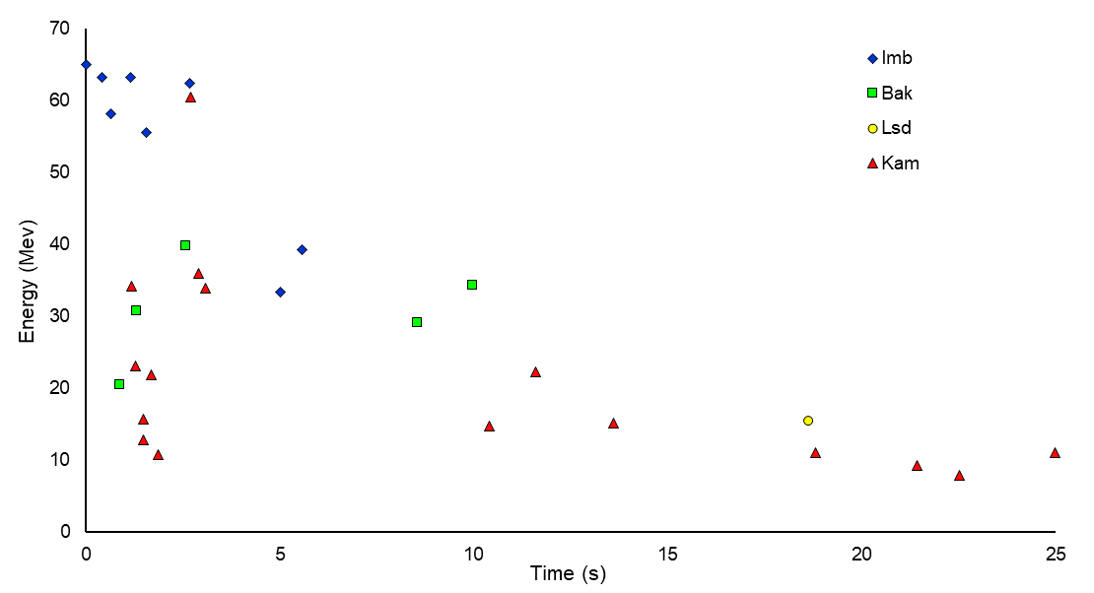

Figure 14. Antineutrino burst at 7:35am re-scaled

49
Also conspicuous by their absence are gravity waves. Maryland was struck by a blizzard at around 6Am UT that caused a power outage, so by 7:35 it was no longer making detections. Fortunately, the Rome bar was still operational but did not detect any energy innovations at the 7:35 time [49]. This indicates that there was no rapid neutronisation immediately prior to the antineutrinos, an essential feature of neutron star formation.
The high energy of the particles combined with the prolonged cooling time (out to 37s if the second Lsd detection is included) indicate higher temperature and either lower surface emissivity or a smaller surface area. When the effects of infall were considered in section 5.6, a value of 0.76Mʘ was chosen to keep the mass of the neutron star within the bounds of what degeneracy can support, this is a value that can certainly be exceeded with the enormous gravitational field and natal kick accreting more material.

5.9 COMPARISON OF 7:35 BURST TO AN EARLIER DETECTION

In 1974 a set of seven $2m^{3}$ water-based Cerenkov counters placed in the Homestake Gold Mine adjacent to the Brookhaven Solar Neutrino Observatory detected 24 antineutrinos [72]. They fell in the same approximate energy range of $20 Mev≤E≤100 Mev$ as the 7:35 emissions although here the comparison ends. These arrived in pulses around 1ms apart, but due to the maximum of 24 recording channels, only 3ms of data was recorded before the channels were full. It is not known if the pulses continued after this time.
At first glance this might not seem to have any particular relevance to the 7:35 detections, but by eliminating events that are unlikely explanations, the remaining possibilities can be examined. This leads to two significant implications for the 7:35 data:

1. Energy levels are similar for both
2. A low bolometric luminosity event can have high (anti)neutrino luminosity

Considering the high energy levels, radioactivity or neutron decay cannot account for them so the event must have been a thermal one. If it was a supernova, then core collapse must have occurred to produce the temperatures necessary for the detections. If they came from a short gamma ray burst then the source would be some compact object like a quasar, pulsar or neutron star, and would thus already be formed. Since no supernova or gamma ray burst is catalogued [73][74] at this time nor mentioned by the authors of the paper, the source was presumably something else.

Equating the flux detected during the two events it can be seen that the small detector in Homestake Mine detected 24 antineutrinos in 3ms, the same as three of the four detectors at 7:35 over a period of over 10s. If the sources were similar then the '74 event must have been much closer, by scaling the measured fluxes an approximate distance for the earlier detection can be made:

For the 7:35 detections:
$$\frac{5.26×1.71×{10}^{46}}{3.11×{10}^{43}}÷10=289wm^{-2}$$
For the '74 detections:
$$\frac{1.2×{100}^{2}}{0.003}=4000000wm^{-2}$$
Scaling the distances:
$$√\frac{289}{4000000}×51000=434parsec$$

In astronomical terms this is in our back yard, it seems unlikely that a gamma ray burst or supernova could have gone undetected. The source must have been a dark low luminosity object but with subsequent high luminosity neutrino emissions. This may be similar to a 'burst candidate' S200114f measured recently by Ligo and Virgo.

Given the age of the Milky Way and a rate of around 1 core collapse per century it is possible that there are a number of old neutron stars passing within say 1kpc that have been cooling for long enough to make them undetectable in the electromagnetic spectrum. They would still be quite capable of accreting matter from anything that got too close and would gradually gain mass.
This applies to all neutron stars whether newly formed like the core of Sanduleak 69-202 or one perhaps billions of years old - consume too much and neutron degeneracy will eventually be overcome leading to further collapse releasing gravitational potential energy, this energy being emitted as neutrinos and antineutrinos.

5.10 ALTERNATIVE INTERPRETATION OF 7:35 DATA

To interpret the 7:35 detections a comparison will be made between the binding energy of a neutron star at the Tolman-Oppenheimer-Volkov mass limit of $2.16Mʘ$, and the same mass when the energy detected from antineutrinos is added.

Appendix 8 contains data on neutron stars, a function is derived from this relating radius to mass, in this case $12.71km$.

using eq.(11) to calculate initial binding energy $E$gives:

$$E_{n}=6.65×{10}^{46}j$$

energy released at source $E_{s}$ as all six flavours of neutrino:

$$5.26×{10}^{46}×1.71=8.99×{10}^{46}j$$

adding to give a final gravitational binding energy $E_{q}$ for the new object of:

$$E_{q}=1.56×{10}^{47}j$$
again using eq.(11) but to calculate radius R from this energy we obtain:

$$R=6319m$$

which leads to an astonishing mean density of:

$$4.07×{10}^{15}gcm^{-3}$$

..or around seventeen times the density of an atomic nucleus!

What appears to have happened, based on this, is a neutron star formed at the Lsd time, accreted material releasing gravity waves and thermal antineutrinos over a period of 4.7hr before consuming one 'meal' too many and the pressure at the centre exceeded maximum neutron degeneracy pressure. It collapsed releasing a large amount of energy before the collapse was promptly halted at around half the neutron star's radius by an even greater repulsive force. From the antineutrino energies, the collapse appears to have released most of its energy in the first 5 seconds followed by a much longer tail.
The emission of antineutrinos implies some particle (or field) that experiences the weak force was present. Whether some material was ejected at this time or not, shouldn't change the likelihood that these particles were prior constituents of the neutron star, present in the newly collapsed object.

The lack of gravitational waves detected at this time is just as expected. The collapse should, although there is no absolute proof of this, have proceeded almost spherically. The process of neutron star formation should have left a deficit of electrons and up quarks, so unlike neutron star formation no electron neutrino burst should have accompanied the collapse, and hence no accompanying gravitational wave either. This leads to the possibility that:

From these calculations, the simplest explanation is that the 7:35am detections were from the collapse of a neutron star into a quark star

Just as the process of neutron star formation from core collapse has been studied, theoretical models have been produced for how quark stars form and what their properties are. A value for the cooling rate of a quark star by neutrino emission has been derived [75] for a 10km radius to be:
$$L_{v10}=3.2×{10}^{46}w$$
re-scaling this to 6.3km gives:
$L_{v6.3}=1.27×{10}^{46}w$
to find the cooling time of:
$$\frac{8.99×{10}^{46}}{1.27×{10}^{46}}≈7s$$

This seems to be in reasonable agreement with the majority of the emissions at the start of cool down in fig.14. The long tail of the emissions starting at 5s does look visually like a thermal cool down unlike the curves predicted for trapped neutrino emission in neutron star core collapse theories.

52
Returning to the antineutrino decay function derived in section 5.4.1, it was seen that only a certain fraction of the energy loss could possibly be explained by gravitational redshift. As the derived energy loss from emission to detection was greater than that calculated for redshift from a neutron star, an additional mechanism to explain the rest of the lost energy was required. With only two values, one from theory alone, there was no mathematical way to determine if an initial rapid drop in the vicinity of the neutron star's gravitational well was followed by a more gradual decay over the rest of the distance. With the formation of a significantly heavier, smaller object using a larger data set, the question can now be answered.
Here the technique is to compare the binding energy of the neutron star $E_{n}$ and the resulting quark star $E_{q}$, subtraction gives the energy released by gravitational collapse. If the ratio of the difference between the two binding energies divided by the energy of the antineutrinos detected here, $E_{d}$ is equal to the redshift calculated for the quark star, then the difference could be explained by the antineutrinos becoming redshifted, i.e.

 | $$\frac{E_{q}-E_{n}}{E_{d}}=1+z$$ | (13)

If the left-hand side of the equation is greater than the right, then as at 2:52, redshift could account for some of the difference, the rest would then need an alternative explanation like additional antineutrino decay but less than the ratio of 1.71.
When any reasonable mass and radius values are entered into eq. (11) to calculate $E_{n}$, the radius calculated for $E_{q}$ always produces a gravitational redshift $1+z$ significantly greater than 1.71. Even if the reading for $E_{d}$ is lowered by as much as 30% to account for experimental errors, and the neutron star is given a radius value on the large side of 20km, the gravitational redshift calculated for the quark star of this mass is always greater than the energy loss travelling 51kpc and therefore conflicts with observation. In other words, the antineutrinos are defying redshift.
Physically this should be impossible, photons and even gravitational waves themselves get redshifted. This leads to the third astonishing property of the antineutrino:-

If the antineutrino cannot be redshifted, it must be unaffected by spacetime curvature

This was not really unexpected. The extreme gravity neutrinos could produce in supernovae, and the problem that might be created if the action was mutual between them and spacetime could produce gravitational effects that had the property of positive feedback. This could lead to runaway effects between the two with neutrinos becoming trapped in their own gravitational well.
If antineutrinos aren't affected by spacetime then this leads to their fourth property:-

If the antineutrino is unaffected by spacetime then it must be massless

Applying the Tolman-Oppenheimer-Volkov limit of 2.16Mʘ to the Schwarzschild radius given by the equation:
 | $$R=\frac{2GM}{c^{2}}$$ | (14)
gives a radius of 6372m.

53
This is however larger than the calculated quark star radius of 6319m, and given that produces an infinite redshift leads to the most profound result that:

The antineutrino detections made at 7:35am were from the formation of a black hole

This result differs from all other theories about the internals of black holes as it is a calculated result, and is not just deduced from a purely hypothetical point of view. It has been produced by analysing the energetics of real particles during real detections using known physics. It is proposed as a viable alternative to the absurd concept of singularities.

This leads to a question: How many physicists are truly comfortable with the concept of a singularity, something which is both aphysical and impossible to prove?

Although the concept is doubtless correct insofar as the mathematics of General Relativity are concerned, extrapolating a theory to infinity seems like a dubious practice. A cornerstone of the singularity concept is that nothing can produce a force great enough to halt collapse once neutron degeneracy is overcome. With a density of $≈17$ times the average atomic nucleus, the quark separation would be around 2.5 times less on average, and it could be that under these conditions the strong force becomes repulsive or some other property of confined quarks dominates.

What is also curious is how close the two values of quark star and horizon radius are. If this is actually correct then it would suggest that the largest, heaviest neutron star collapses to a compact star just inside its own event horizon.

What happens if it accretes matter? The Schwarzschild radius grows linearly with mass and if the radius of the compact star grows approximately to the cube root of its mass (simplistically) then it can be seen that the horizon will always hide the core. This could also explain why no 'naked' quark stars have been reliably observed so far, only neutron stars.

5.11 INTERPRETATION OF DATA AFTER 7:35

The antineutrino burst at 7:35 didn't mark the end of these detections, in fact Kamiokande [35] made several more including a burst of 7 antineutrinos at 7:54am. No gravitational waves appear to have been reported from Rome, either during or after 5:02am [49] when Lsd detected a short burst of 3 antineutrinos also.
These antineutrinos could have been released during sudden changes to the composition of the surface or interior of the core. They could also be due to heating from infall as with the neutron star - there would probably still be some debris around after the quark star formed.
Several reactions could take place involving quarks, up u, down d, strange s, electrons $e^{-}$ and electron neutrinos/antineutrinos $v_{e}/v_{e}^{-}$ [75]

$$u+e^{-}↔d+v_{e}$$
$$u+e^{-}↔s+v_{e}$$
$$u+d↔u+s$$
$d→u+e^{-}+v_{e}^{-}$
$s→u+e^{-}+v_{e}^{-}$

54
One last observational mystery from SN1987A needs explaining.

Why in over 30 years of searching at such a relatively close distance has no telescope, including the Hubble Space Telescope ever found a compact remnant? A newly formed, hot neutron star ought to be visible by now. The simple answer has to be that the misinterpretation of the 7:35am data as being the formation of a neutron star has led to the search for something which isn't there.

The events of February 23rd 1987 witnessed the first ever recorded creation of a neutron star from a core collapse supernova followed just hours later by its ultimate collapse to form a black hole

55

6 BLACK HOLES AND NEUTRINO GRAVITATION

In 1784 English clergyman and scientist John Michell published a letter proposing the idea of a star with such extreme gravitation that the light it produced would be unable to escape. He further noted that while not directly visible, they could be found by observing their gravitational effects on other nearby objects. To have conceptualised such a celestial body in the days long before nuclear physics and modern astronomy, when even the scale of the universe was unknown was certainly highly imaginative.
He called them 'dark stars', which, if the calculations in the last chapter are reasonably accurate is technically more descriptive than our modern 'black hole', a term whose etymology originates more in the theatrical than technical.

For concision, the term black hole will continue to be used, however it will be defined as a quark core from stellar collapse which generates a horizon or boundary through which neutrino species can pass in either direction, everything else can only fall in. Consider them essentially as a new class of object given the fundamental differences in core and horizon properties compared to the more traditional definition of a singularity surrounded by a horizon that nothing can escape. Their behaviour is thus significantly different to warrant extensive investigation.

April 2019 saw the first ever image created of a black hole and its surrounding environment, and two years later the magnetic field lines in the surrounding accretion disk. The images are really quite haunting knowing what lurks at the centre, although observing the horizon not emitting light confirms what was expected, it unfortunately tells us nothing about the interior.

In the last chapter it was shown that thermally created antineutrinos can escape both from a forming black hole as well as being emitted in a burst some 20 minutes later. This leads to an important question: can neutrinos escape from black holes? Just because antineutrinos escape doesn't mean it can be taken as a given that neutrinos can. How then do you show neutrinos being emitted when no such detections have ever been made?

To solve the problem, we must anticipate the result so that we know what to look for. If the interior is indeed comprised of a compact quark core, the dynamics of the system depend crucially on the rate of infall.

If infall is negligible or absent, the baryonic mass should be constant with radius. If however infall is significant, as in the last chapter, the expectation would be neutronisation followed by thermal heating either of the surface or the whole core if it is superconductive. Thermally emitted pairs of neutrinos and antineutrinos of all species would cancel each other gravitationally. Electron neutrinos emitted by the conversion of an up quark into a down quark would however add a radially-dependent scalar gravitational field to the baryonic mass, which, as with fusion driven stars, should increase linearly with distance.
6.1 NON-ACCRETING BLACK HOLE IN GALAXY NGC3115

The first step to determine if neutrinos do escape from black holes is simply to establish whether normal baryonic gravitation exists between a non-accreting black hole and the surrounding stars.
One of the first to be discovered [76] was in galaxy NGC3115 with a mass of approximately three billion solar masses, it is thought to be non-accreting [77]. Its growth has stopped and the galaxy surrounding it contains very little gas or dust, very little star formation and an older, redder stellar population.

The mass derived from stellar kinematics, figure 15 below, appears to be constant with radial distance just as would be expected from baryonic gravitation [76], with no apparent contribution from neutrinos from neutronisation.

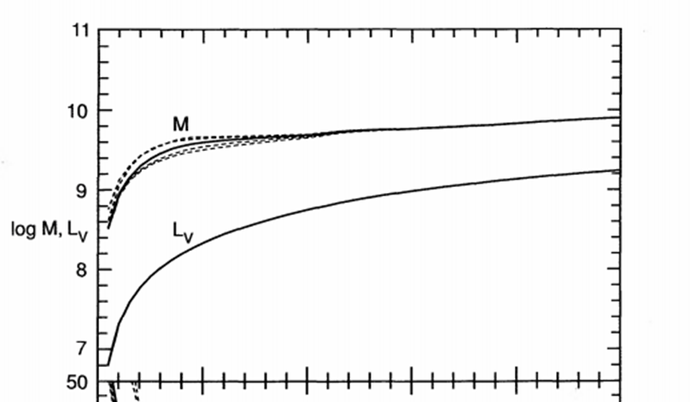

Figure 15. Mass concentration vs radius measurement (0-5 arcsec horizontal scale) for NGC3115

This being the case, whatever object lies inside the horizon appears to generate one of the four fundamental forces - gravity - and seems to do so according to the universal law of gravitation i.e. an inverse square law of attraction. This acts on stars millions of times less massive and can be inferred by their rotation around the hole.

Whether a non-accreting black hole experiences gravity itself can be inferred from binary systems where the other component is a star [78], and the difference in mass isn't too great. The stable orbit observed must according to Bertrand's Theorem come from an inverse-square law of force. While this doesn't rule out a singularity in the interior as such, it does show that the interior could be composed of existing gravitating baryonic matter.

58
6.2 ACCRETING BLACK HOLES IN GALAXIES M87 AND M104

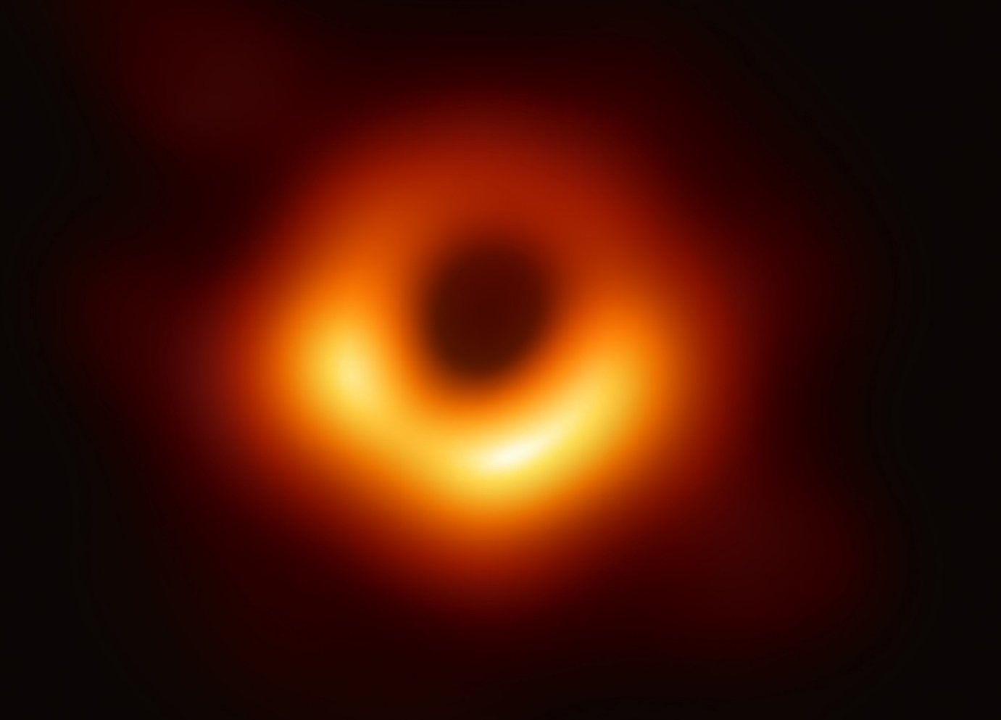

Figure 16. Supermassive black hole and accretion ring at the centre of Messier 87 galaxy. The diameter of the horizon is just over ${10}^{13}m$, a value that would swallow the sun and all the planets out to Pluto. This horizon covers around 1/3rd the diameter of the central dark area with a central mass of around 2 billion solar masses

Many measurements of the supermassive black hole in M87 have been made since Young and Sargent pioneered the work back in 1978. Various values of mass have been reported between around 2-10 billion solar masses, seemingly on the face of it a rather wide range. Many of the papers respectfully cite the values derived in other papers and try to explain why the differences in mass are due to the different methods of measurement or calculation used in those papers.

It appears that they might all be right but for a reason none of them could have anticipated. Appendix 9. contains values for calculated mass vs radius taken from astronomical papers [79]-[86] for the centre of M87 which are plotted in a linear graph, shown below in figure 17.

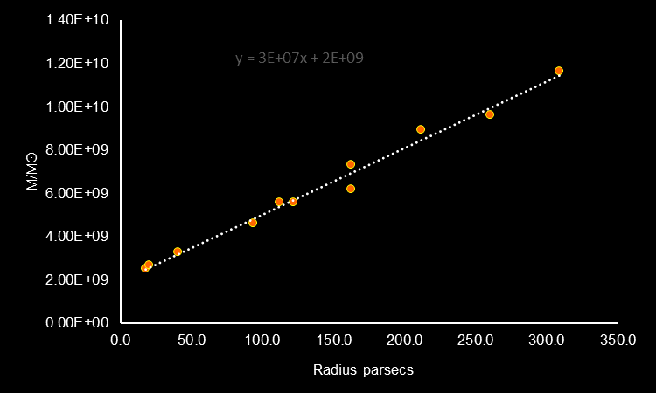

Figure 17. Mass vs radius for the M87 black hole

As can be seen the trend is clearly a linear increase in mass with distance out to 4 arcseconds or around ~320 parsecs where stellar mass starts to become significant. The central baryonic mass is around 2 billion solar masses with a steady increase with distance due to neutrino gravitation.
This is exactly as would be expected with a compact object whose constituents experience both gravitation and the weak force, and are also fed with a steady rate of infall material. Besides helping to confirm the idea that a quark core lies at the centre rather than a singularity, it also justifies the statement that:

Neutrinos do not experience redshift and so are also massless

To check this result the same calculation is done on the black hole [87][88][89] at the centre of galaxy M104, the baryonic mass has a value of around 100 million solar masses, but with a linearly increasing neutrino mass with radius, figure 18.

The increase in mass from the M87 trendline is approximately:

$$3.06×{10}^{7}Mʘ/pc$$

which gives a neutrino virtual mass production rate kgnsˉ¹ of:

$$\frac{3.06×{10}^{7}×1.989×{10}^{30}}{3.26×3600×24×365}=5.92×{10}^{29}kgnsˉ¹$$

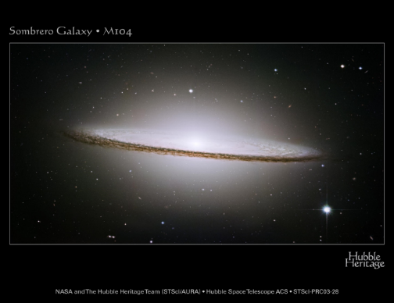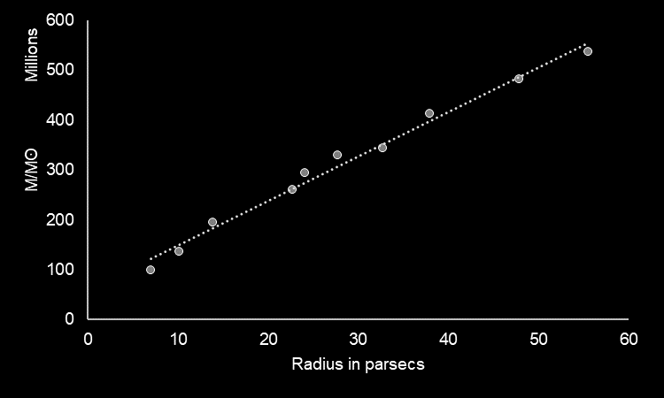

Figure 18. Sombrero galaxy and black hole mass vs radius

To compute the infall rate we need to calculate how much energy as electron neutrinos is being generated by neutronisation,

putting: $infall rate=kgisˉ¹$
$$neutrino energy\left[37\right][38][39]≈10mev$$
$$conversion ev to joules=1.6×{10}^{-19}j/ev$$
$neutrino joules to mass Y=$1.15$×{10}^{-6}kg/j$
$$proton mass m_{p}=1.673×{10}^{-27}kg$$
$$neutron mass m_{n}=1.675×{10}^{-27}kg$$

energy of neutrinos:
$$\frac{kgnsˉ^{1}}{Y}=5.148×{10}^{35}w$$
energy per proton conversion:

$$10×{10}^{6}×1.6×{10}^{-19}=1.6×{10}^{-12}j$$

number of protons converted per second:

$$\frac{5.148×{10}^{35}}{1.6×{10}^{-12}}=3.218×{10}^{47}$$

mass per second assuming one neutron accompanies each proton from a nucleus:

$$(m_{n}+m_{p})×3.218×{10}^{47}=1.077×{10}^{21}{kgs}^{-1}$$

a simple conversion to the more commonly used units of solar masses per year gives a value of:
$$0.017Mʘ/yr$$

This is close to estimates from [79][90][91][92] of $0.01,0.1,0.15 and 0.00092Mʘ/yr$ which give a combined geometric mean of:
$0.019Mʘ/yr$

61
These estimates are too low to explain how it could have grown to our lower estimate of ≈2 billion Mʘ within the age of the universe. Taking that argument into account, the value derived above is around one-fifth the average value needed to explain the above mass if the universe is 13.8 billion years old. The universe is of course a lot more diffuse now than it was at its earlier epoch suggesting that much denser material was available for infall and the hole grew more quickly at first.

6.3 EXPLANATION OF BLACK HOLE 'NATAL KICKS'

Neutron stars are often flung out at around several hundred kmsˉ¹ from type II supernova with a 'natal kick'. Hydrodynamics are unlikely to be able to produce a great enough force to accelerate a solar mass core from rest to this speed, especially if its area is only around 100km². An enormous gravitational kick during neutronisation from neutrinos does however provide a realistic mechanism. As above, this 'natal kick' also applies to black holes. Curiously, their velocity distribution [93] is much the same as the distribution for neutron stars despite their considerably greater mass. One would expect the momenta to be the same and not the velocity.
Given that black holes gain mass by absorbing material, the gravitational effect from neutronisation would depend on the geometry of how the material reached the surface. If it spiralled in from a surrounding accretion disk then it would reach the surface in a roughly circular-symmetric fashion producing little net effect. If however the natal kick sent it into some material, capture would take place more towards the front of the quark core (in the direction of travel and with an attractive polarity) and would continue to accelerate it in that direction explaining the higher than expected velocity.

6.4 THE 'MASS GAP' BETWEEN NEUTRON STARS AND BLACK HOLES

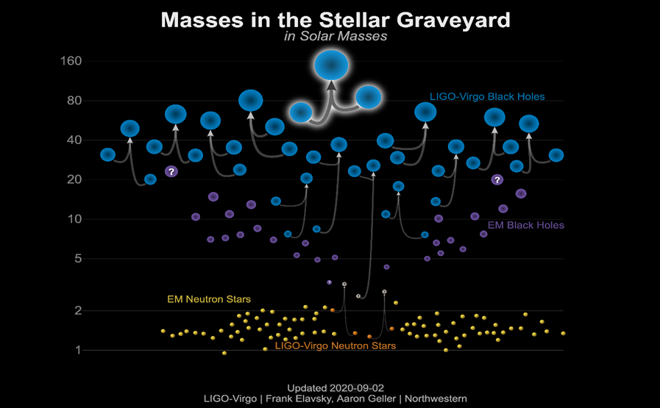

Figure 19. Comparison of neutron star and black hole masses

62
Modern gravity wave detections since 2015 have been almost exclusively between various combinations of neutron stars or black holes merging. A lack of detections between 2Mʘ and 5Mʘ suggests that either very few of these objects exist or that there is some observational artefact at play.

Given that a mass of around 2Mʘ marks the smallest black hole that can be formed, its mass can only grow with accretion and not drop to reveal the quark core. Another factor is that the progenitors are relatively massive stars of at least 10Mʘ or more, something which is necessary for them to be able to form neutron stars and hence quark cores. Given that the smallest only has to accrete some 3Mʘ to cross the mass gap, it would seem there is often sufficient material available to do this. The neutrino bursts from neutronisation causing the natal kicks would both accelerate the core increasing its velocity, as well as drawing in surrounding material with the additional gravitation.

In the last chapter the accretion rate was approximately 1 solar mass per six hours which collapsed the neutron star into a quark core, a rate that would presumably drop with time as the material thinned out. This process would of course be obscured visually for several months giving the core time to absorb a certain fraction of the remnant's mass, it could then exceed 5Mʘ thus crossing the mass gap.

Also of interest is the spread of masses between the lower and upper mass gaps. While it has long been supposed that supermassive stars could collapse directly to a black hole there seems to be only a little observational evidence for these events. The difficulty occurs because the black hole formed would be isolated and without a glowing accretion disk or jet to observe. Only the complete vanishing of a star would be evidence of the process [94].
The neutron degenerate core of these progenitors should still obey the Chandrasekar limit of around 1.4Mʘ after which collapse would proceed. The surrounding layers would then have to fall directly onto the neutron star causing the direct collapse to a black hole. Of note is how close the values of mass in figure 19. above are to supermassive stellar masses, something which lends at least some support to the direct-collapse scenario.

An alternative could be stars above ≈16Mʘ of which around 80% [95] are in binary systems. If one went supernova and formed a black hole, it could then accrete or digest its companion, something which has been observed. This could be slowly through an accretion disk from overflowing Roche lobes or even in one gulp if the 'natal kick' was towards the companion [96].

6.5 WHY THE HORIZON IS AN ESSENTIAL FEATURE

Conventionally, a black hole is a singularity surrounded by a spherical or oblate event horizon through which material, energy and even information can pass in only one direction. It is not a thing, merely the point at which Relativity forbids escape.
The gravitation of the singularity defines the horizon, but the horizon doesn't impede infalling material or stop it being crushed into oblivion at the centre, nor does it impede the motion of the singularity. As such it serves no purpose other than being a trap.

63
The horizon surrounding a quark core differs in one crucial way as we've seen - neutrino and antineutrinos experience the weak force only and are free to pass through it in either direction. Unlike the horizon around a singularity however, it provides a crucial role by preventing mass and thermal energy escaping. If there wasn't a point of no escape, the quark star could ultimately evaporate away eventually leaving nothing. They would therefore have a lifespan rather than being permanent. This will be investigated in the next section.

As supermassive black holes are found at the centre of virtually every galaxy it is a widely held belief that they are essential to galactic formation and evolution [97]. If they had a limited lifespan that was too short, they would be ineffective in fulfilling this role. The more massive they get, the more effective as gravitational engines bringing in gas and dust to form dense clouds where stars can form. The ability to neutronise material and create neutrino gravitation is however completely independent of the hole's mass as nothing inside the horizon can escape bar neutrinos, so the long range reach of this gravitation is determined by infall rather than core mass.

Another reason for the horizon is to overcome the Eddington limit of hot objects like the quark stars which form at temperatures of around ${10}^{11}$K by trapping infalling matter. For the quark core of M87 this limit with M=2x10⁹Mʘ would be:

 | $$1.3×{10}^{31}(\frac{M}{Mʘ})w$$ | (15)

$$E_{Edd}=2.6×{10}^{40}w$$

If we assume this core has approximately the same density as that derived in section 5.10, the radius is about $6×{10}^{6}m$, and substitute the infall rate from 6.2 into eq. (12) we get an energy release from infall of:

$$E_{M87}≈7.9×{10}^{43}w$$

As this far exceeds the Eddington limit, it suggests that the core of a heavily accreting black hole could be surrounded by a layer of superheated plasma. The dynamics of such a system would certainly require a complex computer simulation for analysis, far outside the scope here. However, given that there is no thermal radiation outside the horizon preventing infall, and that once inside the infall cannot escape regardless of whether or not the Eddington limit is exceeded, then it can be seen that the horizon is an effective trap.
As a check, this is around eight orders of magnitude higher than the neutrino luminosity derived for M87, so there is no conflict between energy in and energy out. The black hole could liberate substantial amounts of energy as thermal neutrinos and antineutrinos and therefore cool down, but this would not constitute a problem as it's scalar virtual mass field is generated by neutronisation and does not depend on core temperature.
There is some provisional evidence [98] for active galactic nuclei being sources of high energy neutrinos which lack the expected accompanying electromagnetic signature from the black hole's corona.

6.6 QUARK CORES AS A SOURCE OF LONG GAMMA-RAY BURSTS

Gamma rays are absorbed by the Earth's atmosphere, something which is of course essential for life to evolve on the planet's surface. Observatories were ground based until the 1960's and so these gamma ray bursts (GRBs) were unknown until observation was possible from space. As a result they weren't detected until 1967 when the Vela satellites were put into orbit to detect covert nuclear weapon testing [99].

The origin of these GRBs is currently under investigation, although they are usually associated with supernova events in regions with a high star formation rate and could therefore be linked to violent quark core events.

In chapter 5 the formation of a quark core was deduced from the energetics of antineutrinos detected during supernova 1987. Allowing for these calculations being basically correct led to the peculiar feature that the quark core appeared to form just inside it's event horizon. As was stated the horizon grows linearly with increasing mass whereas the core grows at most to the cube root of mass, so accretion will extend the horizon much faster than the core grows and will always hide it.

Photons and quarks can't of course cross the horizon and escape but thermal neutrinos and antineutrinos can and this leads to an interesting scenario.

Suppose that just after formation accretion from the remnant stellar envelope stops, either because the black hole has received only a small natal kick and isn't ploughing through material and accreting it, or that in it's death throws the star blows off much of it's stellar envelope before collapse. Could the newly formed core lose the equivalence in mass through energy emitted by thermal neutrinos and antineutrinos?

Using the same core density calculated in section 5.10, we can equate the Schwarzschild radius, eq. (14), volume and density to produce a radius where the horizon radius is the same as the core radius. This value comes out as 6289m which when plugged back into the volume at this density produces a mass of 2.13 Mʘ in other words a difference from the SN1987 core of around 0.03 Mʘ.
This equates to around $≈5.4×{10}^{45}j$ which from the cooling rate derived in section 5:10 could easily be lost quickly even if the tail of emissions was at a significantly slower rate.

Once the mass drops below 2.13 Mʘ there would no longer be a horizon containing the core and it would start to radiate, highly red-shifted at first and being unconfined the quarks would recombine back into a baryonic plasma. The rate of this process would accelerate until it released one mighty flash of gamma rays followed by a long afterglow from the disrupted remains.

Interestingly, the binding energy of the core $E_{q}$ is indeed within a factor of two of the energetics of a real GRB event GRB 080319B [99].
6.7 EARLY GALACTIC EVOLUTION

6.7.1 ∆CDM APPROACH

The formation of galaxies occurs in a hierarchical order under standard ∆CDM cosmological theory [100], structure building on top of structure to produce fully matured galaxies over billions of years. Observations [100][101] do not agree with this theory however as they show early galaxies forming at a rate several times faster than predicted. The ∆CDM model uses only baryonic mass and the hypothesised dark matter to create local over densities that coalesce first to form early stars followed by structures similar to globular clusters which eventually merge into galaxies. The problem centres around the dominant gravitational force being in the form of a diffusely distributed dark material that only interacts through gravity.

Early population III stars formed only a few hundred million years [102] after the Big Bang but required something other than their own and the surrounding hydrogen and helium's baryonic gravity to act collectively to create fully formed galaxies. This force is assumed to come in some form of missing matter, created in the Big Bang and distributed throughout the universe. The first problem with this is simply that the universe is constantly expanding making the material ever more diffuse.

The second problem is that this dark matter would have to relieve itself of kinetic energy to contract. A perfectly elastic polytrope of an ideal gas would assume a specific size and density profile and would be unable to collapse further until it could lose this kinetic energy or temperature. This implies that to do so it must experience not just gravity but one of the other three fundamental forces, something which drives most of the experimental searches for it by looking for nuclear collisions similar to those already found in neutrino detectors. If it does not experience one of the other forces it cannot interact with atomic nuclei so it cannot recoil off them, fundamental particles don't behave like billiard balls. If it does it may be able to lose energy and shrink the halo diameter and form galaxies.

Given that over four decades of searching for it have produced a null result, and the fact that the Standard Model of physics makes no provision for it then this makes a strong argument against it. It doesn't even work in theory in it's most fundamental role - that of galaxy formation as it does so too slowly.

A third serious issue caused by this hierarchical system is known as 'tidal stripping' by larger galaxies of smaller ones. The larger galaxy would grab stellar material from smaller systems but not the halo itself, as dwarf galaxies tend to have much higher M/L ratios then by repeated absorption, the M/L ratio of the large galaxy would also increase, conflicting with observation. The idea that the halo would be unaffected by a gravitational interaction seems odd if it is said to be 'collisionless' as in the Bullet Cluster, where the dark matter tracks the stellar component - something which seems more like confirmation of neutrino gravitation!
Chandrasekhar dynamical friction on the dwarf galaxy through the larger galaxies halo would also slow the dwarf galaxy if dark matter existed, but this effect remains unobserved.

66
6.7.2 NEUTRINO APPROACH

Now if we analyse events but use neutrino gravitation instead, qualitatively the picture starts to make more sense.

The very first stars were metal-free and probably very massive and luminous [102]. This would mean high accompanying neutrino luminosities and therefore gravitation. Our Sun as an example doubles its gravitational influence at a radius of about 2kpc, or at the speed of light a time of about 6000 years. The force is therefore both long-range and relatively rapid in action compared to dark halos and occurs as soon as stars have ignited. These gravitational wells surrounding stars would draw in primordial gas and help compress it into new star forming regions.

Being very massive these early stars would end their short fusion powered life with a reasonable probability of forming a black hole, either via a neutron star like Sanduleak 69-
202 or by direct collapse. If the black hole accreted material, then as above in M87 and M104 it would produce even more neutrino gravitation and then possibly go on to form the seed of a new galaxy. These would also have been closer together in the early universe and hence more likely to merge.

There is a broad relationship between galactic bulge mass and the mass of the black hole at its centre [97]. Adding neutrino gravitation to that mass - a long range force - would draw in both more material, and from further away, producing both a larger galaxy and also reduce the number of cluster mergers necessary. This effect from stars and black holes could therefore help explain the number of early but evolved galaxies observed, and why cosmological simulations often produce an excess of dwarf galaxies.

6.7.3 SUMMARY OF DIFFERENCES BETWEEN THE TWO APPROACHES

∆CDM Failings
- Does not match observations
- Gravity of dark matter becomes more diffusely distributed over time
- Dark matter cannot lose energy and contract without one of the other 3 forces
- Dark matter opposes the Standard Model
- Even in theory it works too slowly

Neutrino Gravitation Advantages
- The particles are real and have already been found in neutrino detectors
- First stars had high neutrino luminosities and therefore gravitation
- Force is long range and also acts rapidly
- This source of gravitation has actually been demonstrated as above in M87,M104
- Could form massive galaxies quickly without requiring many mergers

67
6.8 DO PRIMORDIAL BLACK HOLES EXIST?

Another interesting outcome is that if quark cores do form the centre of black holes, it would seem to cast doubt on the possibility of primordial black holes. Unless they formed above this limit of >2Mʘ, then from chapter 5 they would be smaller clumps of unconfined quark matter not hidden by an event horizon, and should have been observed from thermal emissions or evaporation. This means that a lower mass primordial hole would have to contain something else at its centre.

This essentially limits the basic definition of a primordial black hole - that they are the outcome of a quantum event in the extreme environment of the Big Bang and therefore, given the above would have to contain something extremely exotic in their interiors - like a singularity. While none of the material produced here would definitively rule out the possibility of these primordial black holes, they rely on a purely hypothetical central object, quite different to the calculations done here. In other words there would need to be two completely different types of black hole, something which at best seems rather unlikely.

At the time of writing, no reliable, unequivocal detection of a primordial black hole, nor one below a few solar masses have been made. For such an object to be reliably described
would involve the detection of a <2Mʘ black hole or an accreting black hole that exhibited no gravity other than that from its measured mass.

6.9 DETECTION OF GRAVITATIONAL WAVES IN THE GALACTIC PLANE

In the 1990's two cryogenic Weber bar gravity wave detectors were brought into operation in Italy, Nautilus and Explorer. Although similar in construction, mass and dimensions to the original room temperature detectors operating when SN1987A exploded, cooled to a few Kelvin they had much greater sensitivity due to a far lower noise floor.

Another difference to the detections made earlier in Rome and Maryland was the orientation of the bars. Weber bars have their greatest sensitivity, cryogenic or not, in a plane perpendicular to the main axis of the cylinder. Nautilus and Explorer had the same
alignment to within a few degrees, but just as importantly these alignments were chosen to
coincide with the galactic plane only once per sidereal day, meaning that they were most sensitive to gravitational events in the galaxy at these times.

Analysis [103] showed an excess of coincidences around sidereal hour 4, the time when the most sensitive plane of detection aligned with the galactic plane. They considered the energy level of detection to be equivalent to around 0.004Mʘ at a distance of 8kpc, roughly to the galactic centre. Black hole candidates have recently been detected much closer to Earth [104] however, which would reduce the energy of the waves necessary at the point of emission. An estimate of the number of stellar mass black holes in the Milky Way is around 100 million [105] so the frequency of low bolometric luminosity but high neutrino gravity events could be quite high. This concurs with the antineutrino detections in 1974.

Another study [106] using different mathematical analysis found a slight preference for sources in the direction of the galactic centre where of course Sagittarius A*, a 4 million solar mass black hole resides. Again the gravity waves are not linked to a supernova or luminous event but could be the result of accretion into the hole with accompanying neutrino emissions.

Nautilus and Explorer also made coincident detections [107] from a known source in 1998, an object known as a microquasar XTE J1550-564. This is a binary system with one companion a white dwarf or G/K class star, the other a ≈10Mʘ black hole onto which material is accreted producing x-rays as it inspirals. Figure 20 below shows the coincident x-rays and gravity waves detected.

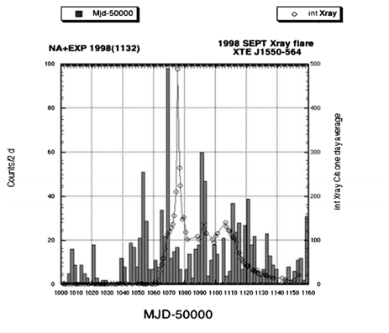
Figure 20. X-ray and gravity wave detections from star/black hole binary system

Again, at a distance of around 5kpc baryonic gravitation alone cannot explain the detections. Of significance here is that the gravity waves or projectiles must always pass through the Earth on their way to Nautilus and Explorer, suggesting that if they're not from a massive source then they are almost certainly neutrinos.

69
6.10 COMPOSITION OF THE CORE

Data from the core collapse of SN1987A was used in the last chapter to predict that a black hole formed at the time traditionally associated with the formation of a neutron star. This ought to be the time when a maximal amount of information is released through gravitational waves and neutrinos, these can of course both escape through the outer envelope of the star immediately.
It has also been shown that whatever lies at the centre of a black hole experiences at least two of the fundamental forces - gravity and the weak force.

If we assume that the material in the newly formed object came from the neutron star before it, the simplest explanation is that the baryonic material has been compressed into a sea of its constituent quarks. They could be supported by degeneracy, thermal pressure, radiative pressure or a repulsive strong nuclear force, or indeed a combination of two or more of these.
At a calculated average density some seventeen times higher than the average atomic nucleus it forms a quark-gluon plasma. These conditions have actually been tested experimentally in particle accelerators, usually either lead or gold nuclei collided at relativistic speeds to briefly produce densities ten times higher again [108]. This quark-gluon plasma has the characteristics of an ideal fluid [109], an interesting result given that ideal fluids are essentially incompressible, this suggests the quarks can strongly resist being squashed together.

Crucially, the pressure generated in a gravitationally-bound object must be resisted otherwise collapse will ensue, in this case it would end in a singularity which is a most undesirable result. The higher the density and higher the mass of such an object the higher the central pressure, this will be calculated for an extreme example based on the heaviest known quasar, TON 618. It has a measured mass of some 66 billion solar masses so a figure of 100 billion will be used for a central baryonic object having also the highest measured density $ρ$ 170 times greater than the average atomic nucleus. A formula [110] is used for the central pressure $P_{cen}$ in a spherical object of uniform density mass M and radius R:

 | $$P_{cen}=\frac{5GM^{2}}{4πR^{4}}$$ | (16)

$$ρ=4×{10}^{19}{kgm}^{-3}$$

$V=\frac{4}{3}πR^{3}=5×{10}^{20}m^{3}$

$$R=4.924×{10}^{6}m$$

$$⇒P_{cen}=1.807×{10}^{45}{Nm}^{-2}$$

This is clearly an enormous pressure but it can be sustained by the quark core. Examining fig.21 [111], the top right shows the conditions measured for a quark-gluon plasma and they can be seen to exceed the pressure calculated above by several orders of magnitude. It seems then that even in this exaggerated example the core should not collapse.

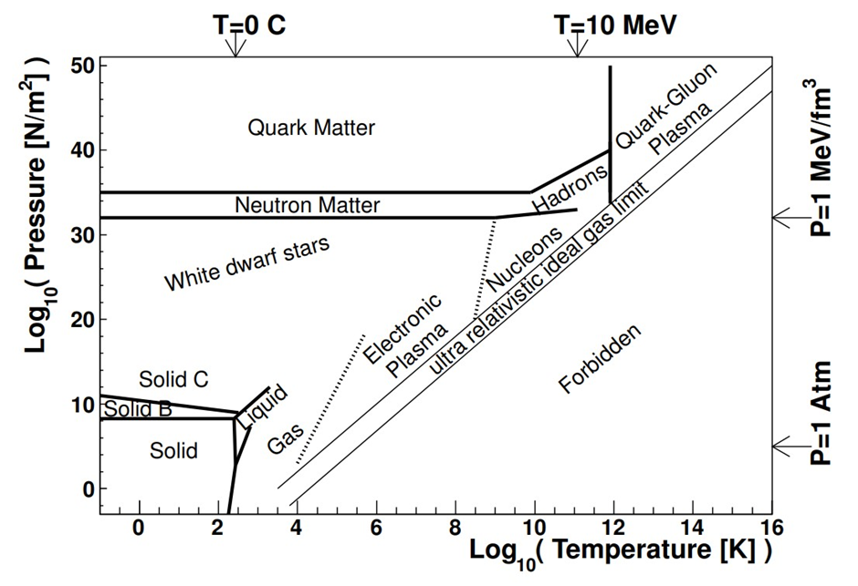
Figure 21. Phase diagram of matter in the pressure versus temperature plane for a non zero baryonic potential

Another important consideration is how does the core cool? Chiral bag models [112] show that emission of pions lose energy from the wall and these decay [113] first into muons and muon neutrinos with an average lifetime of 26 nanoseconds by the reactions:

$$π^{+}→μ^{+}v_{u}→e^{+}v_{e}v_{u}^{-}v_{u}$$
$π^{-}→μ^{-}v_{u}^{-}→e^{-}v_{e}^{-}v_{u}v_{u}^{-}$

The muon neutrinos and antineutrinos both have a monochromatic energy of 29.8mev and the muons being heavier members of the electron family decay with a lifetime of 2.2μs into either a positron or electron, with an additional accompanying electron neutrino and muon antineutrino, or electron antineutrino and muon neutrino. These last two both have a continuous energy spectrum up to $E_{max}=52.8mev$.

This leads us back to re-examine the graph of antineutrino energies shown in fig.14 (p49). Theory predicted most of the energy would be released in around 7s whereas it can be seen that a large portion of the emissions took place in the first 3 seconds. The overall shape of the graph looks on visual inspection to be rather incongruous, the upper part of the curve looks distinctly like thermal cooling, whereas up to 3 seconds there are two regions, one a lower

71
energy zone, or 'bar' comprised of Kamiokande and Baksan detections but with a gap to the mostly IMB detections.

The explanation could be that there are in fact two different emission mechanisms in operation. The upper curve could be the thermal emissions of a quark core approximately half the radius of a neutron star, so around quarter of the surface area but with a higher initial temperature thus leading to the long cool down 'tail'. The other lower energy 'bar' between 1-3s could be from the above pion-muon mechanism.
This would explain the gap between the top of the 'bar' at 40mev and the lowest IMB energy of about 56 mev given that the continuous spectrum from the muon decay can't exceed 52.8mev, and will of course statistically have few neutrinos out of the eleven in that group near the upper limit [113].

It should be remembered that the values in the graph have been derived by multiplying the actual detected energies by the factor of 1.71 derived from the formation of a neutron star at 2:52. This was a comparison between the detected energies here and what core collapse theories predict at source. This calculation must be regarded as a rough approximation with some error likely.
It does however predict the gap from 40 to 56mev fairly accurately which the actual detected energies (fig.6) cannot, so the two different emission mechanisms do help to confirm the presence of an antineutrino energy loss function.

6.11 THE 'BROWNIAN' HEATING MECHANISM

So far only the gravitational effects of neutrinos from neutronisation have been discussed in relation to black holes.

What effect, if any, do the thermal neutrinos and antineutrinos have?

In section 6.5 the question was asked whether all the infall reaches the core's surface or forms a superheated plasma layer. In section 6.2 it was shown that the rate of infall deduced from neutronisation which in turn gives rise to the increasing virtual mass field around M87 black hole matches to within 10% conventional estimates of infall. This suggests that infall does indeed reach the surface which in turn implies that the energetics from infall onto this core happen at the rate of around:

$$E_{M87}≈7.9×{10}^{43}w$$

This would produce a quite phenomenal amount of gravitation but fortunately the neutrinos and antineutrinos cancel each other out. The effect described however relates to the total gravitation on a large scale.

Does this mechanism have any effect at the microscopic level?

Consider a body of uncharged particles only just above absolute zero. Their kinetic energy would be minimal and they would be moving very slowly. Now consider what would happen if a large flux of collisionless, chargeless but massive particles was passed through

72
this body. At any given time an individual particle of the body would be closer to one massive particle than the others, but this situation would change continuously over time as the flux passed through. The gravitational force on the particle would be changing rapidly both in magnitude and direction imparting random motion to it. The particle would therefore be heated.

A detailed description of this mechanism is outside the scope of this study, it would require statistics and detailed computer modelling and would also depend on the type of particles being heated. The mechanism however could be a novel proposal to explain why the coronae of black holes become superheated, and why the overall energy transfer from the spin of the black hole and friction is insufficient to explain the energetics of their accretion disks.

6.12 THE INFORMATION LOSS PARADOX

A conflict between relativity and quantum mechanics has arisen from the theoretical mechanism of Hawking evaporation from black holes. The extreme conditions just outside the event horizon allow particle-antiparticle pairs to be produced with the possibility that one could fall into the hole and be irretrievably lost while the other could escape. Two fundamental tenants of quantum mechanics are time unitarity and reversibility, both of which appear to be violated here.

The error occurs with the mis-application of relativity to the idea of a singular core. Should the particle that falls in continue to be subject to understood physical laws then unitarity and reversibility are not violated. If however [114] its wave function is destroyed by the singularity and the hole then goes on (assuming no further accretion which would eventually stop in an ever expanding universe) to completely evaporate then the information would be lost.

If the core is composed of a quark-gluon plasma however, the wave function of the infalling particle would be preserved even if it were made inaccessible by the horizon. The same laws of physics hold equally inside and outside the horizon hence no violation would occur, and therefore there would be no information loss.

73

7 WHY THE NEUTRINO?

When Wolfgang Pauli proposed the neutrino in 1930 it was based on reasoning that would conserve quantities in the weak interaction during beta decay. In this study it has been found that the location of neutrino emitting sources like stars and black holes just so happen to coincide with regions of 'enhanced' gravity essential for the formation and rotation of galaxies.

To understand that the neutrino is the creator of gravity can be seen from the above, but what properties make it ideal for the purpose? By asking what properties would be necessary in a hypothetical particle to achieve this a comparison can then be made with the existing neutrino to evaluate whether or not there is a match.

Please note: the following analysis of the particle and it's antiparticle will include observations of the neutrino. This is not a confusion of considerations made under a theoretical umbrella being unwittingly mixed with the real physics it's supposed to emulate. The study is meant to emulate the real universe as it is observed and as such the neutrino detections made are an intrinsic part of this, therefore no mistake has been made.

7.1 VELOCITY

The prevailing cold dark matter theory posits low velocity particles so that a large halo can create a gravitational well for a galaxy to inhabit. Because this is based on pre-existing particles they have to stay where they were to maintain this halo. Hot dark matter would have particles with high kinetic energy, exactly the opposite of that required to form a compact dense halo, these would escape off into intergalactic space and the halo would evaporate and there would be no over-densities.

This differs fundamentally from neutrinos which are created continuously. Once the galaxy has matured, neutrino emissions reach a steady state thus maintaining the structure and rotation of the galaxy. The particles must remain within the virial radius for long enough to create the required amount of gravitation but not too long that they begin to accumulate and create ever-increasing gravity.

Let's suppose the hypothetical particle travels at about the same speed as a gas particle or molecule in thermal contact with the cosmic microwave background field at a few Kelvin above absolute zero. Instead of creating gravity on the scale of thousands of years as was seen for the sun to double its mass, it would occur on a scale of billions of years - too slow to explain the early universe. If however the particle travels at a velocity similar to the speed of light it would create galactic gravity on a timescale much faster than the velocity of the stars allowing distant regions to 'communicate' and synchronise with each other. This would be necessary for the galaxy to achieve a stable rotating structure, otherwise it would be an incoherent region of gas, dust and stars etc.

If the speed of light is indeed the universal speed limit, then it would seem our hypothetical particle should travel within say an order of magnitude of it, so the best choice is a fast particle rather than a slow one.

75
A further consideration is that gravity waves travel at the speed of light. If the particle were to travel slower than c then the distortion in spacetime would travel ahead of and around the particle, the particle and gravity would no longer be coincident. This does not seem to be the case experimentally [2].

7.2 MASS

If this hypothetical particle is to travel at the speed of light then of course it must have no
mass of it's own, only virtual mass or the ability to bend spacetime. If the stipulation that it must travel at c is lessened and replaced with the property of travelling at relativistic speeds instead, the particle can now have some mass of it's own.

This wouldn't work however as unlike dark matter which is thought to originate some time at or after the big bang and is therefore permanent, in a constantly emitted particle this mass would have to come from somewhere. Unless it also had virtual mass it would not be able to account for the missing 85%, it would have to come from the baryonic 15% and so the total mass would simply stay at 15%. Another difficulty would be that it would be unable to escape from black holes and so the radial increase in apparent mass around an accreting black hole wouldn't occur. This effect, essential in accelerating galactic growth would then be absent.

To satisfy both conditions above therefore it must only have virtual mass and no mass of it's own. The question of how much virtual mass it should have is considered in the next section in conjunction with the number of particles.

7.3 UBIQUITY

Should this particle be present in great numbers or not? Obviously there is an inverse relationship between number and individual virtual mass to create the required overall effect observed. Multiple stellar mass black holes and other massive halo objects or 'machos' for short, down to roughly one-third the mass of the moon have been ruled out by gravitational microlensing [115]. These would however be in generally stable orbits, different to any fundamental particle that had a virtual mass in this range and was being emitted at a constant rate. Any burst of fundamental particles collectively adding up to masses in this range within a small space would not only be detectable via microlensing but would de-stabilise planetary or even stellar orbits.

They must therefore be ubiquitous and evenly distributed and not accumulate in globules or halos.

Also, the higher the virtual mass the more likely the particle would create detectable quantum effects in other fundamental particles and processes, something which has not been detected other than directly from neutrinos in water-Cherenkov and liquid scintillator detectors. The best choice would therefore be a very small elusive particle that hardly interacts with matter and was produced in great numbers.

76
7.4 ELECTRIC CHARGE

Outside of the nucleus, most of what governs normal baryonic matter is electromagnetism. It is the force that describes chemical bonds, the mechanics of solids, liquids and gasses as well as everything from radio waves through visible light right up to gamma rays.

If the hypothesised particle were to interact electromagnetically then it would be unable to pass through planets, stars and possibly most importantly the interstellar medium unimpeded. It would also be deflected by stellar and galactic magnetic fields and so would not be free to radiate outwards in a straight line.

The fusion process in stars would also be affected as the PP and CNO chains emit electron neutrinos only and not antineutrinos. They would have to emit both to conserve an overall neutral electric charge or the rule that particles and antiparticles have opposite electric charge would have to change.

Having an electric charge would therefore create problems even in theory so the hypothetical particle should definitely be uncharged.

7.5 ENERGY LOSS FUNCTION OR NOT?

Should the neutrino have a decreasing virtual mass in flight or should this remain constant from emission?

Consider the situation now in the present day universe. Around 15% of all the mass can be accounted for in the form of baryonic mass, the other 85% comes from neutrinos. Without decay, the neutrino contribution would have started at zero when the first star formed and would have gradually increased to the present day value. This is at odds with observations [100]-[102] of the early universe where more rather than less gravitation is required initially to accelerate growth, a slow build up would be insufficient to do this.

Had the first stars started emitting neutrinos at a rate commensurate with this rapid development then by now the universe would be in the process of collapsing under overwhelming gravity not expanding, indeed it might have already collapsed.

If we now add a decay function these issues can be sorted. Mature galaxies produce continuous emissions of neutrinos which then go on to decay producing a constant amount of gravitation.
This is one of the features of neutrino gravitation that we should have anticipated.
7.6 ANTIPARTICLE AND CHIRALITY

Should the particle have an equivalent antiparticle and what should its properties be?

It was seen in chapter 5 that having an antiparticle with equal and opposite gravitational effect was essential in core collapse stars both to prevent direct collapse to a black hole and to eject material outwards from the core.
To have the opposite effect requires there to be some sort of difference between the particle and its antiparticle therefore it must have a distinct antiparticle and not be it's own antiparticle in the same way that force carrying bosons are their own antiparticle, or like Majorana fermions.

The properties examined above need to be assessed separately for the antiparticle as it plays a different role. The role of the particle is principally attractive gravitation both in stars and to a lesser degree neutronisation in black holes. The antiparticle is necessary for core collapse as neutrinos are emitted along with antineutrinos during thermal cool down, the properties must therefore be equal and opposite to be complementary.

Speed: During the thermal cool down of a newly collapsed compact object the particle and antiparticle must cancel each other out gravitationally. Assuming the speed of light is the absolute speed limit of the universe then the antiparticle could travel at c or at a lower velocity. If it was significantly slower than the particle then inwards attractive gravitational force towards the core would run ahead of the repulsive antiparticle force producing disruptive tidal forces in the star's outer envelope.
Given that the antineutrinos from SN1987A arrived several hours before the visible light, just as expected, it would seem that the above tidal forces couldn't have happened and so from an experimental viewpoint this antiparticle must travel at a velocity very close at c.

Mass, ubiquity and electric charge. All the above conditions apply as per the neutrino.
Decay function. Relevance to be discussed in the following chapters.

7.7 COMPARISON OF HYPOTHETICAL PARTICLE VS NEUTRINOS

How then does this hypothetical particle compare with the neutrino? Remembering that the properties of this particle were expressly designed to fit observation of the real universe, a simple way to draw comparison is to line these properties up side by side in a table. The fact that theoretical considerations produce the same answers is clear.

Property | Hypothetical Particle | Neutrino/Antineutrino
Velocity | c | c
Mass | 0 | 0
Ubiquity | high | high
Charge | 0 | 0
Chirality | left & right | left & right

Table 2. Neutrino and hypothetical particle properties

78
8 THE COMA CLUSTER

So far, neutrino properties have been studied by analysing black holes, a galaxy and a stellar collapse. The distances involved were hundreds of parsecs, 8-11kpc and 51kpc respectively.

Returning to study [2] shows non-baryonic gravitation operating between galaxies outside their effective virial radii. The scales involved in galaxy clusters are in the order of megaparsecs as compared to kiloparsecs for the galaxies themselves, and as such provide an opportunity to study neutrino gravitation at large distances. Does the neutrino mechanism explain gravitation for such large structures?

8.1 TESTING THE ENERGY LOSS FUNCTION FOR NEUTRINOS

The purpose of this chapter is to establish whether the energy loss function is a necessary part of neutrino gravitation in the same way that it occurs in antineutrino gravitation. To recap, the idea was originally deduced by comparing core collapse theories against the energies that were actually detected on Earth. As this provided just two data points it was impossible to conclude mathematically what the function might be, so instead it was proposed that should the function apply to neutrinos also, what type of function would then fit their observables best? An exponential decay was considered a suitable potential fit, better than linear for neutrinos, but without discrete sources of antineutrinos to measure it is an idea that is very hard to test. The value of the energy loss over 51kpc (a factor of 1.71) was shown to be consistent with the gap in figure 14. (p49) between antineutrinos from pion emission via the chiral bag model and the more energetic thermal emissions, but again it did not give any clues as to the nature of the function.

The value calculated for energy loss was around 40% over a distance of 51kpc which means that the dynamics can only be studied in a very large galaxy, or better still a cluster of galaxies extending over the aforementioned distances. The question of why the neutrino should have a loss function was addressed in the last chapter, now though it is essential to establish whether it does actually have an energy loss function.

To test the mechanism requires modelling a relatively large structure, in this case the Coma Cluster both for mass at radius and luminosity at the same radius. This is done in appendix 11 using a selection of data [116]-[125] to produce trendlines that model the data and smooth out differences to produce more accurate values, shown below in figs.22&23.

The range studied is limited to up to 10Mpc for two reasons; one, the available data for luminosity is limited to this range and minimises the amount of extrapolation required, and two, the effect of dark energy slowly starts to become significant, equalling around half the gravitating mass [118] by 14Mpc.

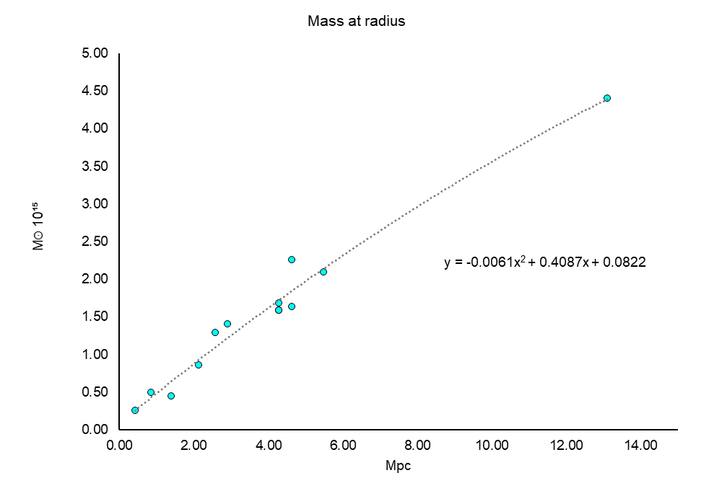
Figure 22. Mass versus radius for the Coma Cluster

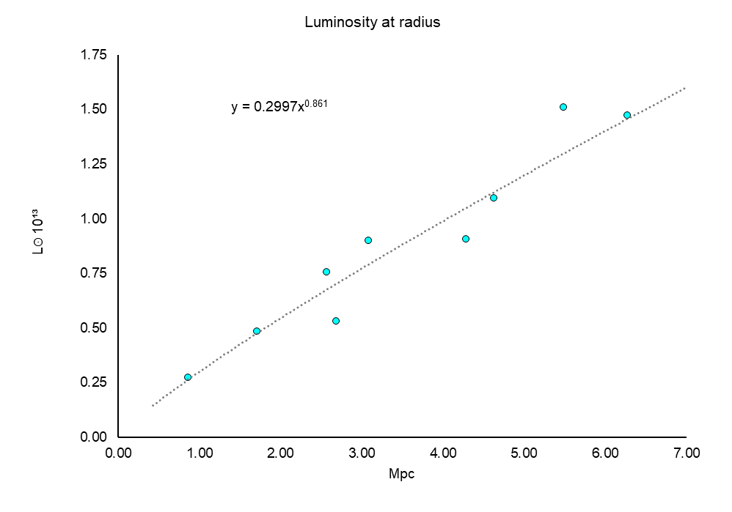
Figure 23. Luminosity versus radius for the Coma Cluster

80
Because of when they were written, a number of the studies use outdated values for the Hubble constant which affects the values of mass, radius and luminosity. These values will therefore be corrected wherever possible using the standard modern value of 70kms⁻¹Mpc⁻¹. Mass and assumed radius scale with the ratios of the constants and luminosity of course with the ratios squared. However, because there could be unknown compensating factors incorporated into the analysis done in these papers, an average of corrected and uncorrected values will be used to minimise overall bias. Reporting cluster mass is apparently fraught with technical difficulties [126], so it is hoped that the process of modelling a spread of different datasets produces a more balanced output. In addition, extremely high or low values of mass or luminosity which are incongruous with the rest of the dataset have been excluded.

Just as with the galactic model, neutrino luminosity is calculated as 6% of bolometric luminosity with continuous emission filling concentric spheres. The neutrino mass is derived from this using the same constant as for the galactic model, and then (lower estimate) 20% is added on to account for luminous baryonic mass and the intercluster medium [127]. The resulting values are then compared as a percentage of the trendline mass at 1-10Mpc radii.

Table 3a. Uncorrected neutrino gravitation

Row K shows the predicted neutrino mass divided by the (actual) trendline mass. Clearly something is wrong with up to 84 times too much mass at 10Mpc! Looking back to the supernova chapter, a decay function for antineutrinos was derived by comparing detected vs emitted (theoretical) energies.

8.2 RESULTS OF ENERGY LOSS FUNCTION APPLIED TO NEUTRINOS

What if this function is applied to the cluster neutrinos, can it correct these values which are too high? The function is integrated to produce an average ratio over 1 at the given distances (row L) and the neutrino mass is multiplied by these to correct the values.

81

Table 3b. Corrected neutrino gravitation

Row P shows the total mass calculated after correction for energy loss as a percentage of the trendline function. An error of only some 1% is a very satisfactory result as it shows that rejecting a linear function was in fact correct, and that the exponential function applied to neutrinos works.

The fact that the result was calculated using exactly the same value of constant, $Y=1.15×{10}^{-6}kg/j$ and the same 6% neutrino luminosity as galaxies NGC5005 and NGC1560 but with the simple addition of a energy loss function derived from a supernova, gives very strong support to the virtual mass proposal.

It produces robust, accurate and repeatable predictions from conventional existing nuclear physics combined with a conventional existing particle.

82
9 UNIVERSAL EXPANSION AND THE HUBBLE TENSION

Take an optical image of a distant galaxy and it's shape and distance from us will not seem to change, it evolves on a timescale so much longer than the exposure that it appears to be static.

At the time of General Relativity's launch in 1915 there was no good reason to assume the entire universe was anything other than static so Einstein added a cosmological constant term to the field equations to balance out the pull of gravity. He was quoted as saying that this was his 'biggest blunder' when around fourteen years later Edwin Hubble announced that measurements showed that the universe is expanding. This was somewhat ironic given that Hubble had used the relativistic doppler effect or red shift to measure the recessional rates of galaxies, something that relies on Special Relativity. Einstein dropped his cosmological constant, something which it turns out is in essence correct but for reasons unknown at the time.

That the universe is expanding outwards implied that it would have been all at one place in the past in a highly condensed state and this led to the Big Bang theory. This was thought to have flaws in it's predictive ability, something that will be examined shortly, so then inflation theory was added and later new inflation to correct the Big Bang model. Cosmologists were however in for a very big surprise when in 1998 the High-Z Supernova Search Team and 1999 with the Supernova Cosmology Project announced their findings. Rather than gravity slowing the expansion down, something appeared to be speeding it up. Dark energy was born and Einstein's cosmological constant was back!

9.1 OBSERVATIONAL PROBLEMS PROPOSED BY NEW INFLATION

At the time of the very beginning of the universe, thought to be the smallest meaningful length of time - the Planck time of ${10}^{-43}s$, all four fundamental forces are thought to have been in a unified state, a state of unbroken symmetry. In in new inflation, gravity separates first and leaves the electromagnetic and strong and weak nuclear forces still symmetric, something which Grand Unified Theories or 'GUTs' attempt to describe.
The new inflationary model is based on these and proposes an exponential expansion of the universe between ${10}^{-36}s$ and ${10}^{-32}s$ to account for the observed features of the universe better than the basic big bang model.

These 'problems' are:

1. Why the universe is relatively close to being spatially 'flat'
2. Why there was an upper limit <${10}^{16}$Gev for the maximum primordial temperature
3. Why no magnetic monopoles and other topological defects have been observed
4. Why the Cosmic Microwave Background or CMB is so uniform in temperature
5. Why density fluctuations derived from the CMB are adiabatic
6. Why despite 4 there is structure in the universe
7. Why fluctuations in the CMB are almost scale-invariant
8. Why despite 1 the universe's expansion rate appears to be accelerating not decelerating

83
New inflation appears to answer these points, but not without some serious 'fine tuning', something the authors [5] admit they are uncomfortable with. Is the theory linked to the
other universal expansion, the mysterious dark energy, or is it something completely different? Could the two be explained by one single mechanism?

These eight 'observables' have been set down because they must be sufficiently explained, points 1,2&3 can be dealt with now however, starting with 1 - spatial flatness. This results from calculating the total energy density of the universe - baryonic mass, dark mass and the contribution of the cosmological constant [128] producing a value of omega very close to 1. The result of this is that the universe should have Euclidian geometry and since baryonic mass is a known quantity, the dark mass has already been explained by neutrino gravitation and the cosmological constant is inserted into the model by hand condition 1 is automatically satisfied.

Point 2 is satisfied observationally as it has already been calculated [129] from the CMB.

Point 3 is an artifact of GUTs, theories which have not been verified and can be criticised for putting an aesthetic conceit - that three of the four fundamental forces should share the same intrinsic geometry - ahead of measured observables. While it is true that new inflation purports to solve these problems, it could be the case that these 'problems' are conveniently here for the model to solve. If these topological defects and magnetic monopoles are not to be found in the present universe, and modern studies have failed to find them, then it could be argued that the model successfully explains them away to no practical benefit, an 'unobserved observable'.
This really is a nebulous suggestion as these things have never been observed nor even any indirect evidence for them. As for the energy where the three forces are supposed to combine $\sim {10}^{16}Gev$, this is so high that it can never be tested experimentally so yet again we have an 'unobservable observable'. Supersymmetric GUTs also predict large amounts of dark matter - an 'unobserved observable'.
And as for the inflaton and the inflation field, where did they go? The prediction of ultra-superluminal expansion is so far outside of known physics it is hard to see why it was ever even considered. It is perhaps the greatest example in physics of the 'ultimate unobservable'. Because of when it occurs, essentially no-one can ever, even in theory prove inflation wrong!

What has been 'unobserved' is proton decay predicted by GUTs, currently the value of the proton lifetime is known to be $>{10}^{35}$ years or around 24 orders of magnitude more than the present age of the universe. If a central tenet of GUTs has been shown by experiment to be wrong, what does it say about inflation theory?
Untestable theories are an awkward area for physics. While they may offer the possibility of solving obscure problems, GUTs, supersymmetry and string theory all fail to deliver the deliverables - things that the Standard Model does. It is relatively simple compared to GUTs and makes quantitively testable predictions. There is no sound practical or theoretical reason to assume that all of the essentially three fundamental forces (strong, electroweak and gravity) are anything other than primitive and independent, to date, all the evidence suggests they are. The primary reason for inflation was to explain structure in the universe despite the uniform initial temperature. A far simpler explanation of this feature is given below, and so no inflation of any sort occurs at any time in the model proposed next.

84
9.2 UNIVERSAL EXPANSION MECHANISM

For this model, the assumed initial conditions are those during the hadron epoch of a Big Bang theory with physics according to the Standard Model, i.e. protons and neutrons have formed from quarks and exist in a super heated plasma along with electrons, photons and neutrinos and antineutrinos. All four fundamental forces are separate and baryogenesis has occurred leaving only matter particles (protons, neutrons, electrons).

As no inflation has occurred, the universe would be considerably older than the 1 second at the end of the hadron epoch as assumed by inflationary models. If material at the farthest edges had been accelerated to relativistic speeds and these thermal isotropic conditions would dictate a diameter of some 20 light years according to these inflationary models [130], then the age would be >10yrs. If material at the farthest edges had not been accelerated to relativistic speeds, perhaps by the strong inward pull of baryonic gravity, then the age would be >>10yrs. Other than this difference, conditions discussed will be taken to be the same as conventional models.

What is of significance during this era is that the neutron-to-proton ratio is frozen out at approximately 1:5. Further absorption of free neutrons after this freezes the net ratio observed today at around 1:7 and principally explains why the universe is mostly hydrogen but with around 25% total mass in the form of Helium 4. The equations governing the initial freeze out are [131]:
$n+v_{e}⇌p+e^{-}$ (17)
$n+e^{+}⇌p+v_{e}^{-}$ (18)

Initially the high temperature allows the reactions to go equally in either direction, this happens if the mass difference between the neutron and proton [131] is >1.29Mev. Once the temperature drops to around 0.8Mev the reaction stops and the ratio of neutrons to protons is then frozen, i.e. one unit on the left side of and eqs. (17)&(18) five units on the right. How do we get to the final ratio of 1:7? Some of the free neutrons undergo beta minus decay according to [131] :
$n→p+e^{-}+v_{e}^{-}$ (19)

Some of the neutrons combine with protons to form deuterium and following that form helium 4. How many neutrons proportionately need to decay in order to get to a 1:7 ratio? By equating a variable x, which by addition to each right side of eqs. (17)&(18) and subtraction from the left produces the correct ratio.

$$7\left(1-x\right)=5+x$$
$$7-7x=5+x$$
$$2=8x$$
$$x=¼$$
This addition comes from effectively half a neutron from the left side of eqs. (17)&(18) decaying via eq. (19) into half a proton. This produces an final particle count of:

$10.5p$, $5.5e^{-}$, $5.5v_{e}^{-}$, $1.5n$, $1v_{e}$ and $1e^{+}$

The neutrons and protons are now in a 1:7 ratio.

What is now required is to calculate an average baryonic mass density for the universe. With a mean overall density [133] of $ρ_{U}$

$$ρ_{U}=9.5×{10}^{-27}kgm^{-3}$$

the baryon fraction is approximately 5%, so baryon density $ρ_{B}$ is equal to:

$ρ_{B}=$ $\frac{5}{100}×ρ_{U}=4.75×{10}^{-28}kgm^{-3}$

dividing by the proton mass $m_{p} gives:$

$$\frac{4.75×{10}^{-28}kgm^{-3}}{1.673×{10}^{-27}kg}=0.284 nucleons/m^{3}$$

This is the matter-mass content of the average cubic metre of the universe. This cubic metre however also contains a proportionate amount of neutrino gravity and antineutrino antigravity. One can see that there is a considerable excess of antineutrinos in the above particle count and that is what gives rise to the net excess of repulsive gravity seen today.
The one neutrino cancels one of the five and a half antineutrinos, all of average energy at the end of the hadron epoch of approximately 0.8Mev, so we have in effect four and a half antineutrinos for every 12 nucleons. What is the relative ratio then of antigravity to baryonic gravity?

approximate baryonic mass for 10.5 protons plus 1.5 neutrons:

$$12×m_{p}=2.01×{10}^{-26}kg$$

approximate antimass for 4.5 antineutrinos at 0.8Mev:

$$=-Mev×J/ev×Y×4.5$$

$$=-0.8×{10}^{6}×1.6×{10}^{-19}×1.15×{10}^{-6}×4.5$$

$$=-6.624×{10}^{-19}kg$$
or in other words an outward force around 33 million times that of the inward pull of baryonic gravity! This of course adds to the already massive radiation pressure.
How the dynamics of this play out is open to question as it depends crucially on whether spacetime itself is also expanding and carrying material with it, or if it is more simply baryonic mass being thrust through spacetime by extreme negative curvature added to the radiative pressure. This will be examined in the next section, 9.3.

Although this has the general appearance of inflation, it is in fact totally unrelated to it by nature and requires no recourse to the speculative unprovable physics discussed above.

It gives a natural explanation for the points 4-7 made above. Taking these in turn:

4. The reactions freeze out at one temperature of 0.8Mev so its to be expected that the
CMB ends up with a uniform temperature. Also, all the material would have been
expanding more slowly before the reactions started and hence would have been in
thermal contact initially. Setting a number of initial conditions to precise levels is
difficult and equates to fine tuning, but having uniform temperature as the only initial
condition is easy [134].
5. The action of an evenly distributed force is the same physically as a gas with uniform
pressure so the expansion is therefore adiabatic, agreeing with the currently accepted
Friedmann-Lemaître-Robertson-Walker (FLRW) metric.
6. The temperature going through the hadron epoch would not be completely even, there
would have been some variation as seen in the current CMB. Regions that cooled
slightly quicker would expand at a greater rate than their surroundings, and so bubbles
of lower density would form compressing and re-heating their surroundings. These
regions would then expand once they'd cooled and would push back against the earlier
bubbles. Once the process stopped there would be denser regions in the space between
the bubble boundaries and this is where the first stars would form leading later to of
course galaxies. Initial variations in temperature would therefore be amplified.
7. In a gas of relatively uniform density the speed of sound is also uniform. In the absence
of obstacles there would be very little diffraction occurring and without boundaries or
regular obstacles harmonic resonances could not build. Variations in temperature and
pressure would therefore be stochastic leading to the expanded bubbles having a
random size distribution, this in turn explains why variations in the CMB are scale-
invariant.

9.3 THE HUBBLE TENSION

With antineutrinos driving the Universe's expansion there is one observable remaining that requires explanation 8 - why is it expanding faster today?

Although the initial expansion would have been fierce, today the Hubble constant of 74.03kmsˉ¹/Mpc [135] is relatively gentle but it is still ~10% greater than the figure derived by Planck from the CMB at a time 380000 years after the Big Bang of around 67.4kmsˉ¹/Mpc [136]. This is driven by the so called dark energy. If the antineutrino is indeed responsible for this, how could the rate now be increasing with time? A potential answer is investigated by considering all the main factors that govern gravity in the Universe.

87
With inertia, material in the Universe needs to be acted on by a force to accelerate it and Relativity puts a limit to the ultimate speed that can be approached. A relatively uniform distribution of antineutrinos would create relatively uniform antigravity, this behaves in a similar way to a gas under pressure. Material near the centre would barely move as it would be acted on evenly through 4π radians. The further material was from the centre the greater the outwards push from the origin and hence the faster it would accelerate. Ultimately material farthest out could be accelerated towards but not to or past the speed of light.
Under these conditions, it is not spacetime itself that is expanding as per dark energy rather it is the curvature of spacetime that is being altered.

Gravitational waves travel through spacetime at the speed of light, but this doesn't say anything about how spacetime itself behaves or how it is generated or even if it has always just existed. Hubble's law says that the further an object is from us the faster its recessional rate. This is in accordance with the above proposal where curvature produced by antineutrinos pushes mass outwards through spacetime, which in itself is not growing.

To calculate the rate of the Universe's expansion a rate of antigravity starting at the Big Bang needs to be derived. To do this requires starting by making a reasonable assumption - that all the baryonic material today was created during the Big Bang. By comparing the ratio of nucleons to excess antineutrinos, their present day energy can be calculated. By comparing their initial energy of 0.8Mev with the present day value, equation (10) will then give a value that can easily be converted from kiloparsecs into time.

Let $ρ_{de}=$ present day energy density of antineutrinos= 68.3% of total Universe density from the Dark Energy Survey [137]

$ρ_{de}=ρ_{U}×0.683=6.498×{10}^{-27}kg/m^{3}$

From above, baryon density $ρ_{B}=0.284 protons/m^{3}$

Ratio of antineutrinos to nucleons $=\frac{4.5}{12}=0.375$

Antineutrino number density $n_{v_{e}^{-}}=0.284×.375=0.107/m^{3}$

$$\frac{ρ_{de}}{n_{v_{e}^{-}}}=\frac{6.498×{10}^{-27}kg/m^{3}}{0.107/m^{3}}$$

$$=6.073×{10}^{-26}kg/antineutrino$$

Dividing by the energy constant Y for the neutrino/antineutrino gives

$$\frac{6.073×{10}^{-26}kg/antineutrino}{1.15×{10}^{-6}kg/j}=5.281×{10}^{-20}j/antineutrino$$

Converting to electronvolts gives a value of

$$0.329ev/antineutrino$$

88
Equation (10), the energy loss function is

$$E_{d}=E_{s}e^{-0.0105d}$$
where
$$E_{d}=0.329ev/antineutrino$$
and
$$E_{s}=0.8×{10}^{6}ev$$
rearranging (10) gives:

$$\frac{ln(\frac{0.329}{800000})}{-0.0105}≈1400kpc$$

which at the speed of light would take around 4.5 million years.

This is considerably more at around 12 times of the age of the Universe than the time of ~380000 years for the Planck derived value for the Hubble constant. The antineutrino energy was therefore in transition during this time reaching it's present day value of 0.329ev on the last four data points shown ( a logarithmic scale doesn't work graphically).

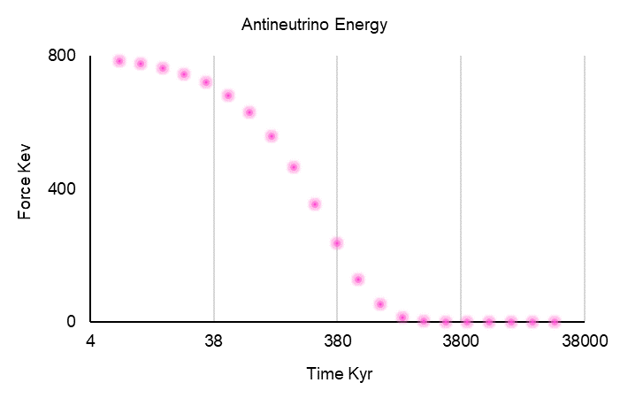

Figure 24. Antineutrino energy over time, early history

Is this curious result just a coincidence, or as is probably more likely the case an important factor in the Universe's evolution? What does this say about the expansion rate increasing to it's present day value? Can it explain point 8?
To give a definitive answer to this question would require a full-blown numerical simulation with many variables and powerful computing facilities to run the simulation on, clearly way beyond the scope of the analysis here. Instead, a simple calculation will show that the antineutrino energy function above is compatible with universal expansion. It is important to note that this is just a test and no more, it is intended to show that the shape of the antineutrino energy curve could be used to model the so called dark energy, or rather that it is not wholly incongruous to it.

89
The three elements that produce gravity will be included:

1. Baryonic mass at a constant amount since the big bang of 4.9% [137]
2. Relic antineutrinos at 0.329ev, constant since the big bang, 68.3% [137]
3. Stellar neutrinos at an amount varying relative to the above, 26.8% today [137]

These stellar neutrinos are modelled using segments of two different sine waves that join with the same gradient producing a rapid rise to 3.0Gyr, followed by a gradual tail off to the present day value shown in figure 25. below. The units given are in electronvolts relative to the antineutrinos which would amount to their numbers (fewer) and total energies (higher upon emission). The attractive force of baryonic mass is also included in units of ev's proportional to the antineutrinos, and is added to the neutrinos. Although the energies are correctly shown as positive in value, the neutrinos and baryons combine to produce attractive gravity the antineutrinos repulsive, taking into account one relic neutrino cancelling one of the five and a half relic antineutrinos.
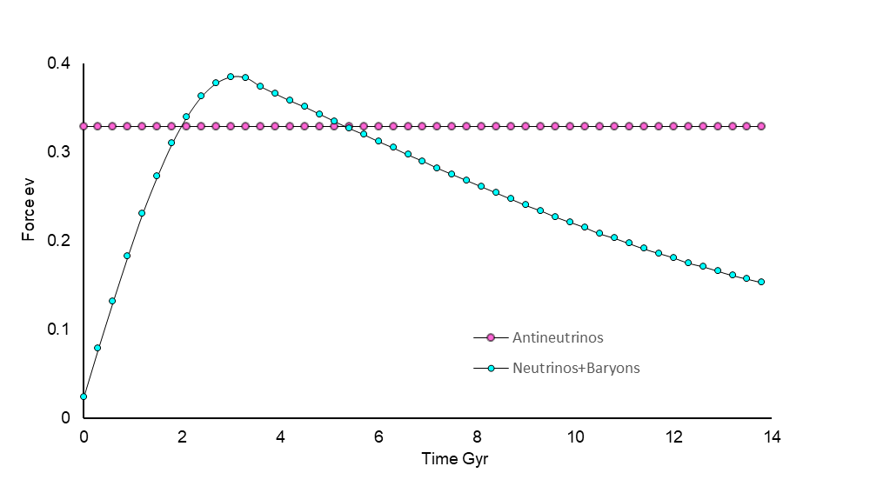
Figure 25. Stellar neutrino and baryon energetics relative to relic antineutrinos

The rapid rise reflects the rate of star formation [138] and type of luminous blue stars in the dense early universe followed by a tail off to the present day, with mature galaxies and a greater population of smaller redder stars.
To calculate the relative expansion rate requires taking distance into account, something which is performed below using arbitrary units to show the ratio of velocity that the three elements produce between them when acting on baryonic mass M. This value of velocity is compared with eleven values derived from the CMB or observations of objects related by the cosmic ladder.
Let:

A=acceleration
D=distance
E=energy in ev's
F=force
M=baryonic mass
T=time
V=velocity

Then substituting in eq. (5):

$$F=MA∝\frac{E}{D^{2}}=\frac{GYE_{v}M}{R^{2}}$$

$$A∝\frac{E}{D^{2}M}$$

$$V=AT$$

$$V∝\frac{ET}{D^{2}M}$$

$$D=VT$$

$$V∝\frac{ET}{V^{2}T^{2}M}$$

$$V^{3}∝\frac{E}{TM}$$

Putting M=1 unit leads to:
 | $$V∝∛\frac{E}{T}$$ | (20)

The values of E in electronvolts and T in Gigayears are put in arbitrarily and factored to produce V in units of kmsˉ¹/Mpc as per observations.

The Planck value of 67.4kmsˉ¹/Mpc is used as the starting velocity for the model as there is a gap between that and the next data value shown at 2.85Gyr [139] given the graduations of 0.3Gyr. Other data is used [140][141] and converted from red shift [142]. Compared to the first interval at 0.3Gyr, a time of 380Kyr is effectively as close to zero as makes no difference, so without rigorous justification the Planck value will be used as the starting point.

Each value of velocity is calculated in appendix 12. with each change in velocity being added to the previous interval to produce an expansion rate that rises, falls and then rises again closely matching measured data values.

91
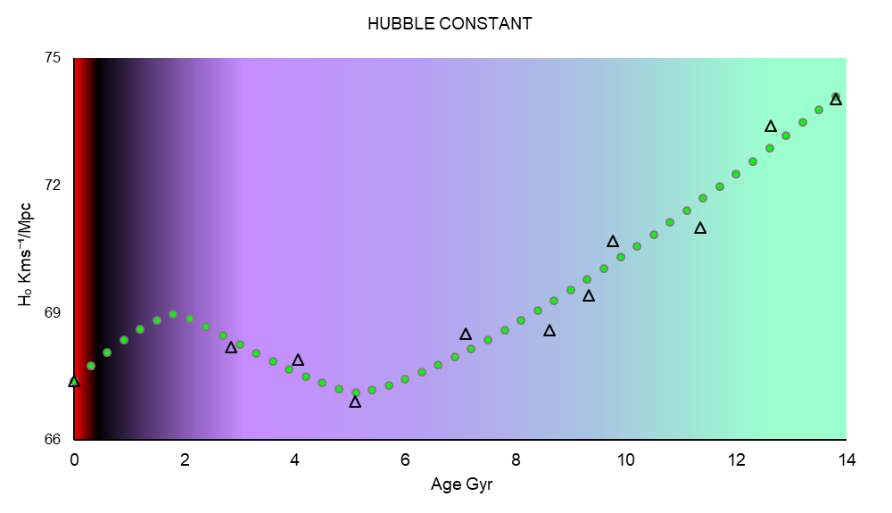

Figure 26. Model of neutrino/baryonic/antineutrino universal expansion rate, modelled
curve (green circles) and measured data (black triangles)

9.4 CONSIDERATIONS OF THE 'DARK ENERGY' MODEL

This is the first attempt to model Universal expansion using virtual antimass, produced by an excess of relic antineutrinos created during the proton-neutron freeze out period of the Big Bang.

Physical values have not been used as they would have required a much more complex computer simulation, the alternative is to compare relative values as a ratio of force, distance and time to produce a curve.

Although criticism could be made that the values of stellar neutrinos having been 'put in by hand', it is true that they are quite reasonable and match observation in the broadest sense in that they only vary by a ratio of less than 3:1 from peak to their present day value. Another point in their favour is that they only rise once before falling back to their present value, in other words the test curve is not convoluted but simple, and hence uses a minimum of physics to achieve the result.

Antineutrinos should be constant if the calculation from the proton/neutron ratio is indeed constant, as should baryonic mass. The three forces should therefore be predicted to a reasonable degree of relative variance and not be out to many orders of magnitude like the cosmological constant problem or vacuum catastrophe. This model completely removes the need for troublesome inflation and also provides a natural explanation for each of the eight conditions outlined above.

92
The importance of removing the need for inflation as per the ΛCDM model cannot be overstated. This model explains structure in the Universe easily, with three feedback mechanisms amplifying initial anisotropies up to extragalactic scales. First the rate of the freeze-out reactions is temperature sensitive, two these cause re-heating of the surrounding areas and three, there would be a certain amount of time dilation associated with the different regions.

The model also takes into account the effects of stellar neutrinos and their virtual gravity, something which accords well with the star formation rate and small contribution from baryons. The mystery of accelerated Universal expansion now has a explanation which is at least viable.

It is therefore proposed that the background of relic antineutrinos is the mechanism for
dark energy

93

10 DISCUSSION

The key findings of this report for neutrinos and antineutrinos are:

1. They interact directly with spacetime distorting it
2. The effect is proportional to their energy
3. This effect drops with distance reaching a base energy of around 0.3ev
4. The energy loss is best described by an exponential function
5. Neutrinos have a positive modulus and antineutrinos negative
6. They are both massless and uninfluenced by the spacetime they distort
7. They solve for a wide range of astrophysical objects using the same constant

The whole idea of neutrinos producing gravity was initially postulating that as they are present around regions of high gravitation i.e. galaxies and the so called cosmic web, they might actually be the source of this gravity. Various possible explanations for the effect were analysed leading to point 1 which turned out to be the most consistent answer. A preliminary trial of the idea was carried out (prior to this report) by modelling the rotation of the Milky Way where a scalar field successfully corrected the rotation curve using baryonic mass plus neutrino luminosity. This indicated that a more serious investigation, this report, was indeed potentially worthwhile.

While the result was exciting it was also simple, something which often bodes well for scientific theories. A good example of this was explaining the retrograde orbit of Mars using complicated concentric celestial orbits around the Earth, whereas Aristarchus proposed that the planets orbited the Sun instead.

There was however a vital factor missing in the proposal for neutrinos - the energy loss function.

Without this gravity would start in the early Universe with only baryonic mass and then build and build, whereas the 5/6th or so dark matter was thought to form at this time and remain constant to the present day. With neutrinos, either there would be too little gravity early on or too much now. Some means of dissipating the effect as it travelled out into the voids of space was clearly needed. The importance of this to this theory cannot be understated, it is vital.

Without this, the collapse to a quark core in SN1987 would not have an energy level high enough to form a black hole leading instead to an exposed quark star, something which has yet to be observed. The accreting black hole in M87 would produce around the same effective mass at the luminous edge of it's galaxy as all the stellar mass combined. There would be no way to explain the gap in the 7:35 detections between the chiral bag pion emission and the thermal cool down, so the actual nature of the physics involved would have been missed.
Calculations for the Coma Cluster would have yielded over 80 times too much gravitation. Dark energy from 0.8mev antineutrinos would be the only significant gravitational force in the Universe today completely dominating everything else and relentlessly pushing everything apart.

95
Admittedly the necessity of energy loss was not considered during the early stages of technical work, it was calculated by investigating the antineutrinos detected at the LSD time. It was however found by applying the same meticulous standards applied in criticism of the 'main' detections at 7:35 leading to the formation of a neutron star onto the earlier data, and so was not missed by any lack of rigour.

The issue of energy loss does however lead to a difficult empirical question - how to measure it accurately and show that it has indeed got an exponential function or otherwise.

As the effect travels through space at the speed of light and declines (in Human terms) slowly, the only comparisons that can be made are between theorised emissions by celestial bodies and detections made here on Earth i.e. we can only ever have two data points. Distances on Earth are far too small to perform direct experiments so only the statistical analysis of say many rotation models for very large galaxies can provide an answer.

The next obvious question is how do we know what the value of the constant Y actually is? In theory it should be easier to answer observationally, for example discrete sources of neutrinos with relatively well known energy levels have been observed like massive high luminosity stars. It is known that very wide orbit binary stars have unexpectedly flat rotation curves, similar to galaxies [143]. If an exceptional example of such a system could be found then the constant could be measured with a reasonably high degree of precision.

To give an example, if a star of mass $\sim 50Mʘ$ and ${10}^{6}Lʘ$ had a small binary companion at around 2/3Lyr then the total mass of the more massive star would appear some ten times it's baryonic mass. Such a system would however need to be completely isolated as to be devoid of external gravitational influences and actually be close enough to be observed in detail. If the value of $Y, 1.15×{10}^{-6}kg/j$ turns out to be a reasonable estimate, then given the tolerance involved in astronomical measurements it may not turn out to be a critical problem anyway. The value of G, the gravitational constant was deduced in a similar empirical way.

The third interesting neutrino constant is the minimum value it would drop to, if the universal expansion calculation is right, of about 0.3ev for antineutrinos. It is around six orders of magnitude lower that the most sensitive modern detectors can study but around four orders of magnitude greater than the estimated energy of the cosmic neutrino background [146]. This means that it is not presently possible to directly detect these neutrinos and antineutrinos as discrete events in an experiment.

It may however be possible to infer the neutrino's minimum value, if it has one, indirectly. One such way might be from for example a large scale effect, like the near-infrared excess that might be attributed to neutrinos and antineutrinos annihilating. It is estimated [144] that from the big bang there are around 336 of all six species of neutrino inhabiting each cubic centimetre of space today. They could react via virtual weak force particles and produce two real photons each of wavelength around 3.8um if the colliding antineutrino and the neutrino both had an energy of 0.329ev. This is quite close to a peak in the near infrared excess at 1.5um. The actual calculation would of course be far more complicated than this as it would involve accounting for all neutrinos and antineutrinos and their various energies say from

96
proton-proton and carbon-nitrogen-oxygen chains or black holes. Then values of distance, volume inhabited, energy loss, discrete sources and red shift of the electromagnetic detections would have to be factored in.
The outcome could be of significance if antineutrinos and perhaps neutrinos too can be proven to posses a minimum value of energy and hence virtual mass, possibly that the values are discrete or even quantised.

The reason this could be important is that attempts to renormalize quantum field theory and apply it to relativity run into difficulty especially with regards to the zero in the resulting integrals producing infinities. Given that neutrinos seem to interact directly with spacetime and appear not to have a zero value of energy but a minimum instead, could this be a way of removing a large obstacle between particle physics and the seemingly featureless internals of spacetime?

The integrals suffer this zero point problem from the application of distances, but as cross sectional area is related to energy it too might have a minimum value which loosely speaking would equate to it's diameter. Just making a very approximate calculation gives an area of about ${10}^{-51}{cm}^{2}$ giving a 'diameter' of $0.3×{10}^{-28}m$ or 0.0003 yoctometres, comfortably around seven orders of magnitude greater than the Planck length so not in trouble in that respect.

Interestingly, calculating the minimum energy for the antineutrino of 0.329ev produces a virtual mass analogous to the rest mass of other Standard Model particles of around 34Gev, if such a thing can be treated as a meaningful quantity. It is still an intriguing result given that it confers with the masses of some of the heavier standard model particles far better than the current measurements of <0.16ev (under the assumption that neutrinos must have mass to oscillate). In this model they don't need mass as they oscillate by direct interaction with spacetime.
It is also a noteworthy observation that neutrinos seem to experience the weak force only and produce gravity, while the Higgs boson gives particles mass via weak force interactions. The results from the study of black holes show that the virtual mass reaction occurs only in one direction, spacetime does not affect neutrinos or antineutrinos even slightly. This of course avoids any undesirable feedback between the two.

What then is the nature of this interaction? As was stated, it can't be the energetics of the neutrino in the same way as virtual gluons contribute around 99% of the mass of protons and neutrons, they simply don't have anywhere near enough to explain galactic rotation. It might be that the neutrino's energy has no direct effect on spacetime as occurs for other particles, no experiment or observation has ever proven or disproven this. What is know is that they have a cross-sectional area related to their energy as well as chirality.
If left-handed neutrinos and right-handed antineutrinos affect spacetime in the same way but with opposite polarity, then it suggests that spacetime also has some internal structure that has a rotational element associated with it. It is also noteworthy that there are three dimensions of space as well as three flavours for the neutrino to oscillate between.
10.1 SIGNIFICANCE OF NEUTRINO VIRTUAL MASS TO ASTROPHYSICS

The key findings from the case studies will now be assessed, these are:

1. A scalar virtual gravity field is created from stellar neutrinos replacing dark matter
2. Data from SN1987 has been reassessed to produce a completely different outcome
3. A new understanding of black holes is obtained explaining many of their mysteries
4. The neutrino energy and loss functions are multiplied to match Coma Cluster gravity
5. A model for dark energy is given with antineutrinos providing the outwards force

Solving the flat, fast rotation of galaxies problem has had a myriad of ideas thrown at it, not all of them well considered.

In many cases MOND theories provide the correct mathematics but do not seek to explain the mechanism by which it happens, relying instead on the premise that it's just the way gravity works. Given this, it's greatest success - showing the link between baryonic mass in galaxies and overall gravitation - ends up being it's downfall, like in the Bullet Cluster.

Many ideas for dark matter have been proposed through the years but most have been ruled out leaving only wimps and some very esoteric alternatives, none of which have succeeded. If a consistent theory of say wimp or axion properties had been produced along with a consistent model for halo density profiles, it would have been possible to say that there was some underlying physics, instead each individual dark matter halo seems to have been treated as a separate case and is botched from one galaxy to the next.

Of a selection of galactic rotation curves measured during this study, the majority displayed a declining stellar mass after around half the virial radius i.e. rather than encountering more stars as the distance from the galactic centre increased, a significant portion of the stars appeared to vanish! Presumably this was applied as a 'correction' to ensure the dark matter halo fitted. Worse than that, sometimes for the same galaxy the stellar mass was put in as two or more stellar profiles each quite different to the other. A stellar profile for any given galaxy can only come from actual astronomical values to produce datapoints of mass at radius, it can't just be put in by hand to suit.

Then there is the issue of not one single dark matter particle ever having been detected...

Nor indeed have unconfined, extragalactic clumps of dark matter ever been observed by their gravitational lensing effect. If dark matter's role is to create gravitational wells for galaxies to form in, then by proxy to the above, dark matter theory is saying that all dark matter forms into clumps necessary for all galaxies to exist... Except for dwarf galaxies DF2 and DF4, both of which appear to have lost their dark matter into space through collision. If this stuff only interacts with ordinary matter by it's force of gravity, then given the number of galaxies in the universe then it would seem overwhelmingly likely that at least some left over dark matter would have escaped into the voids of space and even if initially diffuse, at least some of that would have eventually formed noticeable clumps. This is after all what dark matter is meant to do, yet all extra-baryonic gravitation has only ever been observed in and around galaxies i.e. it is always associated with luminous stars.

98
Neutrino gravitation is quite different. It starts with a particle that actually exists and proposes the simplest possible explanation of how the observed effect happens. Two example galaxies were produced with both rotation curves matched accurately using precisely the same physics in each case - stellar mass and density profile, gas and dust and a scalar field from neutrino luminosity. No fine tuning was required, the same constant of multiplication $Y=1.15×{10}^{-6}kg/j$ was used for both, the same neutrino luminosity of 6% and the same mathematical model.
Given that an identical system was used for one galaxy with real measured values and then transferred to a different galaxy using it's real measured values shows real consistency.

That wasn't the decider however. The real tell tale sign is that it explains the difference in rotation between redder and bluer galaxies by the empirical Tully-Fisher colour relation.
There is no other explanation for this effect other than the difference in neutrino luminosity from cno an pp chain fusion. It even predicts a theoretical limit to the difference too. For this to be a coincidence is so unlikely as to be pointless debating, therefore neutrino gravitation is the most probable answer to non-baryonic gravitation. On a similar note, ultra-diffuse low surface brightness galaxy AGC 114905 is thought to have no dark matter from it's rotation, but probably the correct reason is simply exceptionally low neutrino luminosity.

Supernova 1987 turned out to be an absolute goldmine of information. In fact it really is the beating heart of this theory producing the energy loss function, antigravity, the first corroborated detection of gravitational waves and the birth of a neutron star and then a black hole. As was explained above, no energy loss function means no theory. It would seem that with the exception of a few dissenting voices, most of the data was either dismissed or ignored and a huge opportunity was lost in the rush to vindicate core collapse theory causing the formation of a neutron star. Which still hasn't been found...

The process of meticulously comparing the detailed predictions of a sample of core collapse theories found significant differences between them and the actual detections showing that unless either the theories or detections were wrong, it was unlikely that a neutron star formed at 7:35. The same rigour was applied to the LSD time data and it was found that there was no known physical process that could explain the detections at that time other than a core collapse.
Antineutrino detections were again compared to theory and this time found curiously to be lower. Values for a typical neutron star were used to calculate it's red shift and it was found that this alone could not account for the loss of energy. Rather than reject the mismatch as being a mistake, the theories and data were simply taken at face value, initially the idea seemed rather odd and means were sought later in the chapter to verify it.
This was found by studying the energetics at 7:35, and as the energetics were not infinite a singularity couldn't have formed but red shift was, and thus a black hole had formed - it showed clearly that antineutrinos could escape. They had to therefore be both unaffected by spacetime and massless. It clearly showed that the central massive object in a black hole could convincingly be a quark core, not a singularity.

Returning to 2:52, the implications of releasing the calculated amount of energy from core collapse as thermal neutrinos and antineutrinos suggested that the only result would be a black hole, that being the case then any detections after that point would be impossible.

99
If the constant Y was set too high then retrospectively attempts to correct galaxy rotation curves would fail. The only possible way to reconcile these two scenarios was the astonishing idea that antineutrinos must be producing antigravity

As was seen later this would be essential in preventing quark cores from further collapse and was therefore essential in preserving this description of a black hole and all it's facets, it was also the key to producing a plausible explanation for dark energy.
It was also of great importance to the study of type II supernova themselves. It finally gave them the chance to actually explode!
Antigravity also led to the intriguing possibility that the r-process, if it does occur in supernova cores, could occur before the final collapse rather than after as had traditionally been assumed. In addition, the curious data of gravity waves and antineutrinos before 2:52 might have a mechanism driven by neutron decay. It will be very interesting when the next type II event is detected whether the same pre-collapse pattern occurs or if it is quite different.
The r-process and pre-collapse suggestions are very speculative and only intended to be interesting and thought provoking - and to be taken with a large pinch of cosmic salt!

From a research point of view it is clear how valuable studying core collapse supernovas can be. Plenty of black hole mergers have been detected but only one supernova, SN1987A. The question is, can we catch another one when it happens? Gravity waves, neutrinos and antineutrinos all have to captured in real time with energetics and directional data included for a full picture to be realised, but this is heavily reliant on the supernova's distance.

As was seen for SN1987A a loss of antineutrino energy of 40% happened over a relatively short distance of 51Kpc. The energy loss function puts quite a strict limit on the distance a core collapse could be detected even with some of today's equipment operating with a threshold at a sub Mev level. Half the threshold and you only increase the range by 66kpc so even our nearest large neighbour the Andromeda galaxy is out of range. Presupernova neutrinos from the final stages of nuclear burning may be detectable and provide an alert of a few days of a pending core collapse [145] although the distance would be limited to ~1kpc.

Modern interferometers are vastly more sensitive than the room temperature resonant bar detectors in operation during SN1987A and should have a greater range than the neutrino detectors for picking up gravity waves from neutronisation. These could help fill in some of the gaps in knowledge of core collapse as well as providing an alarm of a few hours before the shockwave reached the star's surface. Their directional ability when run as a network would allow optical and other electromagnetic telescopes to point in roughly the right direction and capture the luminous supernova from the very beginning.

Chapter 6 used the quark core black hole proposal to examine how this would change our understanding of black holes, how they behave and what that means for their place in the Universe.
By lining up the data of calculated mass versus distance for two accreting supermassive black holes in galaxies M87 and M104, it was found that the straight line increase in apparent mass exactly matched predictions of the new neutrino physics. It also finally knocked the idea that neutrinos have mass on the head and reinstated the Standard Model's account of them being massless. This one result alone may well make difficult reading for all the multi-million pound experiments planned and currently running to try to find what the neutrinos mass or mass squared difference is. Just like the null detection of dark matter, this will presumably change the type of neutrino experiments being done.

Other features of black holes were examined, like the mass gap and natal kicks, but probably of most overall importance was why they have this linear increase in mass. It would seem that it could greatly accelerate early galactic formation and produce the Universe we see today and addresses the shortcomings in this respect of the ∆CDM model.

The concept of whether a quark-gluon-plasma core was a realistic physical construct was tested, and it was found that actual experimental results done in particle accelerators helped confirm that it is indeed possible. Pressure calculated for an extreme qgp core was found to be comfortably accommodated by this state of matter. Real particles and real physics could explain the interior of a black hole and remove the need for singularities.

This result lead to one last observation about black holes that seems to have captured everyone's imagination more that just about any other topic than dark matter - the dreaded information loss paradox.
Ideas of quantum hair, the no hair theorem, wormholes, holograms, singularities, white holes and entropy going up then coming back down are no longer necessary now that the bizarre world of real physics has finally been reinstated inside black holes. It turns out there never really was an information loss paradox to worry about in the first place.

Chapter 7 was a kind of thought experiment where it was asked what properties would satisfy the requirement for a stellar generated particle that would create the effect of virtual mass in and around galaxies.
Properties of mass, velocity, charge ubiquity etc. were compared with the specification and it was found that the neutrino is obviously the right particle for the job. That the neutrino is in fact the cause of most galactic gravitation could have been worked out from this starting point, but the all important energy loss function would have to be predicted too. Studying a statistically significant sample of very large galaxies (>100kpc radius) could have produced the loss function.

Although chapter 8, the Coma Cluster is fairly short, it is really where the circle comes to completion by applying both the virtual mass constant Y to the energy loss function using the same 6% neutrino luminosity as the two galaxies from chapter 4. A significant sample of mass and luminosity data was modelled, and when the neutrino functions were applied to this data variations from the model came to a difference of around only 1%.

This calculation was done to illustrate all the facets of neutrino gravitation working together as one large and complete system. Most importantly it verified the energy loss function for neutrinos, both for the values calculated from antineutrinos but also that the mathematical function takes an exponential form justifying the ansatz used in chapter 5. For all the component parts of the theory to come together so successfully in one place, without any modification to the mathematical functions derived or the neutrino luminosity value, and applied to accurately modelled real data shows that it is a consistent and logical gravitational theory.

There is no other gravitational theory today which has the internal consistency to predict both galactic and cluster motion, and most importantly the ability to make repeatable predictions based on actual physical values.

The Hubble Tension or dark energy problem was the subject for chapter 9.

Before proposing an alternative, the rather dire problems associated with the ΛCDM model and new inflation were addressed. These stem from Grand Unified Theories which predict proton decay, magnetic monopoles, topological defects and large amounts of the as yet undetected dark matter as well as the need for a new fundamental force to account for inflation. All of these are experimentally null and void.

The idea of inflation which appears ex nihilo and then vanishes without trace just as quickly succeeds in offering an explanation for structure in the universe, but at what cost? Essentially it's a get out clause - 'we don't know', but without it any conventional Big Bang model fails.
Antineutrinos do offer a simple and intuitive explanation for structure due to the proton-neutron freeze out reactions described by equations 17&18 being highly temperature sensitive. Slight variations in temperature would amplify variations in density and produce 'bubbles' of lower density with regions of higher density in-between. Look at any large region of space from an engineering perspective and it looks quite like a piece of open-cell foam.

In total eight conditions were specified (p83) that any cosmological model would need to meet and for the first seven, some have been verified experimentally, others would be model dependant.

Point 1 spatial flatness has already been shown to be very close to a value of 1.
Point 2 has also been derived from the CMB as being <${10}^{16}$Gev.
Point 3 is as discussed above.
Point 4 the uniformity of the CMB temperature is easily explained if everything in the
universe was initially in close proximity following the same physical rules.
Point 5 that the expansion is adiabatic from the FLRW metric is interesting because it
allows any description to take on the form of a gas under pressure exerting an
outwards force, something which virtual antigravity does well. It is also
interesting as it ties in with the property of the antineutrino derived from the
black hole that formed during SN1987A in that antineutrinos do not experience
redshift. If they did, then universal expansion would not be adiabatic.

102
Point 6 is as above removing the need for inflation.
Point 7 scale invariance would automatically follow from 6 if initial variations in
temperature were also scale invariant.

At the time of writing, point 8 - accelerated universal expansion has not been resolved definitively, although the action of relic antineutrinos acting against stellar neutrinos and baryonic mass was shown in a basic model to have the potential for a solution.

By working 'backwards' the energy and value of virtual antimass was derived from a present day value of 'dark energy' given by the Dark Energy Survey. This appears to drop over a few million years via the energy loss function and then stabilise at around 0.3ev or so giving the appearance of so called dark energy. Varying stellar/galactic neutrino energetics were modelled from early blue neutrino luminous stars to the present day redder, more
mature populations. By adjusting the neutrino energetics using a simple model they produced virtual gravity which moderated the outwards push of the antineutrinos and the inward pull of baryonic mass. These were shown to be able to match a set of eleven distinct values from standard candle measurements and those derived from the CMB.

While this doesn't necessarily settle the case for explaining dark energy, it does use the proposed properties of neutrinos and antineutrinos deduced elsewhere in this study and combines them with known observables. A further benefit is that it describes the effect via distortion of spacetime and as such avoids the necessity for spacetime itself to be expanding, something which is plausible but currently has no supporting observational evidence.

Indications from this, if correct, are that with falling neutrino emissions a big crunch will be avoided and instead the universe will keep expanding getting ever cooler and more diffuse.

11 CONCLUSIONS

The humble neutrino, it would seem, holds the key to explaining almost all of the non-baryonic gravitation in the universe. To achieve this, only one simple addition to the Standard Model is required - the effect of virtual mass is added to the other properties of the massless neutrino family.

The result is a neat system where spacetime tells matter how to move, and matter tells spacetime how to curve. Curvature organises baryonic material into dense well ordered structures which in turn emit stellar neutrinos which bind galaxies together and give a flattened rotation curve.

Should the idea of virtual mass be regarded as far-fetched? Not if you consider that energy also bends spacetime, like the virtual gluons inside nucleons producing almost all their mass with only a small contribution from quark masses. The gluon is of course considered to be massless, although recent research appears to show that it has dynamical mass to create a strong nuclear force which becomes constant at large distances, in other words it too displays the property of virtual mass. Along with neutrinos and photons the source of virtually all gravitation and energy in the universe comes from massless particles.

What then of dark matter? The initial goal was to break the problem of galactic filaments and rotation down into simple well defined elements, then piece together an explanation systematically using only known facts. This was done under the assumption that as dark matter had not been proven, it didn't qualify as a fact and therefore had to be excluded from the search.
The idea of dark matter a hundred or so years ago was perfectly sensible as limitations in astronomy and theoretical physics meant that it couldn't be ruled out and in fact was the simplest logical choice. Since then, evidence has relentlessly mounted up pouring doubts on it's existence with almost all the potential candidates now ruled out by observation. That the idea has become so ingrained is not from a collective will that it is the right answer as it's numerous flaws are too well known, rather it comes from a lack of viable alternatives. The Bullet Cluster is a good example: the predictions of MOND don't work as it is applied to all baryonic matter in the system. This however doesn't prove dark matter.

What does this neutrino theory itself say about dark matter? The two galaxies NGC1560 and NGC5005 had their baryonic rotation corrected using neutrino luminosities taken as a unique function of stellar luminosity, i.e. the shape of their corrections is pre-determined and cannot be manipulated. If say the correction contained neutrino plus dark matter gravitation then the shape of the curve would be different and would not properly correct the rotation. As it uses a direct mapping from real measured physical values which are fixed, this theory must exclude all other non-baryonic gravitation, including dark matter.

Put succinctly, neutrino gravitation is simple and it works, dark matter doesn't, not even in theory. It has never been found and it is not predicted by the Standard Model so it now seems overwhelmingly likely that

Dark matter doesn't exist

105
Dark energy is more tricky however. A lot more tricky.

To begin with there is the fundamental problem of a lack of agreement about what the values of the universe's expansion really are. New techniques like measuring the tip of red giant branch stars produces values significantly different to cephids and type 1a supernovas. While derivations made from the CMB are in some cases model invariant, they do however presume dark matter and so probably underestimate the value of the Hubble constant at that time.

The model produced here was to test if the three types of universal gravitation could be aligned to replicate current values of the Hubble constant and the outcome was indeed positive, or rather at the very least it didn't rule out antineutrinos as being the possible cause of the expansion. The most important point is that there is now a new proposal for a source of repulsive gravity. All the cosmological model constraints were met, especially structure in the universe such that the difficult idea of inflation is now completely debased.

The study of black holes is popular nowadays and it can be seen that they play a vital role in early galaxy formation and hence planets and eventually life. Oddities like the natal kick anomaly can only be explained by neutrinos, but it is also true that the study of them has returned three important properties of the particle.

Antineutrinos were captured escaping from the newly formed black hole in SN1987A hence they must be both massless and unaffected by red shift, even infinite red shift. Two supermassive accreting black holes in galaxies M87 and M104 showed the effect of a linear increase in mass with distance exactly as neutrino gravitation predicts so it is also massless and unaffected by spacetime. These are hugely important results as they show that the neutrino oscillation cannot be because of mass, therefore by reduction the only logical interpretation is that it must be interacting at a quantum level directly with spacetime, which in turn implies that spacetime does indeed have internal structure.

The question that everyone really wants to know the answer to is 'what's inside?'.

The answer was provided by the collapse at 7:35 where the energetics of the radiated antineutrinos allowed a value of radius to be calculated, and as this turned out to be marginally smaller than the event horizon radius meant that a black hole had formed. Although it can't be known for certain, it seems most likely that the core was converted from neutrons into quark gluon plasma and it was shown that the resulting equation of state could sustain the central pressure of even a supermassive core. Fortunately, if this is the case, this substance has been studied in particle accelerators and a lot is known about it.

Supernova 1987A was a very special event indeed and one can only hope that detectors are ready for the next one. The type of progenitor - a blue supergiant, and the data recorded were not as expected, especially data before 2:52 if the neutron star did form at that time. It would be quite an event if another core collapse is observed where a neutron star was again detected forming and eventually became visible if it didn't then collapse to a black hole. The remnant that is predicted to have formed here is probably a non-accreting mass gap black hole as there were only a few detections after it formed. If it has blown off all it's outer

106
envelope then with nothing left to accrete it will probably never be visible. It might also be possible from optical detections to determine if the r-process had indeed taken place during the event.

What's also noteworthy of the event as it marks the first confirmed detection of gravity waves in Weber bars. It is possible that the first devices made detections as far back as 1965 pre-dating the Ligo and Virgo detections by half a century, although without correlating events these are uncertain. Unfortunately the detections have been widely dismissed, and credit not given to the physicists and engineers who built and ran them since the link between gravity waves and neutrinos was unknown. Now that the link is clear it's easy to understand why the data was thought absurd with successive gravity waves carrying the equivalent energy of thousands of solar masses!

It is incredible to think that not one person on Earth would have felt a thing as these waves passed through them, nor do we feel any sensation as billions of solar neutrinos pass through us every second. This feature of neutrinos was of course seen to be quite obvious when the question of what properties a hypothetical particle would need to bend spacetime. The property of antigravity from antineutrinos was deduced in a similar way by asking the question, what's actually needed? There is no other known source of antigravity that is verifiable, something which is transformative to our understanding of core collapse supernovas and therefore quite possibly the source of many of the heavier elements in the periodic table without which nature would be quite different.

If one was to show the Standard Model particle table to someone who hadn't seen it before, they might ask 'well what does that do and what does that do?' You could answer quite easily 'that holds the nucleus of an atom together, and that gives the other particles their mass' until you got to the neutrinos at the bottom. You could only explain that they conserve certain quantities of the weak interaction but other than that they just fly off out into space, they don't actually do anything. The uninitiated person might respond by asking you why all the other particles do something, but not that one. It would probably strike you as a surprise that you hadn't considered this before.

When Wolfgang Pauli proposed the neutrino in 1930 it was intended as a small but necessary addition to the weak interaction, not gravity, and its true nature has been hiding in plain sight ever since. Far from playing a minor role in particle physics it is really the true master of gravity. It forges all the large scale structure in the universe and it works it's magic by producing both positive and negative gravity dynamically, completely transforming our understanding of astrophysics.

Out of all the four fundamental forces it is gravity that shapes the cosmos, and here is a new description of how it occurs. This simple, elegant mechanism is an uncomplicated and logical addition to the existing laws of physics, and it manifests itself not in the form of mass, but of virtual mass creating the effect that we see as

spacetime distortion by the neutrino.

107

APPENDIX 1 Galaxy NGC5005 rotation curve

109
APPENDIX 2 Galaxy NGC1560 rotation curve

110
APPENDIX 3 Antineutrino data at 7:35am

111
APPENDIX 4 Gravitational waves and antineutrinos at Lsd time

112
APPENDIX 5 Early detections 1:47-3:43am

113
APPENDIX 6 Antineutrino energy loss functions

114
APPENDIX 7 R-process calculations

115
APPENDIX 8 Neutron star radii approximator

116
APPENDIX 9 Mass and radius values for M87 black hole

117
APPENDIX 10 Mass and radius for M104 black hole

118
APPENDIX 11 Coma Cluster mass and luminosity data

119
APPENDIX 12 Model for the energy loss function and Hubble Constant

120
APPENDIX 13 Neutrino attributes

121
APPENDIX 14 List of formulae

Page 11 $Mv=N\frac{R}{c}$ (1)

Page 11 $F=\frac{GNMo}{cR}$ (2)

Page 11 $Mvir=N\frac{R}{c}+Ms+Mg+Md$ (3)

Page 12 $V=$ $\sqrt{\frac{GMvir}{R}}$ (4)

Page 18 $M_{ν}=1.15×{10}^{-6}E_{ν}kg/j$ (5)

Page 19 $A=3.018×{10}^{28}×{10}^{(-0.4L)} w$ (6)

Page 19 $V_{b}={10}^{(-{0.1337A}_{b}-0.1136)}$ (7)

Page 19 $V_{r}={10}^{(-{0.1215A}_{r}+0.0140)}$ (8)

Page 36$1+z=\frac{1}{√1-\frac{2GM}{rc^{2}}}$ (9)

Page 38 $E_{d}=E_{s}e^{-0.0105d}$ (10)

Page 42 $E_{n}=0.6\frac{GM^{2}}{R}{(1-\frac{1}{2}\frac{GM}{Rc^{2}})}^{-1}$ (11)

Page 45 $E=\frac{GMṁ}{R}$ (12)

Page 53 $\frac{E_{q}-E_{n}}{E_{d}}=1+z$ (13)

Page 53 $R=\frac{2GM}{c^{2}}$ (14)

Page 64 $1.3×{10}^{31}(\frac{M}{Mʘ})w$ (15)

Page 70 $P_{cen}=\frac{5GM^{2}}{4πR^{4}}$ (16)

Page 85 $n+v_{e}⇌p+e^{-}$ (17)

Page 85 $n+e^{+}⇌p+v_{e}^{-}$ (18)

Page 85 $n→p+e^{-}+v_{e}^{-}$ (19)

Page 91$V∝∛\frac{E}{T}$ (20)
122
APPENDIX 15 List of figures and tables

Figures

Page 3 Figure 1. Galaxies in clusters producing gravitational lensing
Page 4 Figure 2. Contour map of mass distribution
Page 17 Figure 3. Composite rotation curve for spiral galaxy NGC5005
Page 18 Figure 4. Composite rotation curve for spiral galaxy NGC1560
Page 23 Figure 5. Progenitor star and resulting supernova following core collapse
Page 25 Figure 6. Antineutrino burst at 7:35am
Page 26 Figure 7. Antineutrino detections at 7:35am and theoretical models averaged
Page 29 Figure 8. Kam, Bak and Lsd detections
Page 31 Figure 9. Gravitational and Neutrino data taken at the Lsd time
Page 32 Figure 10. Correlations between the gravity wave and neutrino detectors
Page 32 Figure 11. Timing correlations of antineutrino and gravitational data
Page 35 Figure 12. Antineutrino energetics around the LSD time in Mev per minute
Page 38 Figure 13: Antineutrino energy loss functions
Page 49 Figure 14. Antineutrino burst at 7:35am re-scaled
Page 58 Figure 15. Mass concentration vs radius measurement for NGC3115
Page 59 Figure 16. Supermassive black hole and accretion ring at the centre of Messier 87 galaxy
Page 60 Figure 17. Mass vs radius for the M87 black hole
Page 61 Figure 18. Sombrero galaxy and black hole mass vs radius
Page 62 Figure 19. Comparison of neutron star and black hole masses
Page 69 Figure 20. X-ray and gravity wave detections from star/black hole binary system
Page 71 Figure 21. Phase of pressure versus temperature plane for non zero baryonic potential
Page 80 Figure 22. Mass versus radius for the Coma Cluster
Page 80 Figure 23. Luminosity versus radius for the Coma Cluster
Page 89 Figure 24. Antineutrino energy over time, early history
Page 90 Figure 25. Stellar neutrino and baryon energetics relative to relic antineutrinos
Page 92 Figure 26. Model of neutrino/baryonic/antineutrino universal expansion rate

Tables

Page 19 Table 1. Tully-Fisher Galaxy Rotation Velocities in kms¯¹
Page 78 Table 2. Neutrino and hypothetical particle properties
Page 81 Table 3a. Uncorrected neutrino gravitation
Page 82 Table 3b. Corrected neutrino gravitation

123
ACKNOWLEDGEMENTS

I owe a huge debt of gratitude to my father Cliff, who has put a huge amount of effort in over four years as the Editor in Chief on this paper.

As someone who worked in the upper echelons of the UK computer industry as a project manager, his knowledge and experience have been invaluable in assessing my efforts. A career of both writing and ratifying technical papers put him in the ideal position to give me an external view of the work, something which is of course very hard to get working from the inside out. Without his input the end result would certainly still have been interesting, but disjointed and much harder for the reader to interpret.

Recognising that his degree, which included mathematics and physics was good formal training but no longer up to date, he spent time reading books on physics and astrophysics with the purpose that he could more than just assist my efforts. He was able to ask questions that challenged my thinking by getting me to justify why I'd chosen that particle, that force or that order of events. The scientific principle is that you're supposed to theorise your proposed solution to a problem and then try to negate it by finding flaws or shortcomings in it. If it then passes your best efforts to disprove it, it then comes down to the scientific community to metaphorically, put it under the microscope.

It is however in reality very hard to do this yourself. Having someone else there to ask the questions that needed to be asked as well as pointing out things that I hadn't even considered has made a huge contribution to this paper. It is against this that I suggested that he deserved to have his name on the credits of this paper as I feel that it was appropriate. Scientific works are not done in isolation, they involve the practical application of apparatus, theory and of course funding.

I would also like to state my gratitude to all the astronomers, physicists, engineers, technicians and support staff who have produced theories and measurements without which this paper would not have been possible.

124
REFERENCES

[1] What Is Quantum Gravity
space.com/quantum-gravity.html
[2] New Hubble data suggests there is an ingredient missing from current dark matter theories
phys.org/news/2020-09-hubble-ingredient-current-dark-theories.html
[3] All Things Neutrino-Mysteries
neutrinos.fnal.gov/mysteries/
[4] Matter Distribution Around Galaxies
arxiv.org/pdf/1105.3005.pdf
[5] The New Physics
ISBN-10: 0521304202.
[6] Galaxy Rotation Curve
en.wikipedia.org/wiki/Galaxy_rotation_curve
[7] Deriving The Galactic Mass From The Rotation Curve
astronomynotes.com/ismnotes/s7.htm
[8] Scientists find no hint of sterile neutrino
phys.org/news/2021-10-scientists-hint-sterile-neutrino.html
[9] The Baryonic Tully-Fisher Relation
arxiv.org/pdf/astro-ph/0003001.pdf
[10] Tully-Fisher Relation
en.wikipedia.org/wiki/Tully-Fisher_relation
[11] Proton-Proton Chain Reaction
en.wikipedia.org/wiki/Proton_proton_chain
[12] Frank Close, Neutrino
ISBN 978-0-19-969599-7
[13] CNO Cycle
en.wikipedia.org/wiki/CNO_cycle
[14] Baryonic Distributions In The Halo Of NGC5005
arxiv-vanity.com/papers/1503.05981/
[15] The Rotation And Mass Of NGC 5005
adsabs.harvard.edu/full/1961ApJ…133..814B
[16] Rotation curves of high-resolution LSB and SPARC galaxies with fuzzy and multistate (ultra-light
boson) scalar field dark matter
arxiv.org/pdf/1701.00912.pdf
[17] Fitting the NGC 1560 Rotation Curve and other Galaxies in the 'constant lagrangian' Model for
Galactic Dynamics
vixra.org/pdf/1804.0328v1.pdf
[18] NGC 1560
en.wikipedia.org/wiki/NGC_1560
[19] Mass models from high-resolution HI data of the dwarf galaxy NGC 1560
arxiv.org/pdf/1004.3421.pdf
[20] Multiwavelength study of the nuclei of a volume-limited sample of galaxies - II. Optical, infrared
and radio observations
academic.oup.com/mnras/article/382/4/1552/1144881
[21] The identification of dark matter
ISBN 9789814529976
[22] Left-Handed Neutrinos
hyperphysics.phy-astr.gsu.edu/hbase/Particles/neutrino3.html
[23] Tully-Fisher Relation
astrosun2.astro.cornell.edu/~masters/lisadistances/tf.htm

125
[24] The Colour Of The Young Universe
eso.org/public/news/eso0339/
[25] Data Recorded By The Rome Room Temperature Gravitational Wave Antenna, During The
Supernova SN1987A In The Large Magellanic Cloud
Iopscience.iop.org/article/10.1209/0295-5075/3/12/013/pdf
[26] Early History Of Gravitational Wave Astronomy: The Weber Bar Antenna Development
engage.aps.org/fhpp/resources/newsletters/spring-2018
[27] SN1987A: Correlations Between the Maryland And Rome Gravitational Wave Detector Data
And The Mont Blanc And Kamiokande Neutrino Detector Data
Link.springer.com/content/pdf/10.1007%2FBF02515772.pdf
[28] Detection of the Neutrino Signal from SN 1987S using the INR Baksan Underground
Scintillation Telescope
adsabs.harvard.edu/full/1987ESOC…26..237A
[29] Supernova Neutrinos Detected in the Mont Blanc Experiment
adsabs.harvard.edu/full/1987ESOC…26..207A
[30] The IMB Experiment
www-personal.umich.edu/~jcv/imb/imb.html
[31] Observation of Neutrinos from SN1987A by Kamiokande-II
adsabs.harvard.edu/full/1987ESOC…26..219K
[32] Periodicities of the Neutrino Burst from Supernova 1987A
link.springer.com/article/10.1007/BF00643839
[33] Neutrinos from SN1987a in the IMB Detector
Sciencedirect.com/science/article/pii/0168900288910972
[34] Comparative analysis of SN1987A antineutrino fluence
arxiv.org/abs/1409.4710
[35] Supernova 1987A, 30 years later
Link.springer.com/content/pdf/10.1134/S1063778818010106.pdf
[36] New analysis for the correlation between gravitational wave and neutrino detectors during
SN1987A
link.springer.com/article/10.1140/epjc/s10052-016-4277-4
[37] Neutrino Emission From Supernovae
arxiv.org/pdf/1702.08713.pdf
[38] Neutrino physics with JUNO
iopscience.iop.org/article/10.1088/0954-3899/43/3/030401/pdf
[39] Neutrino Emission as Diagnostics of Core-Collapse Supernovae
arxiv.org/pdf/1904.11067.pdf
[40] Neutrinos From Gravitational Collapse
adsabs.harvard.edu/full/1987ApJ...318..288M
[41] Probing Supernova Shock Waves and Neutrino Flavour Transitions in Next-Generation Water-
Cherenkov Detectors
arxiv.org/pdf/hep-ph/0412046.pdf
[42] May A Supernova Bang Twice?
Sciencedirect.com/science/article/pii/0370269387917096
[43] Observation of a Neutrino Burst from the Supernova SN1987A
journals.aps.org/prl/pdf/10.1103/PhysRevLett.58.1490
[44] Detection of a Neutrino Signal from SN 1987A on February 23, 1987 at 7:35 UT: Data from the
Baksan Underground Scintillation Telescope
link.springer.com/article/10.1134/S1063773708110030
[45] Statistical Analysis of the Neutrino Burst from SN1987A
academic.oup.com/ptp/article/79/4/725/1860726
[46] Time Profile of the Neutrino Burst from SN 1987A in the Large Magellanic cloud
adsabs.harvard.edu/full/1987PASJ...39..521S

126
[47] Observation of branched flow of light
nature.com/articles/s41586-020-2376-8
[48] SN1987A: Revisiting the Data and the Correlation between Neutrino and Gravitational
Detectors
arxiv.org/pdf/0810.3759.pdf
[49] Coincidences among the Data Recorded by the Baksan, Kamioka and Mont Blanc
Underground Neutrino Detectors, and by the Maryland and Rome Gravitational-Wave
Detectors during Supernova 1987 A
link.springer.com/content/pdf/10.1007/BF02509396.pdf
[50] The Synthesis of the Elements
ISBN 978-3-642-28384-0
[51] Origin of the heaviest elements: The rapid neutron-capture process
arxiv.org/pdf/1901.01410.pdf
[52] Beta-decay half-lives for the r-process nuclei
sciencedirect.com/science/article/pii/S0375947415002833
[53] The Physics of Stars
ISBN 13: 978-0-471-98798-7
[54] Supernova 1987A
articles.adsabs.harvard.edu/full/1989ARA%26A..27..629A
[55] Nucleosynthesis of Zinc and Iron-Peak Elements in Pop III Type II Supernovae: Comparison
with Abundances of Very Metal-Poor Halo Stars
arxiv.org/pdf/astro-ph/0103241.pdf
[56] Explosive nucleosynthesis in supernova 1987 A
adsabs.harvard.edu/full/1989A%26A...210L...5H
[57] A New Blast May Have Forged Cosmic Gold
quantamagazine.org/did-neutron-stars-or-supernovas-forge-the-universes-supply-of-gold-
20170323/
[58] The Fallback Mechanisms in Core-Collapse Supernovae
arxiv.org/pdf/1401.3032.pdf
[59] How Big Are Superdense Neutron Stars, Really?
space.com/38974-neutron-star-size-from-gravitational-waves.html
[60] Astronomers Detect the Most Massive Neutron Star Yet
space.com/most-massive-neutron-star-detected.html
[61] Neutrino-Driven Winds from Young, Hot Neutron Stars
articles.adsabs.harvard.edu/cgi-bin/nph-iarticle_query?1986Apj...309..141D&classic=YES
[62] A NICER View of PSR J0030+0451: Millisecond Pulsar Parameter Estimation
iopscience.iop.org/article/10.3847/2041-8213/ab481c/pdf
[63] PSR J0030+0451 Mass and Radius from NICER Data and Implications for the Properties of
Neutron Star Matter
iopscience.iop.org/article/10.3847/2041-8213/ab50c5/pdf
[64] What are Neutron Stars?
study.com/academy/lesson/what-is-a-neutron-star-mass-density-weight.html
[65] Neutron star with eleven kilometres radius
mpg.de/14575466/how-big-is-a-neutron-star
[66] Compact Stars: Nuclear Physics, Particle Physics and General Relativity
ISBN-13: 978-1-4684-0493-7
[67] Masses, Radii, and Equation of State of Neutron Stars
arxiv.org/abs/1603.02698
[68] Scientist have just discovered the biggest Neutron Star ever
medium.com/technicity/scientists-have-just-discovered-the-biggest-neutron-star-ever-
8587e93a4131

127
[69] Five extreme facts about neutron stars
symmetrymagazine.org/article/five-extreme-facts-about-neutron-stars
[70] Astronomy 112: The Physics of Stars
websites.pmc.ucsc.edu/~glatz/astr_112/lectures/notes17.pdf
[71] Core-collapse supernova explosion theory
nature.com/articles/s41586-020-03059-w.pdf
[72] Possible antineutrino pulse of extraterrestial origin
nature.com/articles/251485a0.pdf
[73] The Open Supernova Catalogue
sne.space
[74] A catalog of gamma-ray bursts with Earth crossing times
adsabs.harvard.edu/full/1982Apj...259L..51K
[75] Neutrino Emission and Mass Ejection in Quark Novae
arxiv.org/pdf/astro-ph/0406448.pdf
[76] Evidence for a supermassive black hole in NGC 3115
adsabs.harvard.edu/full/1992Apj...393..559K
[77] NGC 3115
en.wikipedia.org/wiki/NGC_3115
[78] A wide star-black hole binary system from radial-velocity measurements
nature.com/articles/s41586-019-1766-2.pdf
[79] Evidence for a Supermassive Object in the Nucleus of the Galaxy M87 from SIT and CCD Area
Photometry
articles.adsabs.harvard.edu/full/1978Apj...221..721Y
[80] The Stellar Dynamics of M87
adsabs.harvard.edu/full/1997AJ....113.1279M
[81] Dynamical Evidence for a Central Mass Concentration in the Galaxy M87
articles.adsabs.harvard.edu/full/1978ApJ...221..731S
[82] The Black-Hole Mass in M87 from GEMINI/NIFS Adaptive Optics Observations
arxiv.org/pdf/1101.1954.pdf
[83] Galaxy Structure from Multiple Tracers - II. M87 from parsec to Megaparsec Scales
academic.oup.com/mnras/article/457/1/421/989033
[84] The Nucleus of M87: Starburst or Monster?
adsabs.harvard.edu/full/1991A%26A...244L...1J
[85] The M87 Black Hole Mass from Gas-dynamical Models of Space Telescope Imaging
Spectrograph Observations
arxiv.org/abs/1304.7273
[86] HST FOS Spectroscopy of M87: Evidence for a Disk of Ionised Gas Around a Massive Black
Hole
ui.adsabs.harvard.edu/abs/1994ApJ...435L..35H/abstract
[87] Orbit-Based Dynamical Models of the Sombrero Galaxy (NGC 4594)
arxiv.org/pdf/1107.1238.pdf
[88] Evidence for a Central Dark Mass in NGC 4594 (the Sombrero Galaxy)
articles.adsabs.harvard.edu/full/1988ApJ...335...40K
[89] Hubble Space Telescope Spectroscopic Evidence for a 1x10⁹ Mʘ Black Hole in NGC 4594
iopscience.iop.org/article/10.1086/310399/pdf
[90] Accretion onto the Supermassive Black Hole in M87
iopscience.iop.org/article/10.1086/344504/fulltext/
[91] The 'Quiescent' Black Hole in M87
academic.oup.com/mnras/article/283/4/L111/1071233
[92] The Event Horizon of M87
iopscience.iop.org/article/10.1088/0004-637X/805/2/179/pdf

128
[93] Investigating stellar-mass black hole kicks
arxiv.org/pdf/1203.3077.pdf
[94] The search for failed supernovae with the Large Binocular Telescope: constraints from 7 yr of
data
academic.oup.com/mnras/article/469/2/1445/3605377
[95] Binary Star
en.wikipedia.org/wiki/Binary_star
[96] Did this Black Hole Swallow a Star?
earthsky.org/space/did-huge-black-hole-lb1-swallow-star-from-inside-out/
[97] The Relationship between Black holes and Galaxies
cosmotography.com/images/supermassive_blackholes_drive_galaxy_evolution_2.html
[98] Coronae of supermassive black holes may be the hidden sources of mysterious cosmic
neutrinos seen on Earth
phys.org/news/2020-07-coronae-supermassive-black-holes-hidden.html
[99] Gamma-ray Burst
en.wikipedia.org/wiki/Gamma-ray burst
[100] A cold, massive, rotating disk galaxy 1.5 billion years after the Big Bang
nature.com/articles/s41586-020-2276-y
[101] Why do Galaxies in the Young Universe Appear so Mature
gemini.edu/node/74
[102] What Were the First Stars Like?
webbtelescope.org/resource-gallery/articles/pagecontent/filter-articles/what-were-the-first-
stars-like?
[103] Study of the Coincidences Between the Gravitational Wave Detectors Explorer and Nautilus in
the Year 2001
arxiv.org/pdf/gr-qc/0210053.pdf
[104] List of nearest known Black Holes
en.wikipedia.org/wiki/List_of_nearest_known_black_holes
[105] How many black holes are there?
stsci.edu/~marel/black_holes/encyc_mod3_q7.html
[106] Bayesian model comparison applied to the Explorer-Nautilus 2001 coincident data
arxiv.org/pdf/gr-qc/0304096.pdf
[107] Correlations between Coincidences of Gravitational Waves Nautilus and Explorer and X-ray
Emission of 4U1820-30 and XTE J1550-564
adsabs.harvard.edu/full/2006ChJAS...6a..63M
[108] Densest Matter Created in Big-Bang Machine
nationalgeographic.com/science/article/110524-densest-matter-created-lhc-alice-big-bang-
space-science
[109] Why does the quark-gluon plasma at RHIC behave as a nearly ideal fluid?
sciencedirect.com/science/article/pii/S0146641004000444
[110] Lecture 3 : Modeling Stars
astro.utu.fi/~cflynn/Stars/l3.html
[111] Advances in Quark Gluon Plasma
arxiv.org/pdf/1304.1452.pdf
[112] Quark-gluon plasma cooling through pion emission in a chiral bag model
sciencedirect.com/science/article/pii/0375947485901885
[113] Measurement of the Energy Spectrum of $v_{e}$ from Muon Decay and Implications for the
Lorentz Structure of the Weak Interaction
core.ac.uk/download/pdf/25241456.pdf
[114] Loss of Information and the Black Hole Singularity
physics.stackexchange.com/questions/309404/loss-of-information-and-the-black-hole-
singularity

129
[115] Massive compact halo object
en.wikipedia.org/wiki/Massive_compact_halo_object
[116] Structure and Dynamics of the Coma Cluster
arxiv.org/pdf/astro-ph/9508070.pdf
[117] Nonpolytropic model for the Coma cluster
adsabs.harvard.edu/full/1994Apj...429..545F
[118] Dark energy and the structure of the Coma cluster of galaxies
aanda.org/articles/aa/pdf/2013/05/aa20781-12.pdf
[119] The mass of the Coma cluster
repository.arizona.edu/bitstream/handle/10150/184770/azu_td_9000149_sip1_m.pdf?
sequence=1&isAllowed=y
[120] On the Mass and Extent of the Coma Cluster of Galaxies
legacy.adsabs.harvard.edu/full/1983Apj...270..422S
[121] The Structure of the Coma Cluster of Galaxies
legacy.adsabs.harvard.edu/pdf/1972Apj...175..627R
[122] Dark matter distribution in the Coma cluster from galaxy kinematics: breaking the mass-
anisotropy degeneracy
academic.oup.com/mnras/article/343/2/401/1038976
[123] The mass of the Coma Cluster: combined x-ray and optical results
adsabs.harvard.edu/pdf/1989Apj...337...21H
[124] Studies on the Coma cluster. III. The virial mass and kinematics
sciencedirect.com/science/article/pii/027510629190020X
[125] The Luminosity Function and Structure of the Coma Cluster
legacy.adsabs.harvard.edu/full/1977Apj...213..327A
[126] Observational mass-to-light ratio of galaxy systems from poor groups to rich clusters
iopscience.iop.org/article/10.1086/339360/pdf
[127] Coma Cluster
sites.astro.caltech.edu/~george/ay21/eaa/eaa-comacluster.pdf
[128] Flatness problem
en.wikipedia.org/wiki/Flatness_problem
[129] Polarization in the cosmic microwave background
scielo.br/j/bjp/a/4x4yfRy8RZS3KZY5ZRrKd9c/?lang=en
[130] How large was the Universe 1 year after the Big Bang?
reddit.com/r/cosmology/comments/8pzch8/how_large_was_the_universe_1_year_after_the
_big/
[131] Primordial Nucleosynthesis
people.ast.cam.ac.uk/~pettini/Intro%20Cosmology/Lecture08.pdf
[132] The equality of the number of protons and electrons
hyperphysics.phy-astr.gsu.edu/hbase/Astro/wcep.html
[133] Estimations of total mass and energy of the universe
arxiv.org/pdf/1004.1035.pdf
[134] Is The Inflationary Universe A Scientific Theory? Not Anymore
forbes.com/sites/startswithabang/2017/09/28/is-the-inflationary-universe-a-scientific-theory-
not-anymore/?sh=4cff01a2b45e
[135] Large Magellanic Cloud Cepheid Standards Provide a 1% Foundation for the Determination of
the Hubble Constant and Stronger Evidence for Physics beyond ΛCDM
iopscience.iop.org/article/10.3847/1538-4357/ab1422/pdf
[136] Tensions between the Early and the Late Universe
arxiv.org/pdf/1907.10625.pdf
[137] The Dark Energy Survey
darkenergysurvey.org/the-des-project/science/

130
[138] A Burst of Star Light
cosmotography.com/images/starburst_galaxies.html
[139] An accurate determination of the Hubble constant from baryon acoustic oscillation datasets
link.springer.com/content/pdf/10.1007/s11433-015-5684-5.pdf
[140] Physical Explanation of the H₀-Tension
researchgate.net/publication/354270074_Physical_Explanation_of_the_H_O_-Tension
[141] An independent determination of the local Hubble constant
arxiv.org/pdf/1710.05951.pdf
[142] Ned Wright's Javascript Cosmology Calculator
astro.ucla.edu/~wright/CosmoCalc.html
[143] Gravitational anomalies signaling the breakdown of classical gravity
arxiv.org/pdf/1401.7063.pdf
[144] Looking for cosmic neutrino background
frontiersin.org/articles/10.3389/fphy.2014.00030/full
[145] Theoretical Predictions of Presupernova Neutrinos and Their Detection
annualreviews.org/doi/pdf/10.1146/annurev-nucl-040620-021320
[146] Did the fake initial conditions (DM-DE-Inflation) behind the low value of Hubble constant
(H0=67(Km/sec)/Mpc inferred from CMB?
researchgate.net/post/Did-the-fake-initial-conditions-DM-DE-Inflation-behind-the-low-value-
of-Hubble-constant-H067Km-sec-Mpc-inferred-from-CMB

131

It should be noted that this inverse law occurs naturally as a direct result of the geometry chosen, it was not a prior assumption or specification.
An interesting comparison between this and Modification Of Newtonian Dynamics theories that the overall mathematical structure is the same for both, Newtonian inverse-square at small distances but with an inverse law dominating when distances are large. 11
The letter Y was chosen as it seems it is the only letter left in the alphabet not used in physics! 18
Opinion: the name is an elegant combination of the place name Kamioka in Japan, and the English acronym for the initial letters of its intended purpose; Nucleon Decay Experiment. 24
Paper [27] incorrectly gives the mass of the Maryland detector as 3100kg (a typo, 1300kg instead?) when in fact a bar of aluminium 2 feet in diameter and five feet in length [26] assuming $2.7g{cm}^{-1}$ density would have a mass of 1200kg. This error is also seen in the different fundamental resonant frequencies of 1660Hz, Maryland and 814Hz, Rome. Multiplying the Maryland data by the inverse scaling factor (3100/2300) returns the data set to its original values, any scaling based on mass alone, although significant to the overall sensitivity could be misleading as sensitivity is dominated by the transient frequency around resonance and direction relative to the bar's axis. The graph has been re-scaled accordingly in a spreadsheet, appendix 4. 30
This has nothing to do with neutrino mass, the inference here would be a value of approximately 7ev [25], far larger than the current upper limit of <0.16ev 33
An important point should be noted. All of the work done so far in this chapter has been done without any reference whatsoever to the newly proposed neutrino mechanism. Nothing other than conventional text-book physics has been used, and all the data has been freely available since the event. No criticism can therefore be levelled at the preceding analysis being based on new, unproven physics; it could in fact have been done at any time since 1987. 34
Absorption or annihilation en-route would produce fewer detections not lower energy. Neutrino detections for energy and luminosity therefore need to be multiplied by a factor of 1.71 to produce the correct values at source. 36
Multi-messenger event GW170817, a binary neutron star merger, anticipated the detection of neutrinos over a wide range of energies including emissions up to 14 days after the event. Although none were actually detected, it is possible that an off-axis jet would not send a measurable flux in our direction. However, over a distance of 40Mpc there is no possibility of detection regardless of emission direction if the energy decays with an exponential function. A calculation of $0.12×40×1000=4.8Gev$ loss for a linear function shows that within the efficiencies of Antares, IceCube and Super Kamiokande detections should have been possible but none were. An off-axis null would still be a satisfactory explanation for the null-result, however an exponential function would explain the null-result regardless of the direction and flux emitted as they would have lost almost all their energy over that distance making them presently undetectable. 38
The commonly understood term 'gravity' is used here as an abbreviation for 'curvature of spacetime', likewise for 'antigravity'. It is not to be taken that the antineutrino behaves like a particle with 'antimass' as this would violate the principle of equivalence, rather it has the action on spacetime that would a particle that had virtual antimass. 40
Obtaining basic, raw data to analyse can often be a challenging task. Up to completing the technical study of the r-process above, and despite extensive searching, data before and after 2:52am hadn't been found, only information taken from the graph in figure 9 was available. The inference was therefore that in the absence of data after the Lsd burst no further activity occurred after the core collapsed which raised the question of when the r-process actually occurred. Given the difficulties faced by conventional theories in explaining the ejection mechanism, it seemed logical to place the r-process before rather than after the collapse at that stage. The data discovered at a later stage, before and after 2:52am does not however seem to add any additional clues as to how the r-process ejection mechanism operates, and so the 35s window remains a possibility as proposed above. 44
Using averaged values at the earlier time as some of the kamiokande data was only included as per the gravitational coincidences, energy for the antineutrinos not given. The method is approximate. 45
A cryogenically cooled bar was being developed by the team in Rome at the time to give improved sensitivity, but it wasn't yet operational. By a stroke of good luck, a room temperature bar Geograv was still running and taking readings. 50
The values of radius are quite approximate, apparently more accurate methods to measure radius are currently under development but were not available at the time of writing. 51
It has been suggested that the first detection made by Kamiokande at 7:35 was a neutrino although this has been debated. 57
An absolute requirement was that each value of mass be at a certain specified radius, unfortunately a number of excellent papers could not be used as the exact radius value was not clearly specified. 59
The factor of 3.26 is used to convert light years to parsec, in the full equation both numerator and denominator are multiplied by c which cancel 60
Not to be confused with Hawking Radiation 64
An increase in density caused by an increase in central pressure would grow the core by less than the cube root of mass 65
Incidentally, the black hole's mass if it was created primordially, and was something else than a quark star might still compress and neutronise infall before reaching the centre releasing neutrinos. Unless another feature or mechanism of the object was found it would still have to measure under two solar masses to prove it was a not a quark black hole. If it was a singularity however, it would follow from the definition of a singularity that even neutrinos couldn't escape. 68
It might also be possible in future to use gravity waves detected from merging black holes to discern the difference between two extended quark cores merging as opposed to two singular points 70
In the case of IceCube-170922A, a muon neutrino of energy 290Tev from a distance of 1.75Gpc detected at IceCube, it would appear that the detection should have been impossible given the decay function $e^{-0.0105d}$ of the neutrino over that distance. This would seem to count against the decay function, however, as the electroweak unification energy is about 159Gev then symmetry between the two forces would be unbroken and the particle would not be expected to behave in the same way as neutrinos and antineutrinos studied here with energies of a few Mev.
Pedantically a tautological error of course. There would be no now if it had already collapsed 77
Over large distances, something which cannot be recreated on Earth
Strictly speaking the functions chosen in the graphs, linear or otherwise, should have constants equal to zero as unlike an individual galaxy a cluster should have zero mass and also zero luminosity at its centre. It is however not critical in this application. 79
If produced in equal numbers and energies these would at this stage cancel gravitationally, they would be important however in maintaining thermal equilibrium until the hadron epoch started
No literature was found that specified the relative ratio of these equations so it will be assumed to be 1:1 85
The reader may have noticed that the number of electrons is not equal to the number of protons. Given that the electromagnetic force is around 39 orders of magnitude stronger than (baryonic) gravity, then any small imbalance would result in a universe dominated by the electromagnetic force. Clearly this isn't the case so with a ratio of electrons minus positrons to protons of about 9/21, primordial conditions must have somehow known to create an excess of another 12 electrons - in advance! Apparently this is a mystery in physics [132]. 86
The relative percentages will of course vary through time which is unimportant as long as they arrive at the correct amounts at 13.8Gyr.
The actual forces for all three elements are of course subject to an inverse square law of force but this has not been shown, even a logarithmic vertical scale would not show the relative differences visually which is the intention of this graph. 90
More specifically helicity as they always travel at c, although it is more commonly referred to as chirality when it comes to neutrinos. 97
Recent results from the CLURE neutrinoless double beta decay have like all other similar experiments come up empty, the fact that neutrinos produce virtual mass and antineutrinos virtual antimass explains the non detections as the neutrino is therefore not it's own antiparticle. 100
The infall calculation also helped independently verify the energy constant Y to around 10%. 101
This does raise the question of what predictions can be made from the CMB as they currently presume the presence of dark matter. In it's absence it will be interesting to compare the new predictions to ones as they stand. It is apparent from the graph that the trend from 5.09Gyr back to 2.85Gyr is actually upwards. A theory which assumes initial conditions at the CMB time of no dark matter or dark energy [146] produces a higher value for the Hubble constant at the CMB time of 72.3kms-1/Mpc, congruent with the aforementioned upward trend. 103

